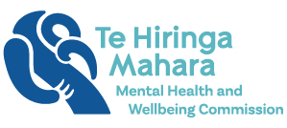
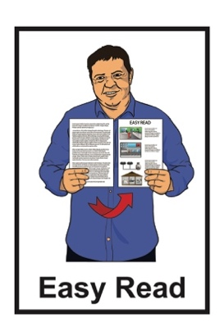

Summary of a report:

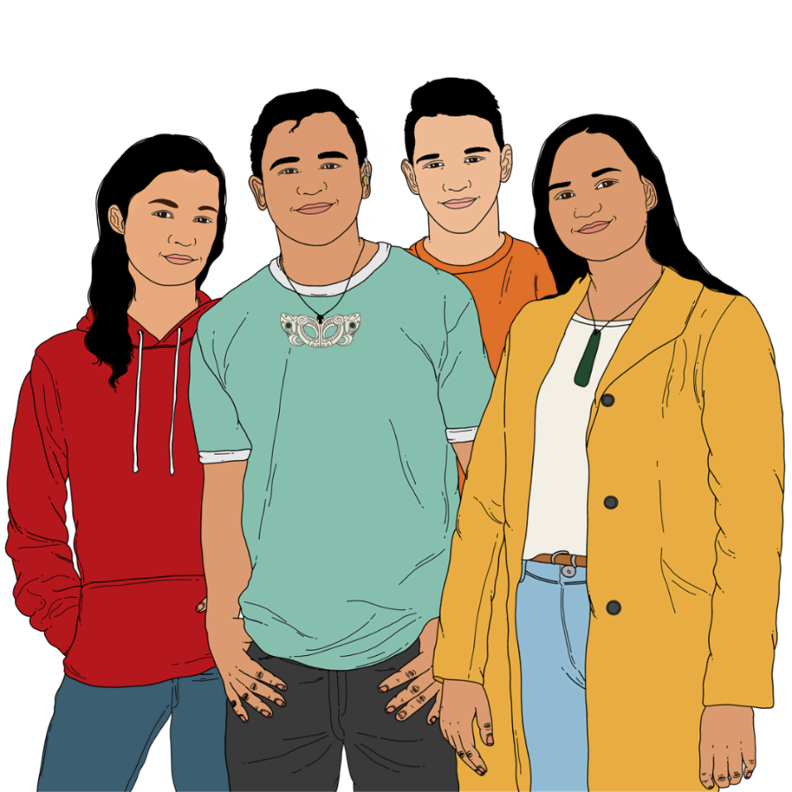
Young people speak out about wellbeing

Published: May 2023

What you will find in here

Page number:

About this summary 3
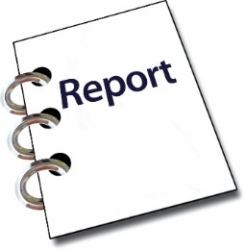

What the report is about 5
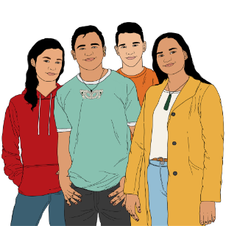

- Feeling unsure about the
future 8

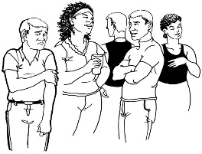
- Racism and discrimination 11

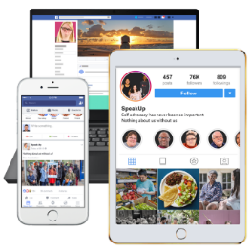
- Social media and online
safety 15

Page number:
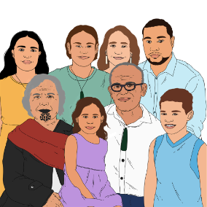

- Whānau wellbeing
and intergenerational
connections 17
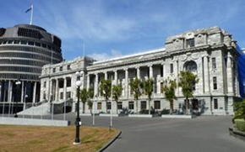

What happens next? 22

Where to find more information 24

About this summary

Te Hiringa Mahara – Mental Health and Wellbeing Commission wrote a report called:
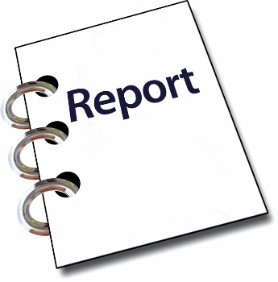
Young people speak out about Wellbeing: An insights report into the Wellbeing of Rangatahi Māori and other Young People in Aotearoa

Te Hiringa Mahara – Mental Health and Wellbeing Commission is:

- a government agency
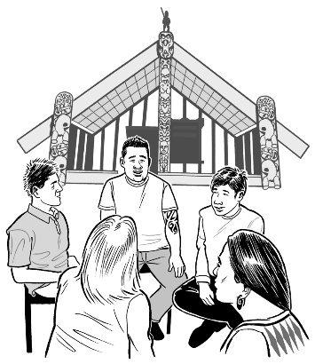
- kaitiaki of mental health and wellbeing in Aotearoa New Zealand.

Kaitiaki is the person or organisation that looks after / cares for something.

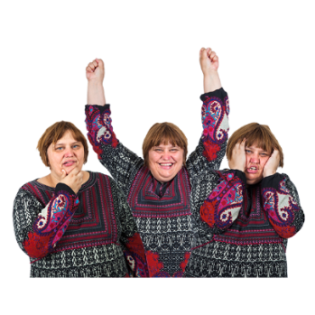
Mental health is about how you feel.

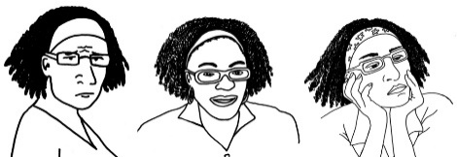
Wellbeing means things like:
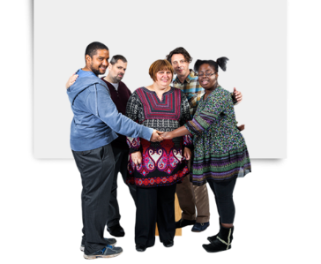
how we feel about ourselves
getting support when we are feeling sad or worried
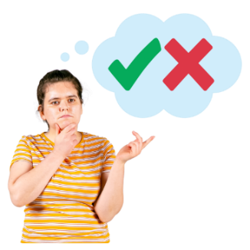
feeling safe
being able to decide what is important to us.

This is an Easy Read summary of the full report.

A summary tells you the most important ideas.

What the report is about

The report is about the wellbeing of:
rangatahi Māori / young Māori
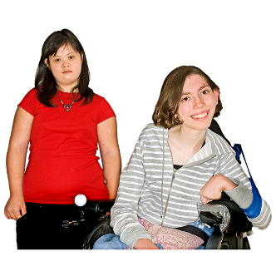
- other young people.

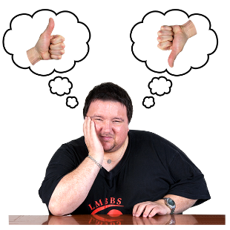
The report helps us all to understand what makes the wellbeing of young people in Aotearoa New Zealand:
better
worse.

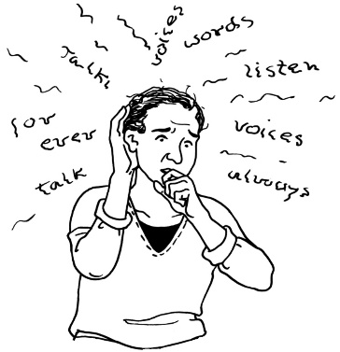
The report says that young people can have poor wellbeing for lots of reasons like:
having a hard time at home
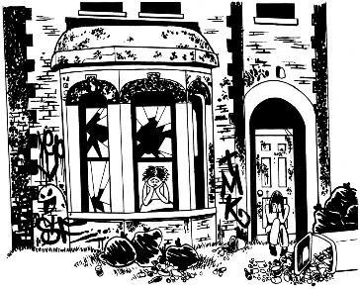
not living in good housing
not feeling connected to their community
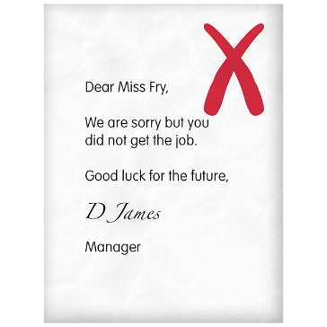
not finding work
not being able to get a good education.

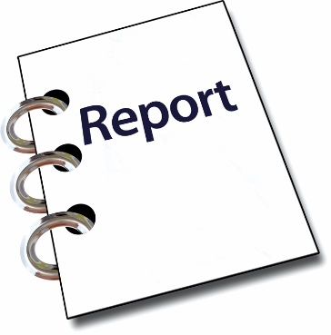
The report looks at 4 main reasons the wellbeing of rangatahi Māori and young people is being affected.

These 4 main reasons are:

- Feeling unsure about the future / years to come

- Racism and discrimination

- Social media and online safety

- Whānau / family wellbeing and intergenerational connections.

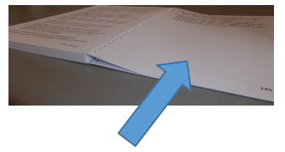
We will look more closely at the
4 main reasons on pages 8 to 21.

Feeling unsure about the future
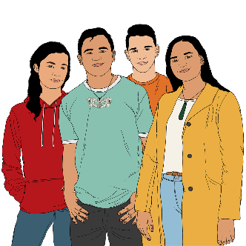

Young people said they would feel happier about the future if:
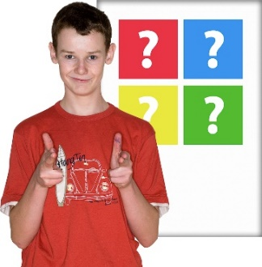
government agencies involved rangatahi Māori and young people in decisions about their future / years ahead
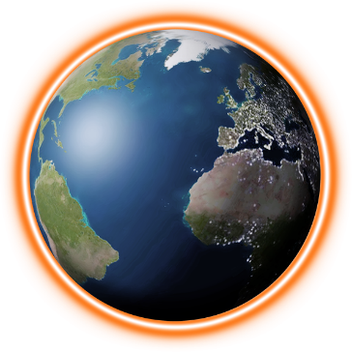
there was better support for the things that young people are doing to slow down climate change
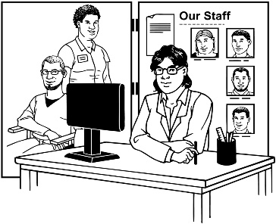
more people around
Aotearoa New Zealand had access to services like mental health services
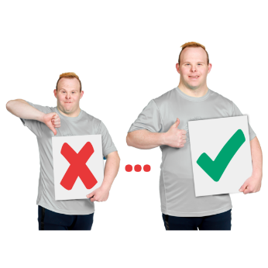
support services were more aware of how young people want services to change for the better.
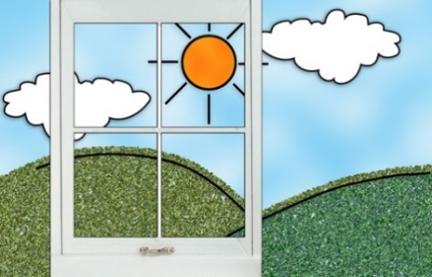
Climate change is about changes that are seen in the weather / earth that last a long time.

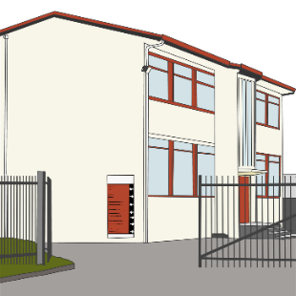
Young people also said that new subjects should be taught at school like:
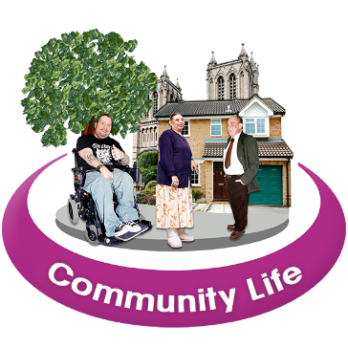
civic engagement education which is how to be a part of the community
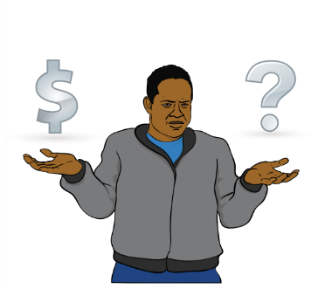
mental health awareness
financial literacy which is how to manage money
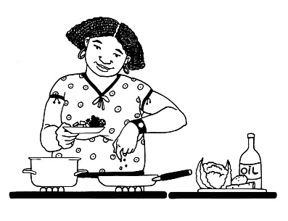
household management which is how to look after the running of a house like cooking and cleaning
what it is like to become an adult.

Young people also said that they need more access to:
support that helps them find jobs
education / learning
housing that does not cost too much money
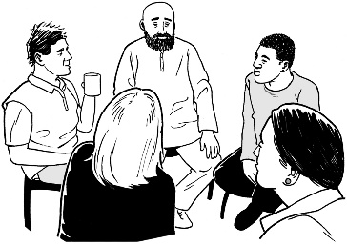
support from people who know what they are going through.

Racism and discrimination

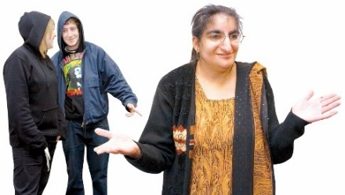
Racism is when people are treated unfairly because of their skin
colour / where they come from.

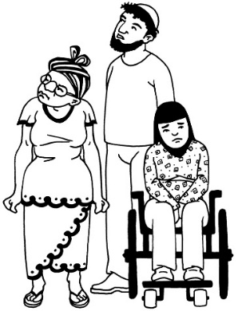
Discrimination is when people are treated unfairly because of things like:
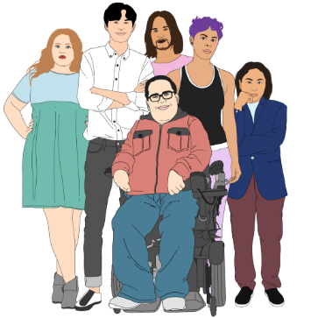
being a man / women / someone of a different gender
their sexuality
their religion / beliefs
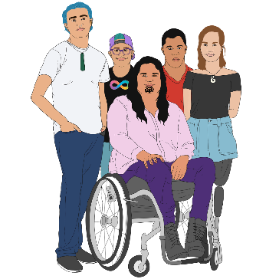
their culture
being disabled.

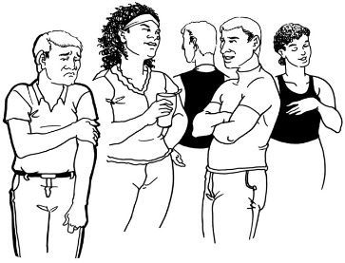
Young people feel like they are discriminated against a lot.

This is more so if young people are:
rangatahi Māori
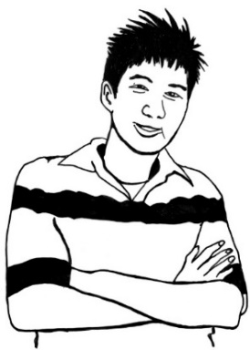
from an ethnic group such as Pacific Islander or Asian.

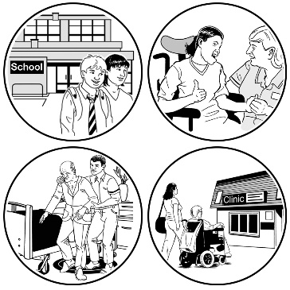
Some of the ways young people want to see less discrimination is by making sure that services that support young people understand:
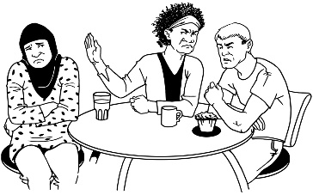
how people treat them differently because of things like their:
- gender
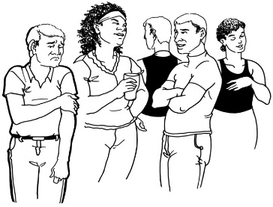
- sexuality
- ethnicity
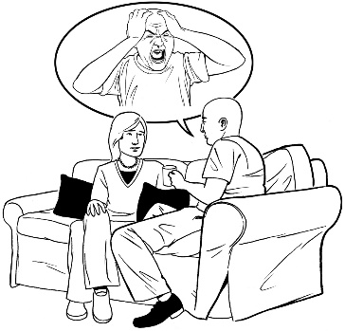
what their culture means to them
how bad things that have happened to them make them feel.

Young people also want to see:
- more checking to stop discrimination / racism on:
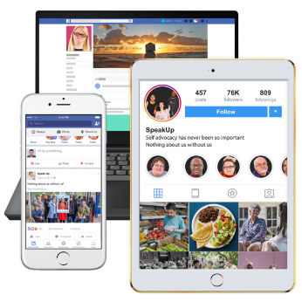
- social media like
Facebook / TikTok
- media sites like news websites
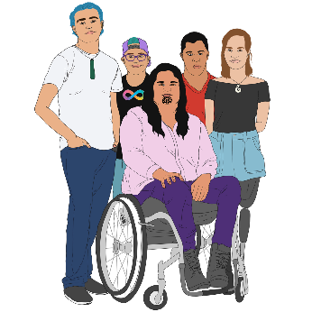
- more work places that include disabled young people.

Social media and online safety

Being online / using social media is a big part of life for young people.

To make it fair for everyone to be online young people felt that everyone should have access to:
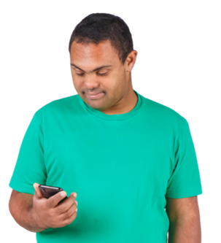
the internet
a computer
a phone.

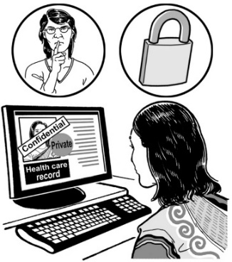
Young people need to feel safe while being online.

Young people can be better supported to be safe online if the people around them know how to be safe online like their:
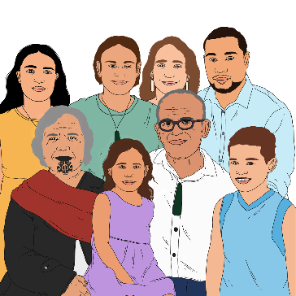
caregivers
whānau / family.

There also needs to be more checking on what kinds of news they are getting so they do not see news that:
upsets them
is not true.

Whānau wellbeing and intergenerational connections

Intergenerational connections means connections between family members of different generations like:
tīpuna / grandparents
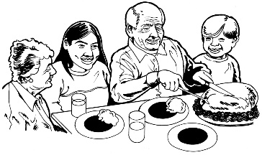
mātua / parents
pāpara / uncles
whaea / aunties.

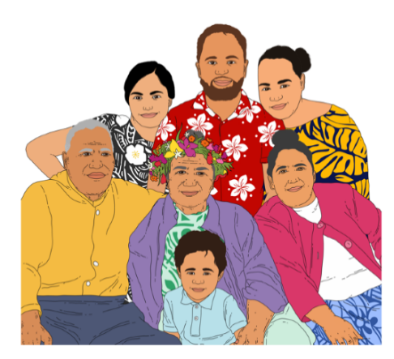
A big part of wellbeing is feeling connected to your:
whānau / family
culture.

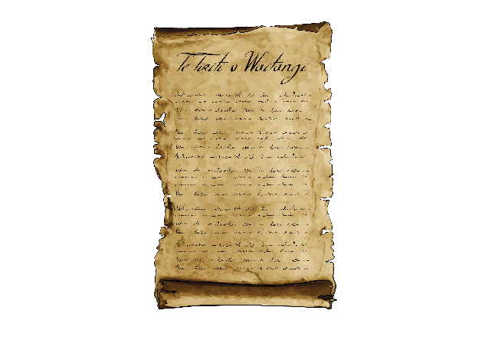
Some ways of supporting young people and whānau to have good connections are by:
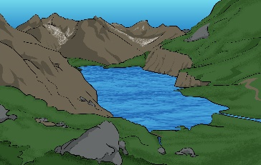
- iwi / hapū / whānau making decisions about their lives as talked about in Te Tiriti o Waitangi / The Treaty of Waitangi
- having ways that rangatahi Māori can connect with their:
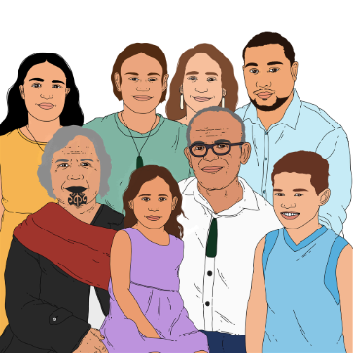
- whenua / land
- whakapapa / family history.

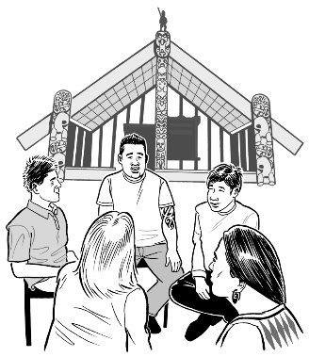
Te Tiriti o Waitangi / The Treaty of Waitangi is about Māori and the New Zealand Government:
making decisions together
protecting things that are
important to Māori.
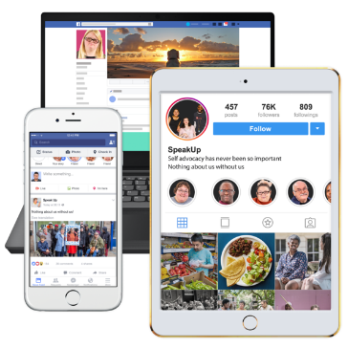
Some more ways of supporting young people and whānau to have good connections are by:
parents / older whānau members having a good understanding of how to use online / social media
- having better support services for parents / caregivers who are looking after young people with:
- mental health issues
- addictions.

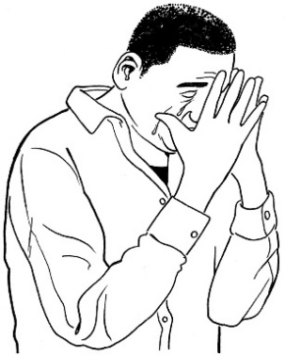
Mental health issues are when people may feel:
sad / worried a lot
confused
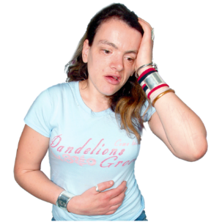
sick
unable to do everyday tasks.

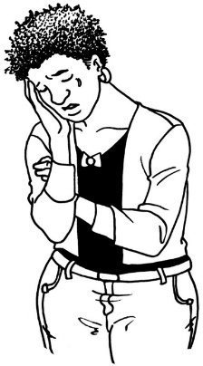
Having mental health issues may also mean having conditions like:
depression
anxiety
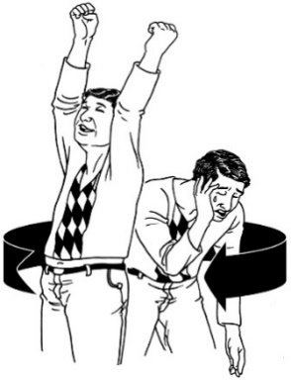
bipolar disorder
schizophrenia
eating disorders.

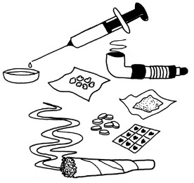
Addiction means not being able to stop yourself from using things like:
drugs
alcohol
gambling – like:
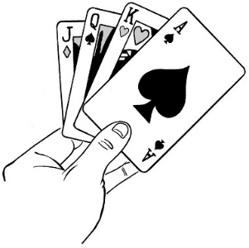
- betting money on the horse racing
- going to a casino.
.

What happens next?

Te Hiringa Mahara will share the report with different government agencies.

They will share what they found in the report:
when talking to leaders in the Government
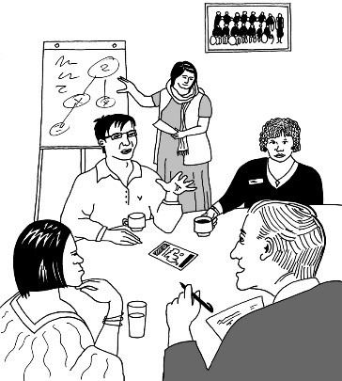
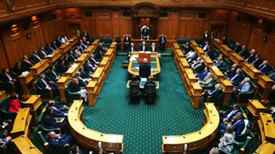
when giving the Government advice on how to help the wellbeing of rangatahi Māori and other young people in Aotearoa New Zealand
with support services that focus on He Ara Oranga.

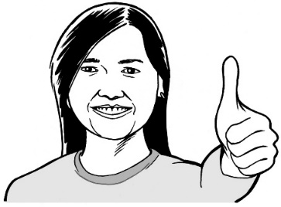
He Ara Oranga is a different way of looking at wellbeing.

More information about He Ara Oranga is on the Te Hiringa Mahara website:

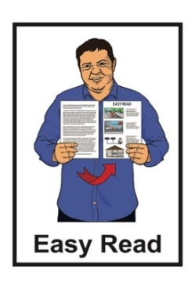
www.mhwc.govt.nz/our-work/he-ara-oranga-wellbeing-outcomes-framework/

This information is not in Easy Read.

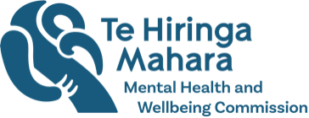
Te Hiringa Mahara will also look to see if the things rangatahi Māori and young people have asked for:
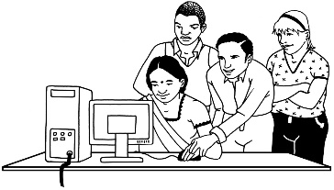
are available

are up to date.

Where to find more information

For more information about
Te Hiringa Mahara – Mental Health and Wellbeing Commission go to their website:
www.mhwc.govt.nz

You can contact them by:
email:
kiaora@mhwc.govt.nz
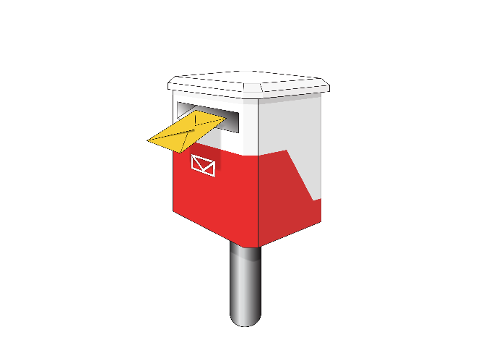
- post:
Te Hiringa Mahara
DX Box SP22502
Wellington
This information has been written by
Te Hiringa Mahara | Mental Health and Wellbeing Commission.
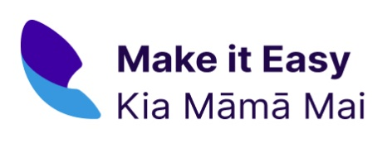
It has been translated into Easy Read by the Make it Easy Kia Māmā Mai service of People First New Zealand Ngā Tāngata Tuatahi.

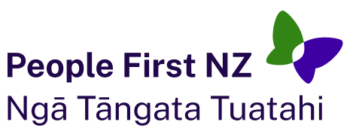
The ideas in this document are not the ideas of People First New Zealand Ngā Tāngata Tuatahi.

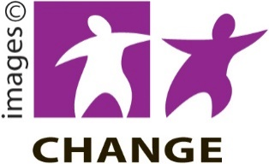
Make it Easy uses images from:
Changepeople.org
Photosymbols.com
SGC Image Works
Huriana Kopeke-Te Aho.
All images used in this Easy Read document are subject to copyright rules and cannot be used without permission.

