

Te Hiringa Mahara - Stakeholder Survey

Powered by

 **Do:**

**Understand your feedback.** What surprises you most? What has been confirmed for you? What themes or discussion points emerge that you can discuss with your team?

**Share the feedback with your teams quickly.** A shared understanding provides the foundation to reach agreement on focus areas and for designing good actions. Don’t forget to celebrate the successes!

 **Don't:**

**Keep the feedback to yourself.** Let people know the findings and you’ll ensure their participation next time.

**Over-analyse the feedback.** We know some people love exploring and dissecting the data in detail. But we suggest taking a simple approach, focusing on the obvious areas and saving time to develop actions with your teams.

**Take the results personally.** This can be easier said than done! It can be confronting, and it takes courage to openly discuss the feedback sometimes.

**Get into debates about whether the data is right or wrong.** There is a natural tendency to rationalise away information we don’t agree with.



### How Strongly Agree to Strongly

Disagree Likert scale questions are scored



Each score contributes:

|  |  |  |  |  |  |  |  |
| --- | --- | --- | --- | --- | --- | --- | --- |
| Don't Know |  | Strongly Disagree | Disagree | Somewhat Disagree | Somewhat Agree | Agree | Strongly Agree |
| No Score |  |  |  |  |  |  |  |
|  |  | 0% | 20% | 40% | 60% | 80% | 100% |

Don't know responses are excluded in calculating the score. The number of people that do not know may indicate an issue. Is it a lack of

awareness that needs to be

addressed?

Red is an area that needs focus. What can you and your team do to improve this? Do you need help from others to solve it?

Orange shows potential concerns and identifies where you could act. What could you build on?

Yellow is good. But are there key areas important to your organisation that should be

improved?

Green is excellent! This is worth celebrating. How could you make

this even better? What best

practice can you share with other teams and leaders?

Each response on this scale contributes a score as outlined below. The responses are then averaged to give your overall question score as a %. For example, if 5 people selected 'Strongly Agree' and 5 people selected ‘Strongly

Disagree’ the score would be 50%

5 x Strongly Agree responses at 100% = 500% | 5 x Strongly

Disagree responses x 0% = 0%

Score = 500% / 10 responses = 50%

### Don't guess. Ask.

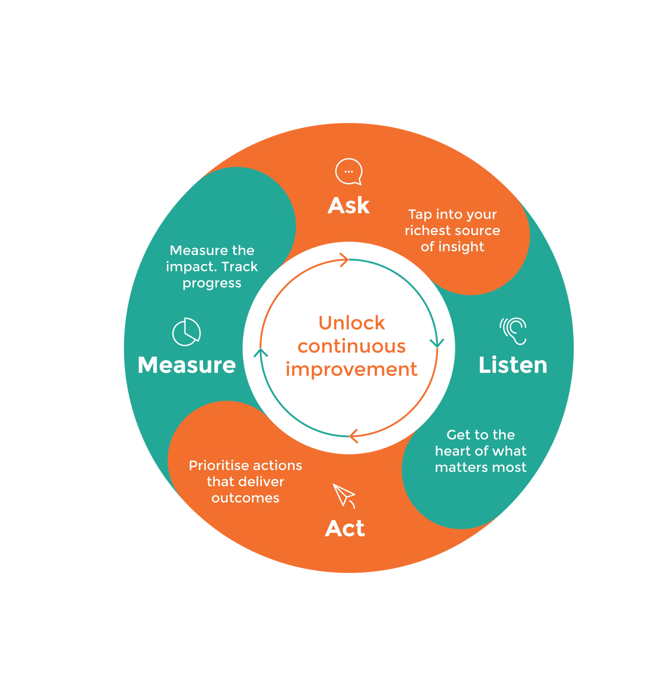

The AskYourTeam framework is borne out of insights from leading organisational models from around the world, and refined through 10 years of active collaboration with our customers.

**Ask:** Don't guess. Ask your richest source of insight.

**Listen:** Get to the heart of what matters most with relevant, actionable insights.

**Act:** Make smarter decisions, faster and prioritise actions that will deliver the best outcomes.

**Measure:** Measure the impact of your actions. Celebrate success or course correct if you need to.

Do it all again and again to create a sustainable loop of continuous improvement.

## 267

14.2%

71.4%

Completed

## 35

Incomplete

## 1572

Not started

Average across all Agree-Disagree questions in your survey

1874 people were invited.

267 people completed the survey. The participation rate is 14.2%.

Participation rates help us understand how representative the feedback is.

While we are not aiming for 100%, a higher percentage indicates a representative sample.

The survey results reveal a positive reflection of the work Te Hiringa Mahara are having through their role in the sector.

There also appears to be pressure on the commission to fulfill roles which are not in their remit to do, and so some reminders or clarity of expectations may be useful.

Results to the questions asked are positive and reinforce the work the team are doing in this important space, with comments highlighting a desire for the commission to “continue” and “keep” doing the great work they do, showing appreciation for the impact of the work done to date. Participants shared positive perceptions from their engagements and the quality of advice they receive from Te Hiringa Mahara.

There is a call for the need for lived experience, minority groups, and appropriate cultural responsiveness to be at the centre of how mental health and addiction is supported across Aotearoa and these will need to continue to be a focus for Te Hiringa Mahara moving forward.

Some demographic groups show some different results, so some exploration into those and why their experience is different could be valuable.

We will look at these in more detail throughout the report with next steps highlighted towards the end.

Your higher scores or most positive feedback was in these areas

* **Positive Engagements with Te Hiringa Mahara:** Participants have reported positive interactions with Te Hiringa Mahara. This suggests that the organisation is effective in its engagements with stakeholders.
* **Confidence in Te Hiringa Mahara's Advice and Information:** There is a high level of confidence in the quality and reliability of advice and reports from Te Hiringa Mahara. This indicates trust in the organisation's outputs.
* **Te Hiringa Mahara's Advocacy on Important Issues:** Te Hiringa Mahara is recognised for speaking up about critical mental health and wellbeing issues. This highlights the organisation's commitment to addressing significant concerns.

Example Data

#### Questions

I have had positive engagements with Te Hiringa Mahara: **75% average score**

I feel confident in the quality and reliability of advice, reports and information from Te Hiringa Mahara: **77% average score**

Te Hiringa Mahara speaks up about important mental health, addiction and wellbeing issues: **74% average score**

Throughout the feedback there was a mix of responses in the comment area about work that is within the Commission’s mandate and broader issues that relate to the whole sector (what the Te Hiringa Mahara has limited ability to impact). Key concerns raised in the comments will be further explored later in the report, a couple of repeated themes were:

* **Need for Culturally Responsive Approaches:** Participants emphasize the need for culturally responsive mental health services. This suggests a gap in addressing the specific needs of diverse communities.
* **Improving Communication and Engagement:** There are concerns about the complexity of language and unclear objectives in Te Hiringa Mahara's communications. This indicates a potential need for clearer and more accessible communication in some areas.
* There were also some **demographic groups** that showed lower results than others, for example the Manawatu- Whanganui and Hawkes Bay regions, and Prisoner groups.

Example Data

#### Question to highlight as an outlier

Te Hiringa Mahara is seen as the guardian or a kaitiaki of mental health and wellbeing in Aotearoa, NZ: **59% average score**

(It is worth noting that there were varied results to this question – with peak body and prisoners giving significantly lower results than other groups.)

# Average Category Score

Engagement & Feedback

Mental health & wellbei ng

Communication

Partnerships & Purpose

65%

72%

72%

76%

The category average is calculated using the score of each question in that category. Categories only apply to the Strongly Agree to Strongly Disagree Likert scale question types. The ‘Custom’ category is made up of customised questions and not based on AskYourTeam’s recommended question set.

### Partnerships & Purpose

The voices and perspectives of people with lived experience are visible in the work of

Te Hiringa Mahara

Te Hiringa Mahara is seen as the guardian or a kaitiaki of mental health and wellbeing

in Aotearoa, NZ

59%

72%

### Communication

Overall, our perception of Te Hiringa Mahara is positive 73%

Te Hiringa Mahara communicates effectively 71%

### Mental health & wellbeing

Te Hiringa Mahara speaks up about important mental health, addiction and wellbeing

issues

74%

Te Hiringa Mahara contributes to improving mental health and wellbeing outcomes 71%

### Engagement & Feedback

I feel confident in the quality and reliability of advice, reports and information from Te

Hiringa Mahara

77%

I have had positive engagements with Te Hiringa Mahara 75%

100%

90%

80%

70%

60%

50%

40%

30%

20%

10%

0%

Prisoner (11)

Other (92)

Refugee or migrant... (13)

Older person (65+)... (41)

Asian (22)

Young person (under ... (21)

Disabled (43)

Māori (86)

65% 66% 67% 68% 68% 69% 69%

71% 72% 74% 74% 74% 76%

### Overall organisation average: 71%

LGBTQIA+ (34)

Children in State Ca... (14)

Pasifika (40)

Rural communities (47)

Veteran (7)

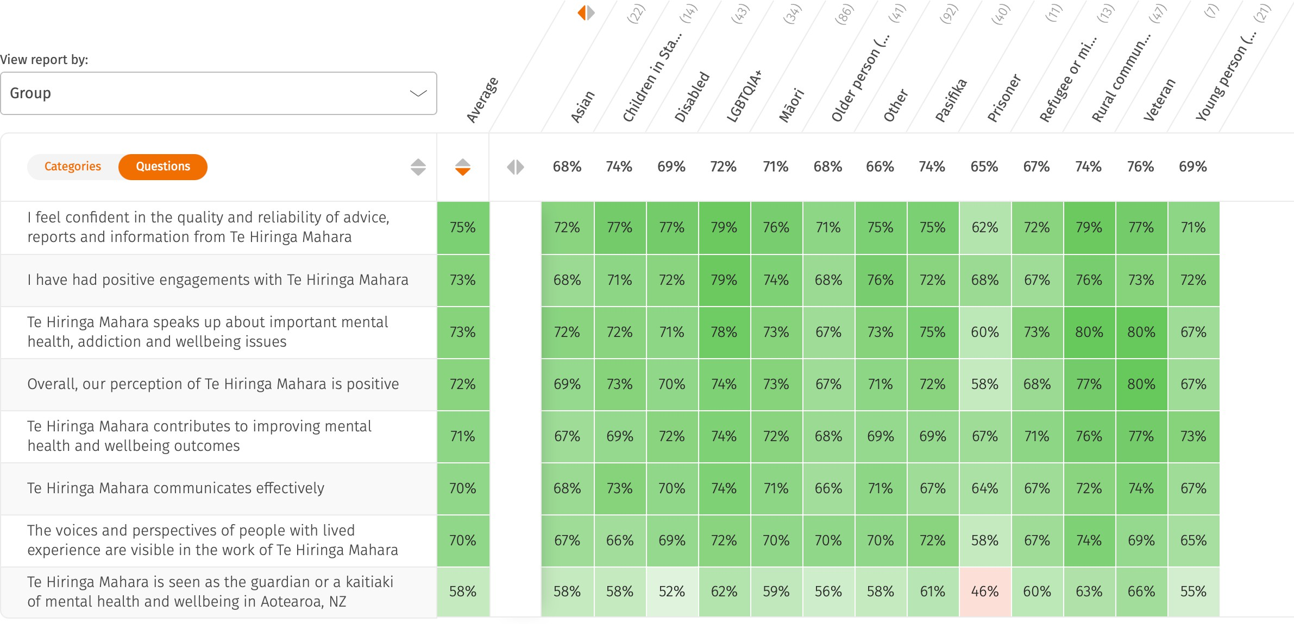

100%

90%

80%

70%

60%

50%

40%

30%

20%

10%

0%

Peak Body/ professio... (12)

MHA service user (28)

Academic/ researcher... (41)

Whānau/family member... (64)

63%

68% 69% 70% 70% 70% 71% 71% 71% 72% 72% 72% 72% 72% 73%

Public (28)

Other (10)

### Overall organisation average: 71%

Govt Agency (44)

LE peer support work... (21)

Kaupapa Māori organi... (36)

NGO/Charity/Communit... (105)

Service Provider (35)

Iwi/H apū (24)

Lived experience (94)

Practitioner/ Clinic... (44)

MH A sector (108)

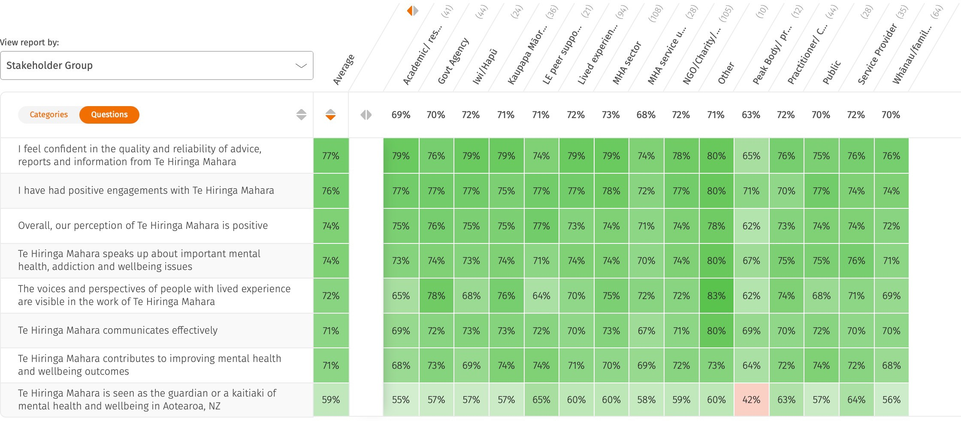

100%

90%

80%

70%

60%

50%

40%

30%

20%

10%

0%

Manawatū-Whanganui... (13)

Hawke’s Bay (5)

Gisborne (8)

61% 64%

69% 69% 70%

71% 72% 72% 76% 77%

### Overall organisation average: 71%

Southland (6)

Wellington (62)

Bay of Plenty (21)

Auckland (75)

Waikato (13)

Canterbury (27)

Otago (22)

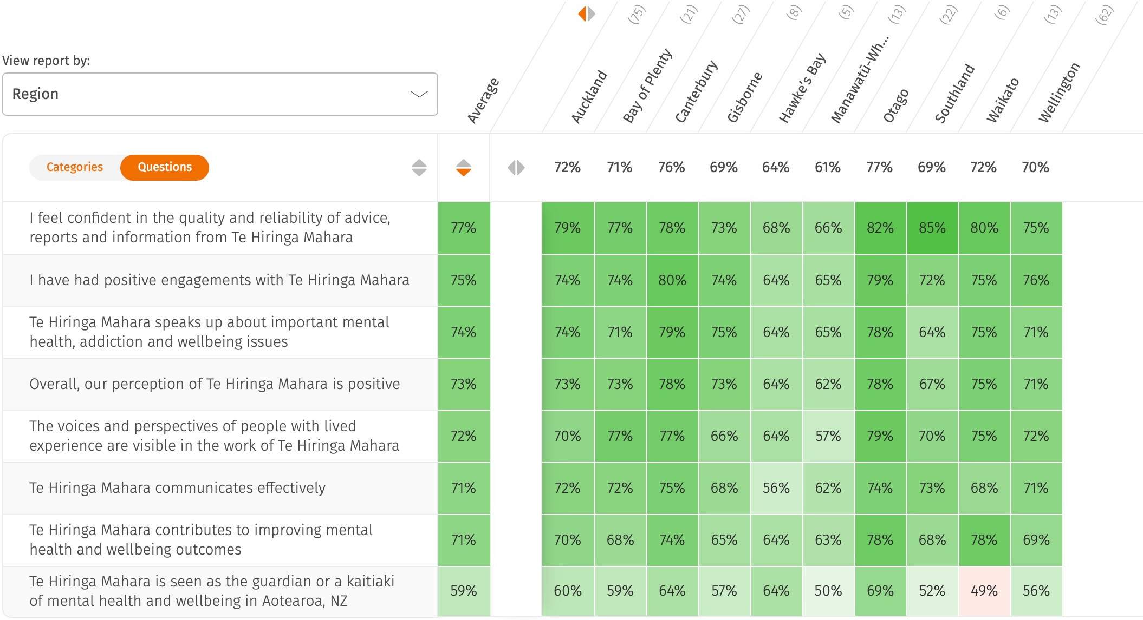

What are the key contributions Te Hiringa Mahara can make to improving future mental health and wellbeing outcomes over the next year?

It was great to see in the comments, a lot of answers started with ”Continue”, and “Keep”, so some of the areas highlighted are already happening, and there is encouragement to continue them.

An overall tone of the comments is that Stakeholders are calling on Te Hiringa Mahara to step into a bolder, more visible leadership role.

#### Key areas highlighted by stakeholders :

1. Honouring Te Tiriti o Waitangi and elevating kaupapa Māori leadership
2. Embedding lived and living experience in all system layers
3. Holding the system accountable with timely and public advocacy
4. Driving equity in access and outcomes
5. Building a thriving and supported workforce
6. Increasing visibility, connection, and accessibility
7. Influencing system transformation across sectors

There is further explanation of each of these in the next slides. Overlaying the mandate, strategy and role of Te Hiringa Mahara is important and being able to communicate out to those who have contributed to clarify what can and will be done.

### What are the key contributions Te Hiringa Mahara can make to improving future mental health and wellbeing outcomes over the next year?

#### Honouring Te Tiriti o Waitangi and elevating kaupapa Māori leadership

* + Honour Te Tiriti in practice, not just principle
  + Support kaupapa Māori-led services, models and leadership
  + Fund iwi/Māori providers and uphold data sovereignty
  + Address tokenism and institutional barriers

#### Embedding lived and living experience in all system layers

* + Elevate lived experience beyond peer support
  + Embed whānau voice in monitoring and service design
  + Address under-representation of key groups
  + Ensure feedback leads to real change – not just consultation

### What are the key contributions Te Hiringa Mahara can make to improving future mental health and wellbeing outcomes over the next year?

#### Holding the system accountable with timely and public advocacy

* + Be courageous in naming underfunding, racism, and inequity
  + Take a more public stance in media and reports
  + Monitor service performance and policy failures
  + Push real-time responses, not delayed reports

#### Driving equity in access and outcomes

* + Close access gaps for Māori, Pacific, youth, rural, rainbow groups
  + Tackle gatekeeping, long waitlists and discrimination
  + Advocate for addiction and maternal mental health services
  + Support grassroots, community-led care

### What are the key contributions Te Hiringa Mahara can make to improving future mental health and wellbeing outcomes over the next year?

#### Building a thriving and supported workforce

* + Build capacity across Māori and lived experience workforces
  + Address burnout and skill gaps
  + Support cultural competency and pathways to registration
  + Prioritise funding for community providers’ staffing needs

#### Increasing visibility, connection, and accessibility

* + Increase public visibility and accessible communications
  + Use plain language and inspiring storytelling
  + Engage directly with communities (kanohi ki te kanohi)
  + Celebrate what’s working, not just problems

### What are the key contributions Te Hiringa Mahara can make to improving future mental health and wellbeing outcomes over the next year?

#### Influencing system transformation across sectors

* + Push for joined-up solutions across housing, justice, education
  + Emphasise prevention and holistic models
  + Monitor strategy implementation (e.g. Kia manawanui).
  + Promote community-led innovation and integration

Clearly all of these can’t be achieved in one year, they are also not all in the remit of Te Hiringa Mahara, but speak to the needs within the sector.

It is important to look at what is more aligned and impactful in achieving the purpose of the Commission. And being able to respond to the expectations of stakeholders on the role you fulfill.

There were comments included that add to the themes seen in the previous question and then were a number of new themes which also came up, mainly broader issues that are also impacting those working in this space. These are reported in two groupings.

1. **Reinforced themes** to what was included in the main question
   * **Te Tiriti o Waitangi & Māori Leadership** – Ongoing call for holistic Māori-led approaches and services that reflect cultural needs.
   * **Lived Experience & Co-design** – Calls for genuine representation and transparency in how voices are selected.
   * **System Accountability** – Need for clearer next steps, bolder public advocacy, and action beyond reporting.
   * **Equity, Access & Social Determinants** – Reinforcement of concerns around poverty, rural invisibility, and underserved groups.
   * **Workforce** – Reiterated issues with burnout, lack of diversity, and experience gaps.
   * **Visibility & Communication** – Need for simpler language, more visibility, and better public awareness.

#### New Themes

* + **Role Confusion** – Unclear distinction between Te Hiringa Mahara and other agencies (MoH, HQSC, etc)
  + **Reporting Clarity** – Request for more targeted, impact-focused reporting rather than broad summaries
  + **Misuse of Access & Choice Roles** – Concern over professionals without lived experience filling peer- intended roles
  + **Tokenism in Participation** – Feedback about lack of inclusivity and transparency in who gets a voice
  + **Harm Reduction Gaps** – New concerns around substance misuse practices and public education
  + **Public Health Promotion** – Suggestion to focus more on exercise, nutrition, and lifestyle to improve wellbeing

A number of these are not primarily in the Commission’s role but may be able to influence or highlight to others through their work.

Another key area to highlight was:

* **Recognition and appreciation:** Participants expressed appreciation and recognition for the efforts and contributions of Te Hiringa Mahara. They highlighted the positive impact of creative work and the knowledge gained from these efforts. There was a strong emphasis on the value of the work done in challenging environments and the leadership in various initiatives.



### It’s important to not try and do too much and dilute the impact, but prioritise what can be most effective in line with the strategy and purpose set for Te Hiringa Mahara

#### Advice for prioritising action – continuing the great work in the spaces of:

1. **Advocate Visibly** – Develop or further develop, a real-time advocacy model to speak out on inequity, service failures, and systemic issues as they arise.
2. **Centre and Co-Govern with Lived and Living Experience** – Being a mechanism to connect with diverse, transparent LLE advisory network and embed them in system monitoring and design where possible.
3. **Continue to Influence Funding Toward Kaupapa Māori and Community Success** – Identify high-impact models and recommend bold funding realignment directly with iwi/community provider focus.
4. **Demystify the System** – Contribute to how people can make use of the system by helping with education and understanding of the various roles those within the system have and can play in supporting outcomes.
5. **People are calling for Focus Deep Insight Projects on Underserved Populations** – Conduct targeted, community-led evaluations for specific groups where and when possible (e.g. veterans, prisoners, rural, rainbow, youth and maternal).



### It’s important to not try and do too much but prioritise what can be most effective in line with the strategy and purpose set for Te Hiringa Mahara

#### Next Steps

* + Evaluating what is possible with the resources available or where resource needs to be deployed to support the voice of stakeholders in line with the purpose of Te Hiringa Mahara.
  + Communicate out what has been heard and what is being actioned as a result to have buy in to the process for future years. Being clear about the role of Te Hiringa Mahara is important to reinforce with those who have expectations out of line with that your team is there to do.
  + Share feedback to the team around the appreciation that was given in the comments about the efforts and support provided. Stakeholders thanked the team for their dedication to education and information sharing, and encouraged them to continue their great work.





Thank you Kirsty Allott

[kirsty.allott@askyourteam.com](mailto:kirsty.allott@askyourteam.com)