


Te Hiringa Mahara

Stakeholder Survey 2026


Powered by

 Do:
Understand your feedback. What surprises you most? What has been confirmed for you? What themes or discussion points emerge that you can discuss with your team?
Share the feedback with your teams quickly. A shared understanding provides the foundation to reach agreement on focus areas and for designing good actions. Don’t forget to celebrate the successes!

 Don't:
Keep the feedback to yourself. Let people know the findings and you’ll ensure their participation next time.
Over-analyse the feedback. We know some people love exploring and dissecting the data in detail. But we suggest taking a simple approach, focusing on the obvious areas and saving time to develop actions with your teams.
Take the results personally. This can be easier said than done! It can be confronting, and it takes courage to openly discuss the feedback sometimes.
Get into debates about whether the data is right or wrong. There is a natural tendency to rationalise away information we don’t agree with.


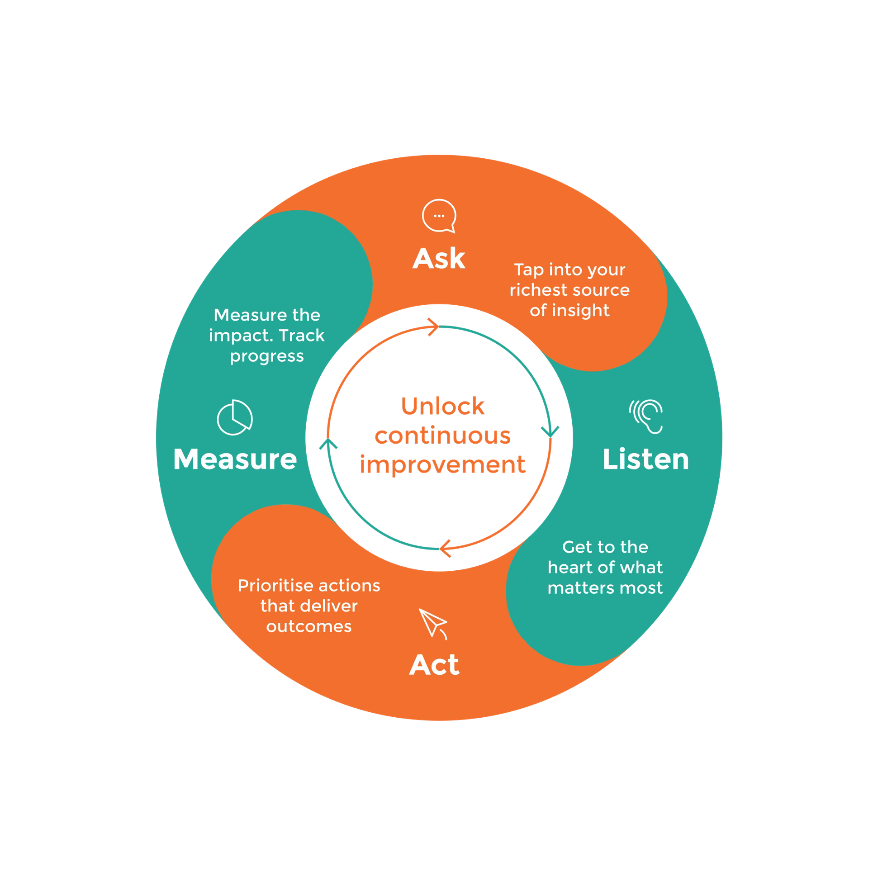
Don't guess. Ask.

The AskYourTeam framework is borne out of insights from leading organisational models from around the world, and refined through 10 years of active collaboration with our customers.

Ask: Don't guess. Ask your richest source of insight.

Listen: Get to the heart of what matters most with relevant, actionable insights.

Act: Make smarter decisions, faster and prioritise actions that will deliver the best outcomes.

Measure: Measure the impact of your actions. Celebrate success or course correct if you need to.
Do it all again and again to create a sustainable loop of continuous improvement.

123

5.9%

71.3%

Completed

18

Incomplete

1959
Not started

Average across all Agree-Disagree questions in your survey
Your participant target was 2100. 123 people completed the survey. The participation rate is 5.9%.

Participation rates help us understand how representative the feedback is.
While we are not aiming for 100%, a higher percentage indicates a representative sample.

Three key messages found in this year’s survey:
- The numbers are stable, with overall results changing very little from 2025.
- Stakeholder expectations have evolved with increasing focus on implementation, influence and visible change rather than additional monitoring.
- Confidence remains high. Stakeholders continue to express confidence in Te Hiringa Mahara and are asking it to amplify, not fundamentally change, it’s role.

While there were a number of changes to the questions asked this year, the overall survey results remained almost unchanged from 2025, stakeholder comments reveal an important evolution in expectations. Rather than asking Te Hiringa Mahara to change direction, stakeholders are asking Te Hiringa Mahara to amplify its existing role by becoming more visible, more courageous in its advocacy, and more influential in ensuring evidence translates into system change.
Despite the lower response rate, there was noticeably stronger alignment across the free-text responses than last year, suggesting growing consensus around Te Hiringa Mahara's strategic priorities.
The survey results indicate that participants generally hold a positive view of Te Hiringa Mahara's contributions to mental health and wellbeing. They suggest that Te Hiringa Mahara is making significant strides in improving mental health and wellbeing outcomes.
Addressing the concerns raised in the free-text responses, such as enhancing accountability, integrating diverse perspectives, and improving communication, could lead to more effective and inclusive mental health services.

Despite significant pressures across the wider mental health system, stakeholders continue to express confidence in Te Hiringa Mahara itself. Trust in the organisation, confidence in the quality of its advice and reports, and recognition of its communication and advocacy all remain consistently strong. Many free-text responses simply encouraged Te Hiringa Mahara to "keep doing the great work", suggesting stakeholders see the organisation as making a positive contribution even while recognising broader system challenges.
Your higher scores or most positive feedback was in these areas
- Effective communication and trust: Te Hiringa Mahara has been successful in building trust and confidence among its stakeholders. The organisation communicates effectively, ensuring that the voices of people with lived experiences are visible in its work.
- Contribution to knowledge and advocacy: The work of Te Hiringa Mahara has significantly contributed to increasing knowledge and understanding of mental health and wellbeing. It has also been effective in speaking up about important mental health, addiction, and wellbeing issues.
- Quality and reliability of information: Participants feel confident in the quality and reliability of advice, reports, and information from Te Hiringa Mahara. This indicates that the organisation provides valuable resources that inform decision-making and advocacy.
- A large number of comments reflect on Te Hiringa Mahara continuing to do the good work it does. Value is seen in what is being done already and encouragement offered to keep doing the great mahi already underway.

Related Questions
Te Hiringa Mahara communicates effectively: 73% average score
I feel confident in the quality and reliability of advice, reports and information from Te Hiringa Mahara: 75% average score
Overall, I have trust and confidence in Te Hiringa Mahara: 73% average score

What needs some work

Your lowest scores or less positive feedback was in these areas
- Enhancing accountability and equity: There is a need for stronger accountability and equity in the mental health and addiction system and a request for Te Hiringa Mahara to contribute to holding others accountable as a strong independent role. Participants call for the implementation of recommendations from reports and ensuring agencies are held responsible for progress.
- Improving stakeholder engagement: Improving communication and stakeholder engagement is crucial, especially with priority population groups. Suggestions include regular face-to-face meetings and early involvement in decision-making to enhance transparency and trust and increase the use of the resources created by Te Hiringa Mahara into users activities.
- Addressing diversity and inclusion: There is an emphasis on integrating Māori perspectives and supporting indigenous therapies. This focus aims to improve outcomes for Māori communities and ensure diverse voices are included in decision-making processes.
- How to get engagement from stakeholders to provide this feedback. Limited weight can be given when only 6% responded and some of the groups we can report on had less than 10 people, so not clear if they’re representative of how your stakeholders feel.

Example Questions
Te Hiringa Mahara contributes to improving mental health and wellbeing outcomes: 70% average score
Te Hiringa Mahara collaborates effectively for positive sector change: 67% average score
I have used Te Hiringa Mahara advice, reports and information to inform my decision making, advocacy or practice: 64% average score

Understanding your results

How Strongly Agree to Strongly
Disagree Likert scale questions are scored









Each score contributes:
Don't Know |  | Strongly Disagree | Disagree | Somewhat Disagree | Somewhat Agree | Agree | Strongly Agree
No Score
 |  | 0% | 20% | 40% | 60% | 80% | 100%

Don't know responses are excluded in calculating the score. The number of people that do not know may indicate an issue. Is it a lack of
awareness that needs to be
addressed?
Red is an area that needs focus. What can you and your team do to improve this? Do you need help from others to solve it?

Orange shows potential
Yellow is good. But are there key areas important to your organisation that should be
improved? Green is excellent! This is worth celebrating. How could you make
this even better? What best

concerns and identifies where you could act. What could you
build on?
practice can you share with other teams and leaders?

Each response on this scale contributes a score as outlined below. The responses are then averaged to give your overall question score as a %. For example, if 5 people selected 'Strongly Agree' and 5 people selected ‘Strongly
Disagree’ the score would be 50%
5 x Strongly Agree responses at 100% = 500% | 5 x Strongly
Disagree responses x 0% = 0%
Score = 500% / 10 responses = 50%

Average Question Score Across All Participants

I feel confident in the quality and reliability of advice, reports and information from Te
Hiringa Mahara
Te Hiringa Mahara speaks up about important mental health, addiction and wellbeing
issues

75%

75%

Overall, I have trust and confidence in Te Hiringa Mahara 73%

The voices and perspectives of people with lived experience are visible in the work of
Te Hiringa Mahara
73%

Te Hiringa Mahara communicates effectively 73%

Te Hiringa Mahara contributes to improving mental health and wellbeing outcomes 70%

The work of Te Hiringa Mahara has contributed to increasing my knowledge and
understanding of mental health and wellbeing
70%

Te Hiringa Mahara collaborates effectively for positive sector change 67%

I have used Te Hiringa Mahara advice, reports and information to inform my decision
making, advocacy or practice
64%

This is a Strongly Agree – Strongly Disagree Likert scale question type. See 'Understanding your results' slide for more information on how these scores are calculated.

Commission’s knowledge and advice uptake rate
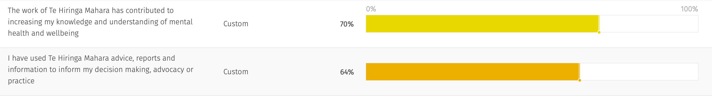

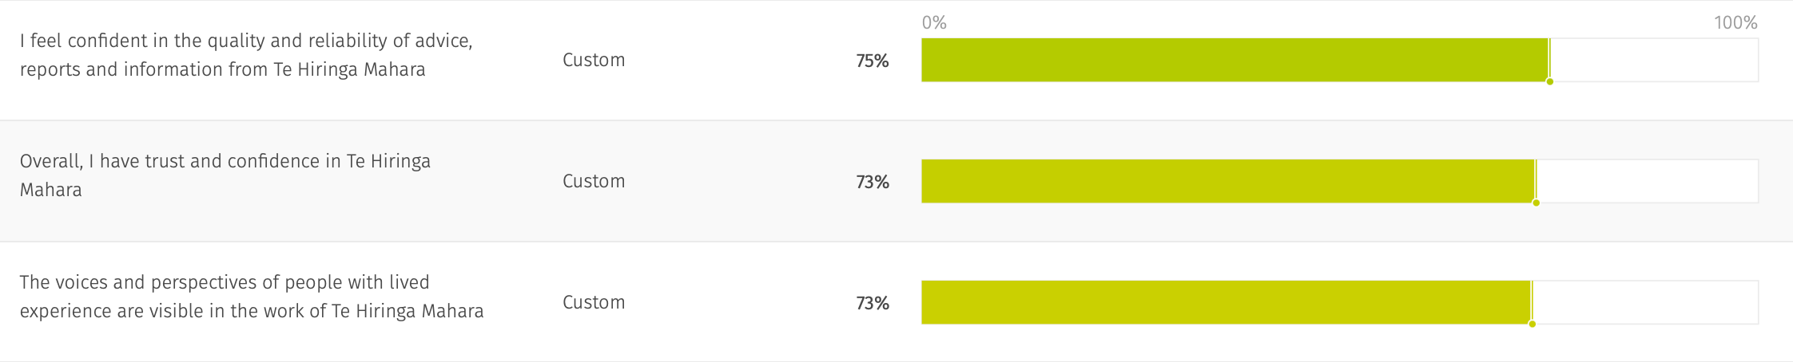
Stakeholder, Māori, Lived Experience trust and confidence score

This is a Strongly Agree – Strongly Disagree Likert scale question type. See ‘Understanding your results’ slide for more information on how these scores are calculated.

Public advocacy and sentiment
Across the stakeholder groups the “Other service provider” group were most positive, at 93%, the next was “Lived experience peer support worker” with 80%. While the lowest at 62% was “Peak body/professional group” and “Member of the public” at 66%.

Sector and system alignment and collaboration
Across the stakeholder groups the “Other service provider” group were very positive, at 83%, while “Peak body/professional” group were lowest at 55% and “Member of the public” 56%.

Commission’s knowledge and advice uptake rate
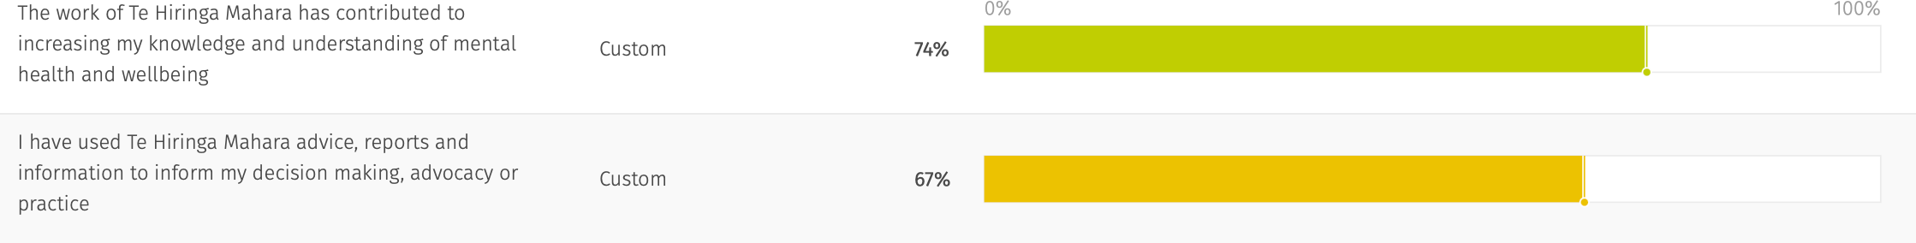

Stakeholder, Māori, Lived Experience trust and confidence score
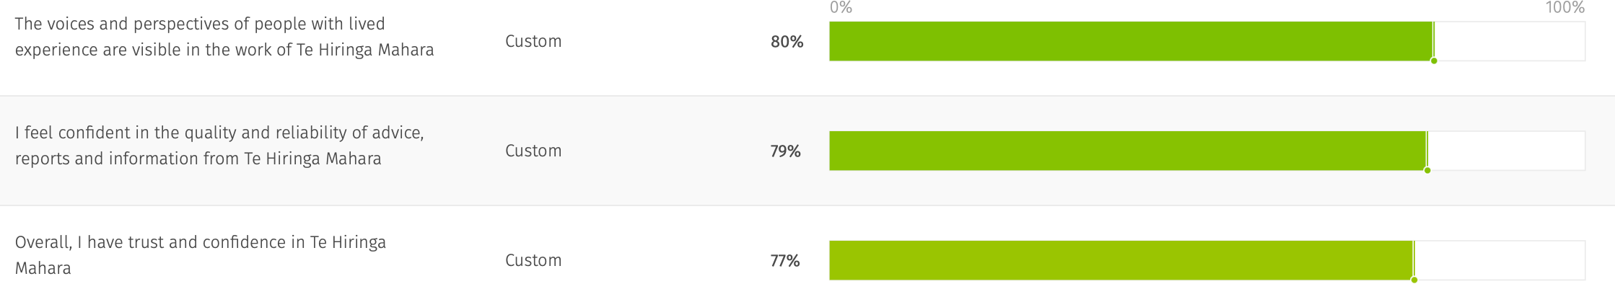

These results are for the “Iwi/Hapu” and “Kaupapa Māori Organisation” stakeholder groups combined and represented in the Impact Measure categories. In all questions they were higher than the general average results. With results 3-6% higher for this sub-set of the stakeholder groups.

Public advocacy and sentiment

Sector and system alignment and collaboration

Again, these results continue from the previous page and show the “Iwi/Hapu” and “Kaupapa Māori Organisation” stakeholder groups combined and represented in the Impact Measure categories. In all questions they were higher than the general average results. With results 3-6% higher for this sub-set of the stakeholder groups.

Commission’s knowledge and advice uptake rate
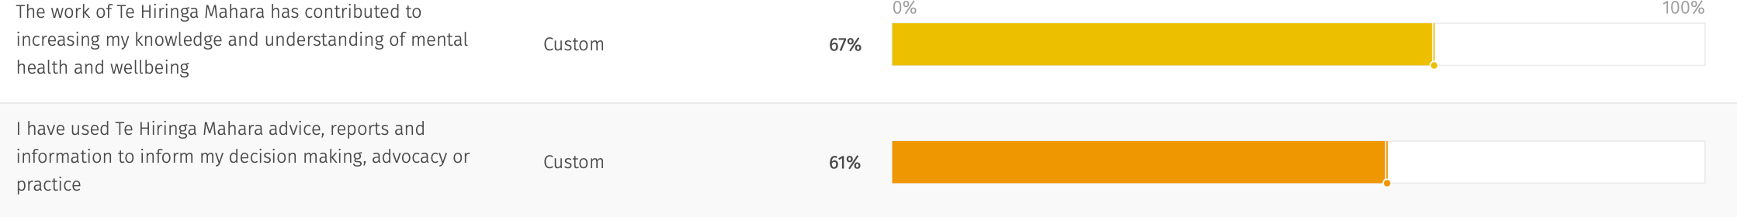

Stakeholder, Māori, Lived Experience trust and confidence score
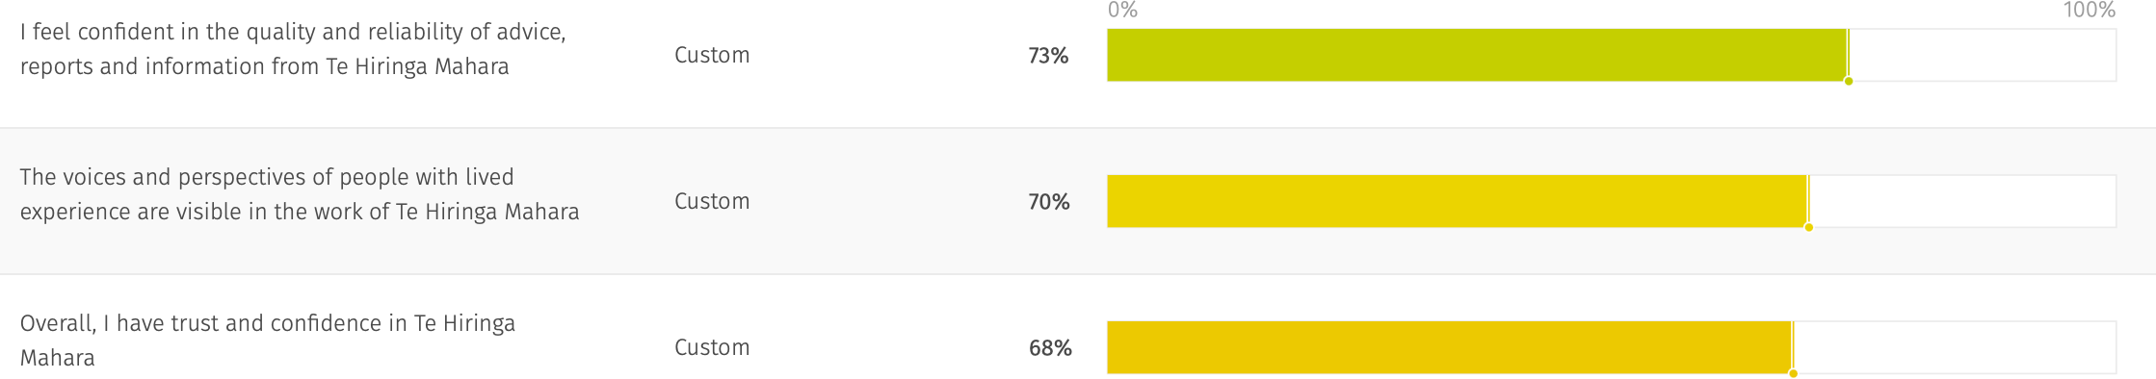

These results are for the “Lived experience peer group worker” and “Person with lived experience of mental distress or addiction” stakeholder groups, by Impact Measure categories. This sub-set were lower than the general average results, with results on average 3% lower. The most notable difference, in the question, “Overall, I have trust and confidence in Te Hiringa Mahara” 5% lower than the overall average.

Public advocacy and sentiment

Sector and system alignment and collaboration

Again, these results are a continuation from the previous page, for the “Lived experience peer group worker” and “Person with lived experience of mental distress or addiction” stakeholder groups, by Impact Measure categories. This sub-set were lower than the general average results, with results on average 3% lower. The most notable difference, in the question, “Overall, I have trust and confidence in Te Hiringa Mahara” 5% lower than the overall average.

Comparison 2025-2026

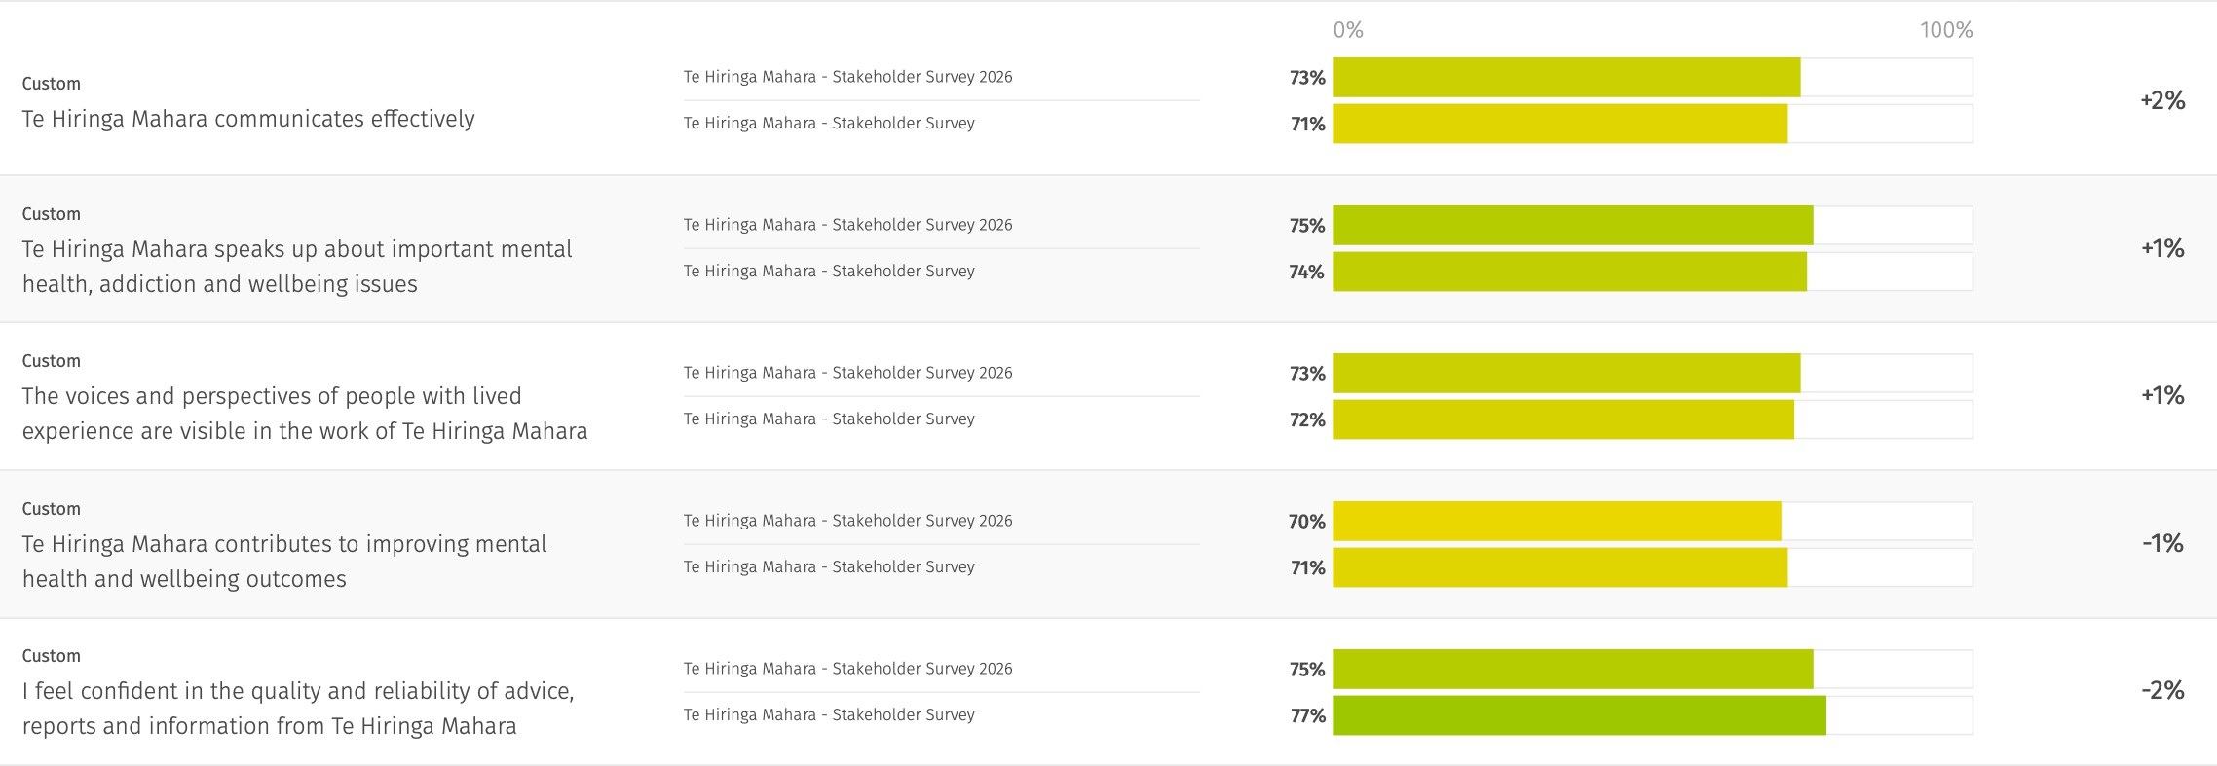

For the five questions which remained the same and enabled a year on year comparison, the resulting shifts have been insignificant. With some questions added, changed or deleted this year, this is a subset of the full questions asked.
In 2025 the range of question averages were 77-59% this year it was 75-64% and yet the overall average of 71% was unchanged.

Summary regarding demographic groups

A challenge faced this year with demographic groups, is that for some there numbers in the demographic group are very low and so it can be hard to take a lot of significance in the differences we can see between demographic groups with low response rates. Some highlights from the information presented:

- Priority population group: Averages were highest for the Rural Community and Refugee groups at 74%. Averages were lowest for the Disabled and LGBTQIA+ groups at 61%.
The lowest ratings by questions came from The Disabled Community on “collaboration for positive change” and LGBTQIA+ on the “voices and perspectives of people with lived experience are visible in the work of Te Hiringa Mahara”. Both rated 51%.
- Stakeholder group: Averages were highest for “Other service Providers” at 83% and ”Lived Experience Peer Support Workers” at 78%. Lowest averages came from “Member of the public” at 57% and ”Peak body/professional group” and ”Academic/researcher/consultant”.
The lowest rated questions were “I have used Te Hiringa Mahara advice, reports and information to inform my decision making, advocacy or practice” at 48%, and “The work of Te Hiringa Mahara has contributed to increasing my knowledge and understanding of mental health and wellbeing” at 50% from Members of the Public. Followed by “Te Hiringa Mahara collaborates effectively for positive sector change” and ”I have used Te Hiringa Mahara advice, reports and information to inform my decision making, advocacy or practice” from the Peak Body/Professional Group, both at 55%.
- Region groups: Otago has the highest average of 83%, and Canterbury at 80%. The lowest average came from Wellington at 64%.

The following pages show the question heatmap for these demographic groups. The biggest range of responses came from the Stakeholder
Groups. Note that the colouring in the heatmaps are not the same as the likert scale, here above 50% is shades of green, below 50% are shades of red. i.e. the most vibrant green is representing the highest scores.

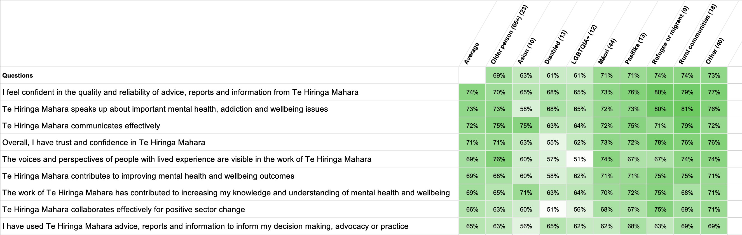

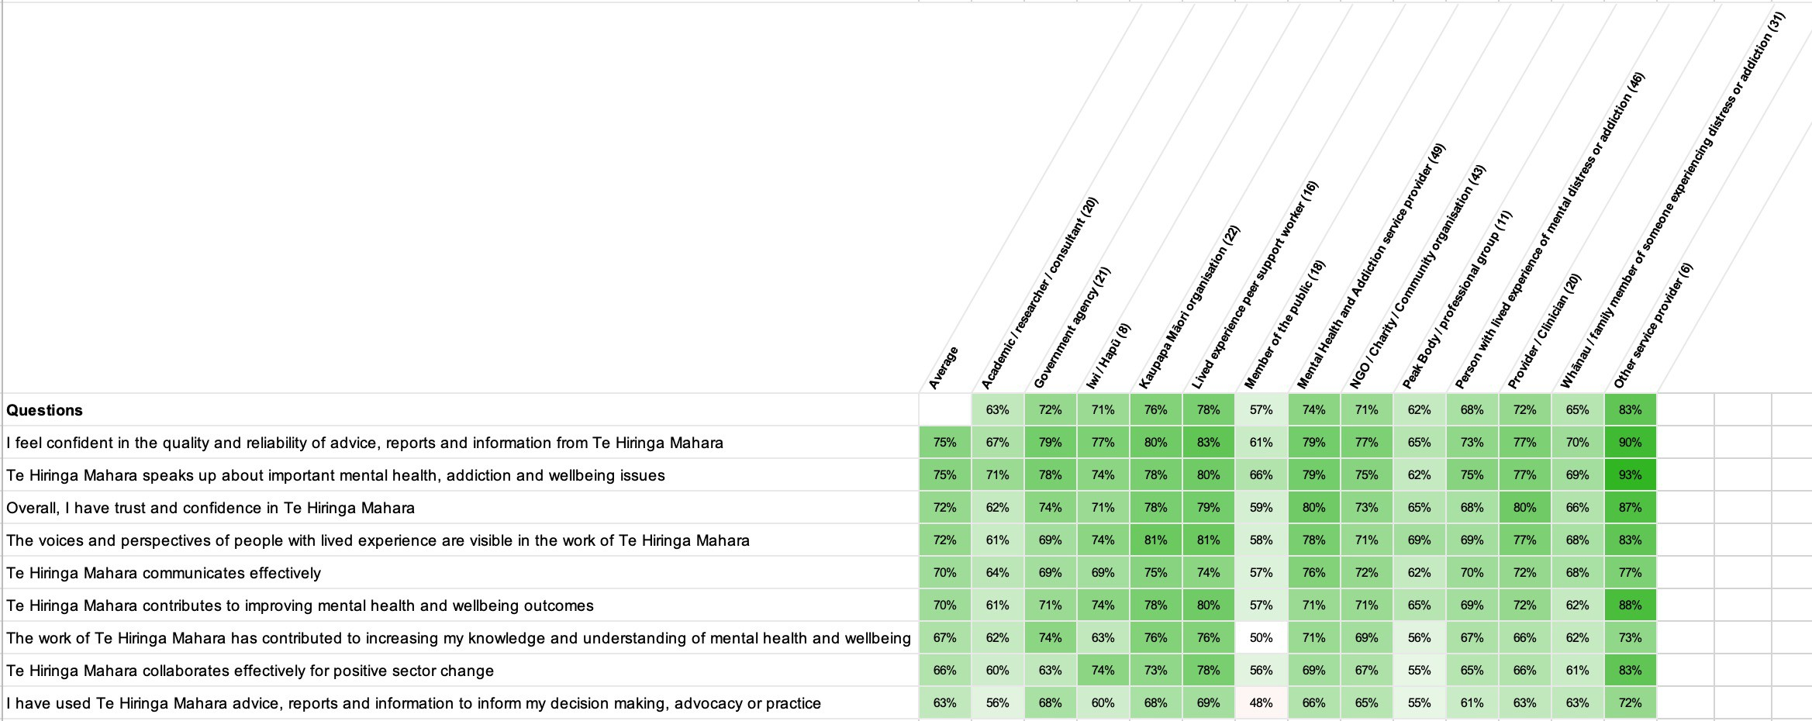

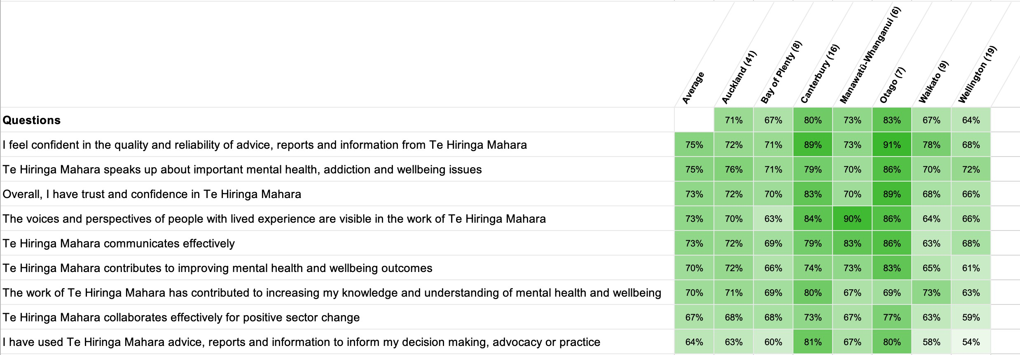

What are the key contributions Te Hiringa Mahara can make to improving future mental health and wellbeing outcomes over the next year?

Responses reflected a high level of engagement and demonstrated a strong understanding of Te Hiringa Mahara's role within the wider mental health and wellbeing system.
Compared with the previous year's survey, stakeholder feedback showed greater consistency around a smaller number of strategic priorities. While last year's responses contained a wide range of individual suggestions, this year's feedback converged around several clear themes, providing greater confidence that these represent the sector's most important priorities.

Overall, stakeholders are not asking Te Hiringa Mahara to fundamentally change its role. Rather, they are asking Te Hiringa Mahara to amplify the role it already plays by being more visible, more courageous, more influential and more connected to the voices of communities. Across the responses there is strong confidence in Te Hiringa Mahara's purpose and independence. The challenge identified by stakeholders is not what Te Hiringa Mahara does, but how it can maximise its influence to ensure evidence, lived experience and independent monitoring translate into meaningful system change.

The key areas highlighted by stakeholders in the free-text comments:
- Strengthen Independent Advocacy and Accountability
- Centre Lived Experience and Whānau Leadership
- Champion Equity through Māori Leadership and Culturally Responsive Approaches
- Drive Improvement through Evidence, Monitoring and Implementation
- Build a Stronger and More Sustainable Mental Health System
- Increase Visibility, Engagement and Public Influence

Key themes:
- Strengthen independent advocacy and accountability
The strongest theme across responses was the expectation that Te Hiringa Mahara continue to be an independent and courageous voice for mental health and wellbeing.
Stakeholders value Te Hiringa Mahara's monitoring role but increasingly want to see stronger advocacy that not only identifies issues but actively influences change. There was a consistent desire for Te Hiringa Mahara to hold government and the wider system accountable for progress against recommendations and to speak more publicly about emerging issues.

Centre lived experience and whānau leadership
Stakeholders strongly supported Te Hiringa Mahara's commitment to lived experience but encouraged a shift from consultation towards genuine partnership and leadership.
Many respondents wanted lived and living experience voices to be more visible in decision-making, presentations, workforce development and policy influence. Whānau voices were also seen as needing greater prominence.

Champion equity through māori leadership and culturally responsive approaches
Stakeholders continued to see Te Tiriti o Waitangi and Māori wellbeing as central to Te Hiringa Mahara's role.

Respondents called for stronger advocacy for kaupapa Māori approaches, equitable funding, culturally responsive services and improved outcomes for Māori. Several also highlighted the importance of ensuring other underserved populations, including Asian, children, remand and refugee communities, are represented within policy and service design.

Key themes continued:
- Drive improvement through evidence, monitoring and implementation
Stakeholders continue to place significant value on Te Hiringa Mahara's monitoring and reporting functions.

However, there was a noticeable shift in emphasis this year. Rather than simply requesting more monitoring, respondents wanted stronger follow-through to ensure evidence leads to tangible system improvement. Some suggested highlighting examples of successful practice, tracking implementation of recommendations, and translating evidence into practical action.

Build a stronger and more sustainable mental health system
Many responses reflected concern about the long-term capability and sustainability of the mental health and addiction system.

Stakeholders highlighted workforce shortages, lived experience workforce development, early intervention, prevention, community-based models of care and innovation. There was also a growing emphasis on addressing the wider social determinants of wellbeing rather than focusing solely on treatment services.

Increase visibility, engagement and public influence
Respondents wanted Te Hiringa Mahara to become more visible and accessible to communities.

Suggestions included stronger communication, greater public awareness, more regional engagement, face-to-face opportunities, simpler reporting and closer relationships with community providers.

The relatively high agreement scores combined with aspirational free-text feedback suggest stakeholders are not dissatisfied with Te Hiringa Mahara's performance. Rather, they see Te Hiringa Mahara as being well positioned to have even greater influence and are encouraging it to lean further into its unique role.

While aligning any action planning to the impact measures Te Hiringa Mahara has in place, suggested areas to consider would be to:
- Amplify influence rather than expand scope: Stakeholders are not asking Te Hiringa Mahara to become a different organisation. Rather, they are asking it to maximise the influence of the work it already does through stronger advocacy, greater visibility and more active follow-up of recommendations made.

- Demonstrate impact: Several responses questioned what happens after reports are published. Consider developing clearer ways of communicating:
  - What changed
  - What recommendations were adapted
  - Where progress has occurred
  - Where barriers remain.
This helps demonstrate the value of monitoring beyond publication.

- Continue evolving lived experience leadership: Stakeholders increasingly expect lived and living experience to influence, not simply inform, Te Hiringa Mahara’s work. Opportunities might include:
  - Greater visibility of lived experience leadership
  - Co-design
  - Governance
  - Presenting findings
  - Implementation planning.

- Increase public accessibility: Rather than producing more information, consider making information easier to access and understand through:
  - Shorter summaries
  - Visual storytelling
  - Webinars
  - Podcasts
  - Community conversations
  - Regional engagement
- Review the stakeholder engagement strategy: The response rate is the biggest risk to this survey. Rather than simply trying to increase participation, seeking to understand why participation declined. Questions worth exploring include:
  - Is the stakeholder list current?
  - Are people experiencing survey fatigue? What is the schedule of survey
  - Do stakeholders know what changed because of previous feedback?
  - Would different engagement methods increase participation?
This is important to make sure the time and effort put into this survey gives useful information from a good representation of your stakeholders.

Independent review completed by Kirsty Allott of UPPO NZ Limited.
Thank you for the opportunity to review your stakeholder survey results and include some suggested next steps.
If you have any further questions, please don’t hesitate to get in touch.


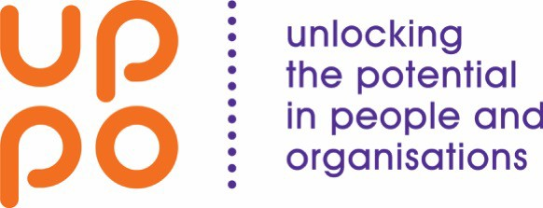


Powered by

