Waenga Mōrearea, He Ara Oranga
He Tirohanga o Te Ara Tūroa
Bold Directions for the future of Aotearoa's Mental Health System
A synthesis of the closing participatory session from Te Ara Tūroa

Acknowledgements
Te Hiringa Mahara – the Mental Health and Wellbeing Commission, Ember Innovations, and TheMHS (Australasian Mental Health Conference) co-designed the final participatory session at Te Ara Tūroa — a shared space for collective reflection, provocation, and system imagination.
We jointly acknowledge and thank everyone who contributed insight, courage, and lived experience to this process. This synthesis reflects their voices and offers a picture of the shared direction of travel emerging across the sector.
Many of the ideas surfaced here are not new. They echo long-held aspirations, community wisdom, and insights raised repeatedly by tāngata whaiora, whānau, practitioners, researchers, and leaders across Aotearoa. Their re-emergence at Te Ara Tūroa does not signal a lack of progress - instead, it affirms their endurance, their ongoing relevance, and the determination of the sector to keep them alive in our system conversations. Together, they form a throughline of hope and persistence, pointing toward a mental health system grounded in connection, dignity, equity, and care.

Executive Summary
The closing session of Te Ara Tūroa invited around 200 delegates to co-create a vision for the future of mental health and wellbeing innovation in Aotearoa. Using a Liberating Structures approach — What? So What? Now What? — participants identified what is happening across the system, why these signals matter, and where bold action is most needed.
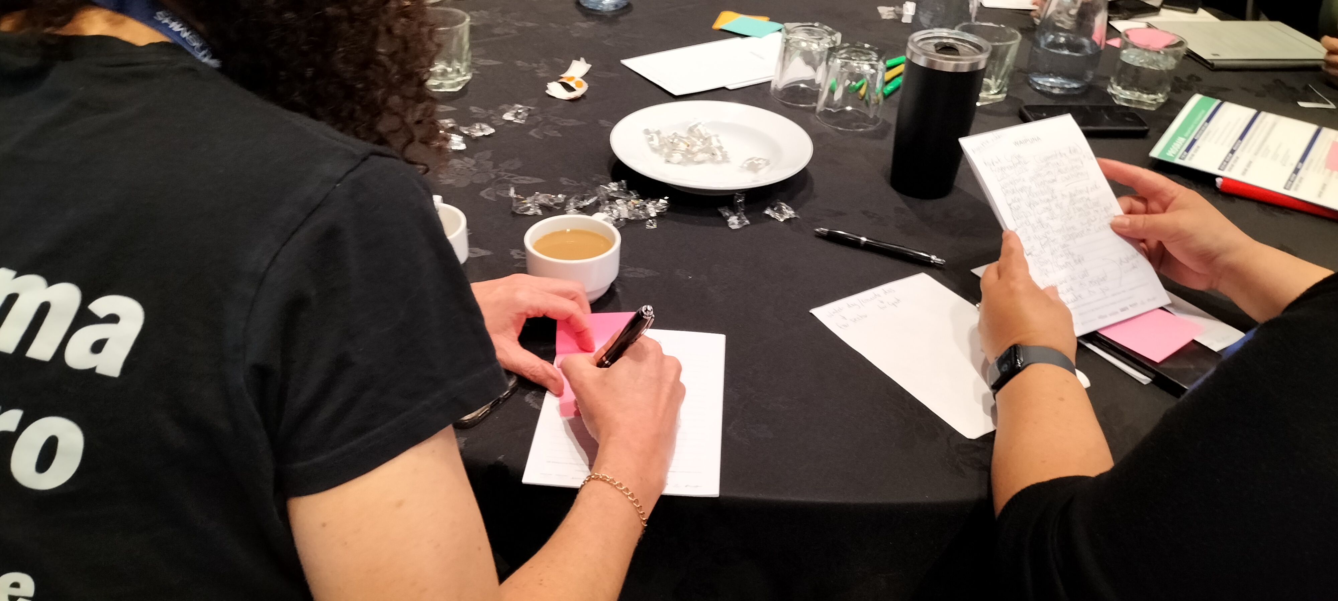
Across sectors and communities, several strong aspirations converged:
- courageous and collaborative leadership,
- investment that builds momentum and community capability,
- youth- and peer-led innovation, and
- a shift toward whānau- and community-centred ecosystems of care.
These are not organisational directives; they are sector-wide signals of energy, urgency, and possibility.

WHAT – What We Noticed
Participants identified six major themes signalling where change is already emerging:
- Young People: Youth as innovators, designers and responders. A shift from consultation to meaningful participation, leadership, and authorship.
- Peer Support: “Peer first, peer last.” Lived-experience leadership is an essential design principle, not a peripheral service component.
- Service Design & Early Intervention: A strong call for health promotion, prevention, trauma-informed practice and community-based hubs. Early support is relational — everyday connection prevents crisis.
- Human-Centred: Systems must centre dignity, connection, whakapapa and healing. Every encounter shapes wellbeing or harm.
- System: Fragmented commissioning, power imbalances and crisis-driven responses undermine wellbeing. There is appetite for re-design that prioritises whānau outcomes and equity.
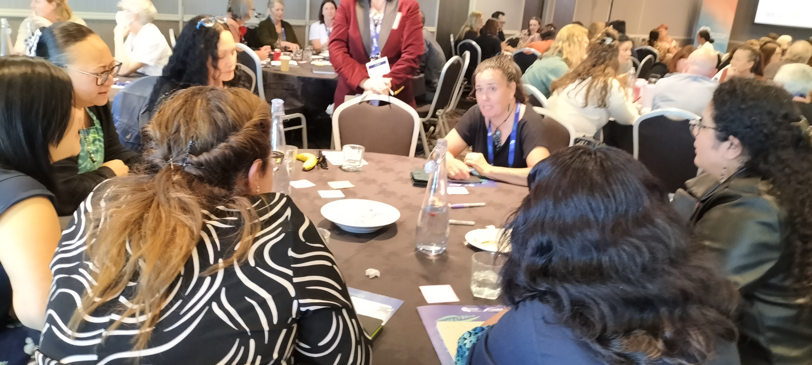
- Tech / AI: Digital futures are arriving quickly. The opportunity lies in ethical and participatory tools that empower rather than replace relationships.

SO WHAT – Why It Matters
Participants interpreted these signals and identified implications for transformation. Seven themes emerged:
- Youth: Young people must be positioned not only as co-creators but as a major part of the solution — beneficiaries, architects, experts and leaders.
- More Connected System: Fragmentation wastes energy and undermines outcomes. Collaboration, not competition, is essential.
- Community: Community capability and self-determination must be trusted, resourced and central. Everyday people hold the keys to wellbeing.
- Lived Experience: Lived experience leadership remains undervalued; recognition, remuneration and influence must increase — and essential voices are still not being heard.
- Leadership & Innovation: Systemic change requires brave, enabling leaders who build on what has been hard-won, while creating space for new thinking and innovation.
- Investment: Funding must be stable, transparent, trust-based, and long-term to sustain innovation and community capacity.
- Respites & Workforce Wellbeing: People and systems need spaces for restoration and reflection — including a healthy, well-supported workforce capable of sustaining complex mahi.

NOW WHAT – What Actions Make Sense
The Now What phase generated bold, actionable directions for the future:
- Joined-Up Commissioning: Design cross-sector commissioning spanning housing, employment, social, whānau and health services — with shared outcomes and accountability.
- Leadership & Culture: Resource a network of courageous, collaborative leaders committed to transparency, connection, and continuity beyond political cycles.
- Investment in Workforce: Stabilise and strengthen the workforce through equitable pay, sustained funding, and wellbeing-centred employment conditions.
- Whānau-Centred Ecosystem: Shift from hospital-centric care to ecological, community-based, whānau-led models grounded in place and whakapapa.
- Youth-Led Innovation: Establish youth-led design labs and digital innovation pilots — recognising developmental transitions and bridging gaps between child, youth and adult services.
- Peer Leadership: Resource and embed lived-experience leadership in commissioning, policy and service delivery.
- Structural Reform: Create legislative and structural enablers that support interagency collaboration and continuity of direction.
- Values-Led Funding & Transparency: Move to investment models aligned with collective wellbeing outcomes, supported by transparent funding flows and decision-making.
- Community Power: Devolve resources and decision-making to hapū, community networks and local innovators.
- Learning System: Build a national learning system that tests, iterates, scales and shares what works — relational, evidence-informed, and adaptive.
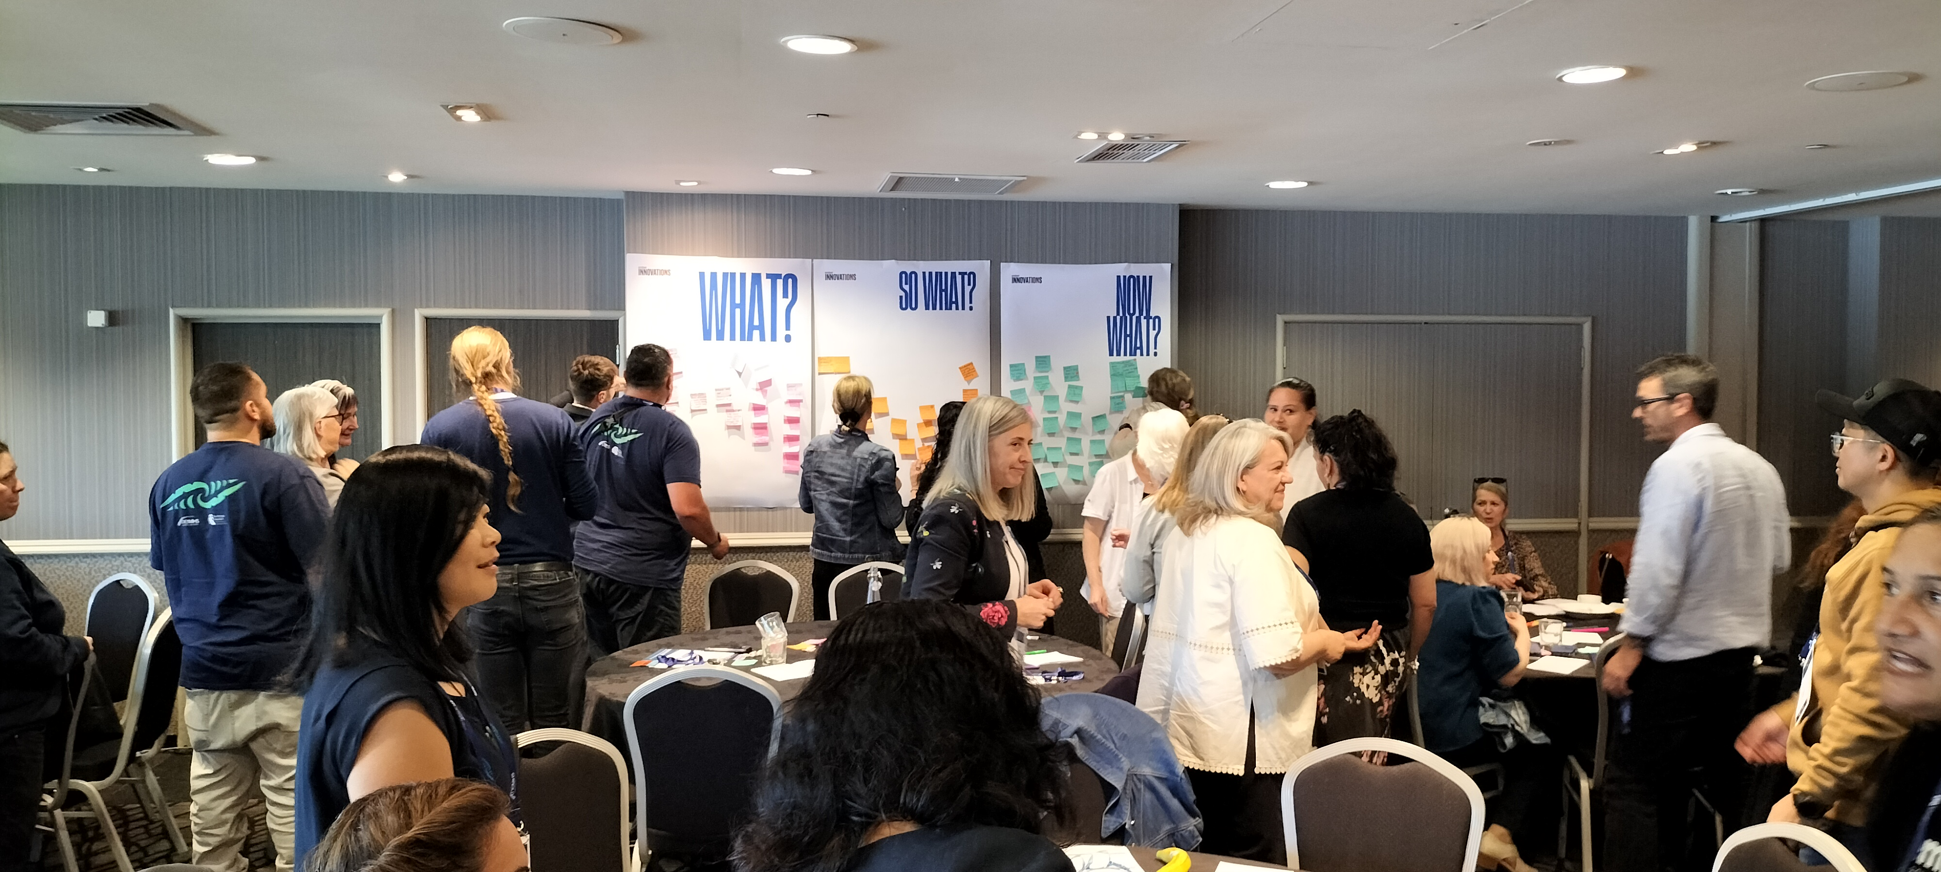

Cross-Cutting Insights
Five themes emerged consistently across all layers of the conversation:
- Connection as infrastructure — across people, sectors and systems.
- Whānau-centred, community-led care as the foundation of wellbeing.
- Youth and peer leadership as engines of innovation.
- Courageous, compassionate leadership as the driver of transformation.
- Commissioning reform — long-term, trust-based, transparent and value-aligned.
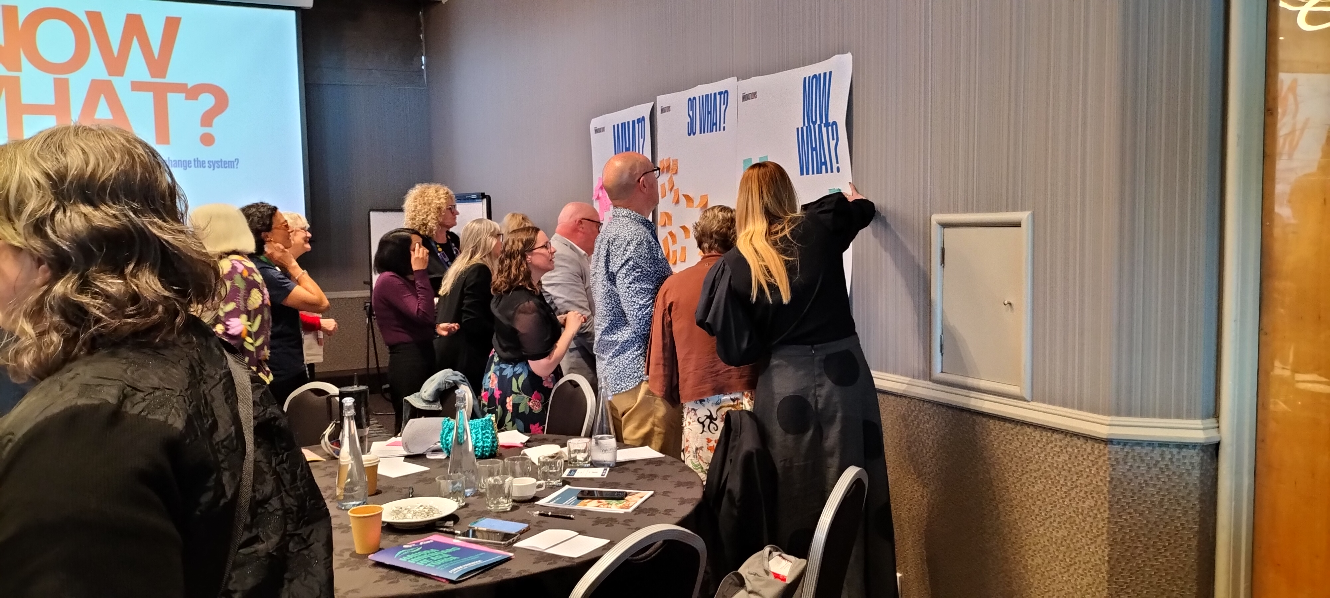
Insights to Action
These ideas are not directives. They are collective aspirations voiced across Te Ara Tūroa - powerful signals of where sector momentum is building.
Joined-Up Commissioning
A future where commissioning spans housing, employment, social, whānau and health services — with shared outcomes defined with community and tāngata whaiora, accountability and continuity beyond election cycles.
Courageous, Connected Leadership
A sector hungry for leaders who build on what is working, share power, seed innovation, and lead with values, transparency and compassion.
Youth- and Peer-Led Innovation
Young people and people with lived experience want to create, lead and test solutions — and the system is ready for funding and legitimacy to follow their leadership.
Whānau-Led and Community-Centred Ecosystems
A shift from hospital-centric care to whānau-anchored, place-based, relational, ecological models of wellbeing.
A Wellbeing Commissioning Framework
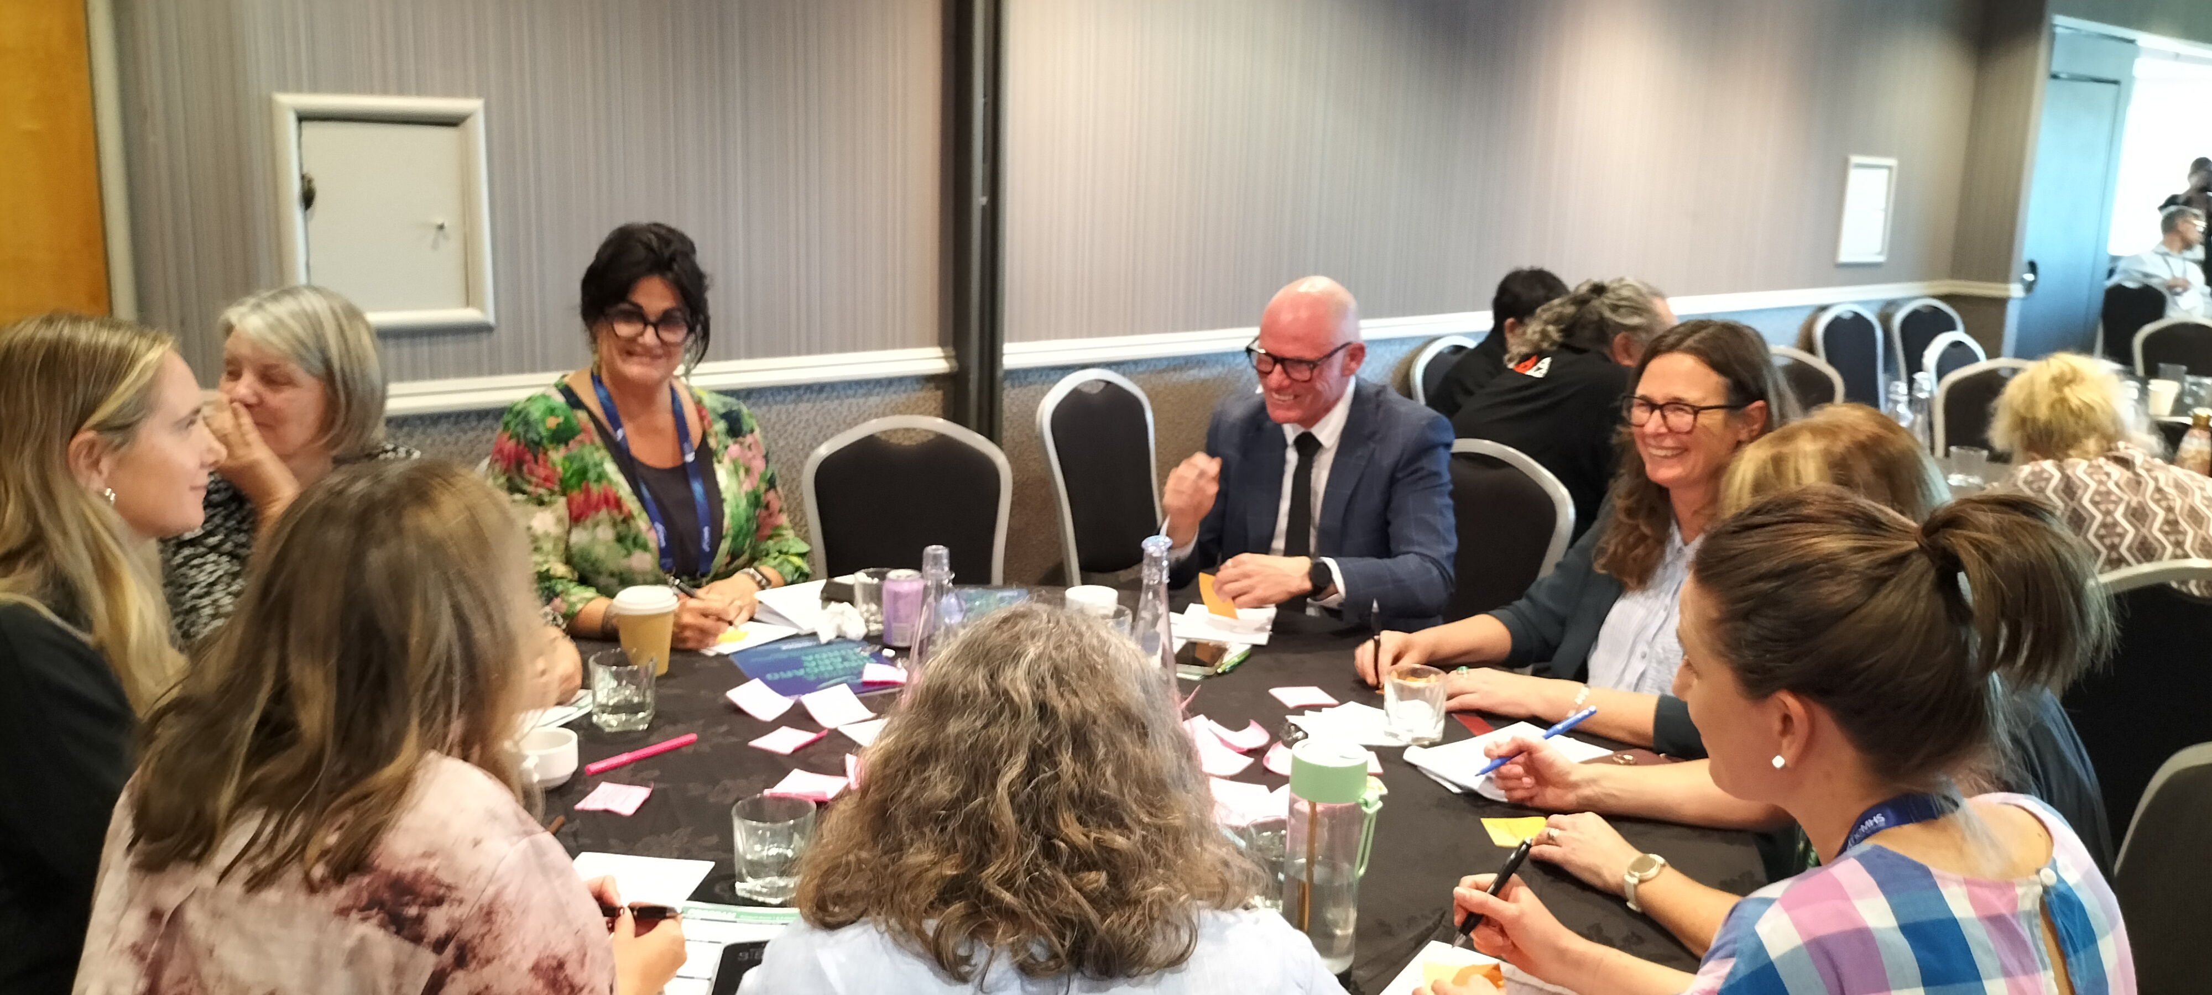
Investment that is long-term, values-led, transparent, and trust-based - grounded in measures of success defined with and by tāngata whaiora and whānau. This shifts commissioning beyond pilot cycles toward scaling what works and what already has momentum.

Whakamutunga
Te Ara Tūroa demonstrated the power of participatory design to surface collective wisdom and practical action.
The energy, clarity and courage shared in this session reflect a system ready to evolve — toward connection, trust and shared purpose.
