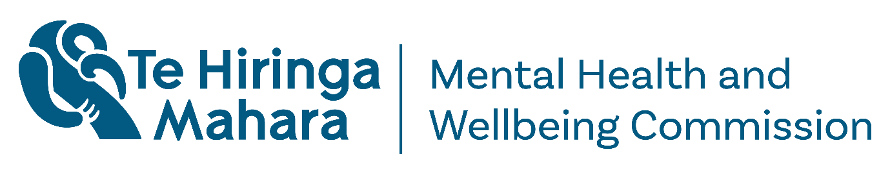
Crisis responses monitoring report
Adapted in 2025 by Accessible Formats Service,
Blind Low Vision NZ, Auckland
TN: The logo at the top of the page is Te Hiringa Mahara Mental Health and Wellbeing Commission.

About Te Hiringa Mahara
- Te Hiringa Mahara—Mental Health and Wellbeing Commission is an independent crown entity and a kaitiaki (guardian) of mental health and wellbeing in Aotearoa New Zealand.
- Te Hiringa Mahara monitors the wellbeing system, mental health and addiction services and advocates for improvements to services and the experiences of people who experience distress or addiction.

What this report is about
- This is a monitoring report about mental health or substance-related crisis responses, including how they currently work in New Zealand, the types of responses and support people can get, and what a good crisis response could look like in New Zealand.
- A mental health or substance-related crisis is deeply personal to people, so people experience them in different ways.
- Crisis responses are urgent support, assessments or interventions for people experiencing a crisis that needs more support than they get from a doctor, nurse or community mental health and addiction worker.

Key findings

Fewer people are getting support for crises
- Fewer people have accessed crisis responses in the last five years. Fewer people have also accessed mental health and addiction services, even though more people need mental health and addiction support.
- Calls to crisis lines are decreasing, but there are more urgent calls from people needing support in a mental health or substance-related crisis. Crisis calls from Māori and young people are often more urgent than others.
- Over the last five years, more people have called Police for a mental health related issue. Slightly more people have called for an ambulance, but fewer people aged 19-24 years old.

There are many challenges with crisis responses
- Over half of people in crisis call crisis phone lines. People who do are waiting longer to speak to someone. In 2020, people waited two minutes to talk to someone and by the end of 2024, people wait over five minutes.

- People stay longer in mental health and addiction services than five years ago. In 2020, people stayed in inpatient services for 18 days and by the end of 2024, people stay for 20 days.
- Crisis responses look different across New Zealand. Some areas of New Zealand have limited options and staff, which means some people cannot get the support they need.
- There are even less options for people experiencing substance-related crises compared to mental health crises.
- Some challenges for crisis responses include a lack of mental health and addiction staff, inconsistent care, and a lack of coordination. Coordination includes different services and people working together to support people, and transferring people between services or home.

Māori and young people need more support
- Māori use mental health and addiction services and crisis services more than other people.
- Māori are more likely to go to emergency departments for mental health.
- Māori are more likely to make urgent calls to crisis phone lines.
- Half of the people who experience crisis in a Police setting are Māori.
- Māori are more likely to experience crisis within 48 hours of being admitted to an inpatient mental health or addiction service, and more likely to be readmitted to an inpatient mental health or addiction service.
- Young people under 25-years-old need more urgent support by the time they reach out to a crisis line.
- More young people experiencing crisis go to emergency departments than other age groups, and are involved in more ambulance mental health incidents.

Some crisis responses work well
- Good crisis responses are managed across the country, culturally safe, available 24 hours a day, not coercive, include peer support workers and include support for young people. When crisis responses include all these things, less people need to go to emergency departments and experience less trauma.
- Some parts of crisis responses work well in New Zealand, such as kaupapa Māori services and services run by peer support workers.

Changes we want to see in crisis responses
- Crisis responses in New Zealand need to improve a lot, so that people experiencing crisis get appropriate help where and when they need.
- We have made some recommendations to Health New Zealand to improve crisis responses.
- Health New Zealand should develop a national crisis response system by 30 June 2027.
- A national standard should make sure people can get information about what they can expect when experiencing crisis, no matter where they live.
- This system should ensure people get support as soon as they need it, and that support is compassionate, and people have safe and welcoming places to go.
- The crisis response system should value lived experiences of crisis, mental health and addiction, have peer support and culturally safe support, uphold people's human rights and be trauma responsive.
- Crisis responses should meet the demand of people experiencing crisis, such as offering more support in the evenings and weekends.
- There should be many options available to people in every region of New Zealand. Options could include crisis phone lines that are open all day every day, online support, crisis community teams, crisis cafés, respite services, kaupapa Māori services, peer support, options for young people and inpatient services when needed.
- Health New Zealand should progress some more actions by 30 June 2026.
- Set up access to crisis phone lines, available for people all day every day, everywhere in New Zealand.
- Make it easier for people to move from crisis services to primary care, such as doctors, nurses and community mental health and addiction workers.
- Evaluate how effective peer support workers are in emergency departments, and how effective crisis cafés are for people experiencing crisis.

What happens next
- Te Hiringa Mahara has published the full report on our website. We will share this report with the Minister of Mental Health, government agencies, such as Health New Zealand and the Ministry of Health, mental health and addiction services and lived experience networks.
- You can read the full report on our website https://www.mhwc.govt.nz/our-work/mental-health-and-addiction-system/ [or this link https://tinyurl.com/ps4enkhy]

Contact us
- For questions or more information about the report, please contact kiaora@mhwc.govt.nz
- If you need support or assistance, please call or text 1737. You can also visit our website for more information about support, https://www.mhwc.govt.nz/where-to-get-support/
End of Crisis responses monitoring report

