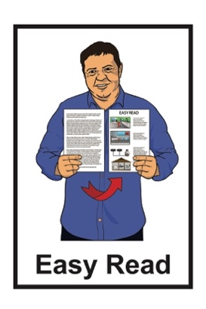
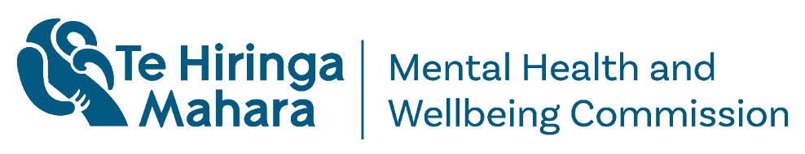

Crisis responses
monitoring report
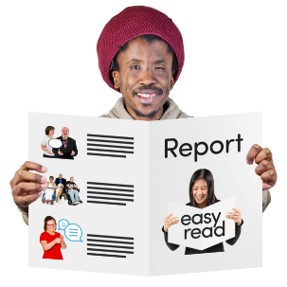

Published: November 2025

Before you start
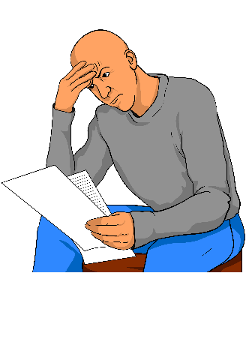

This information may upset some people when they are reading it.

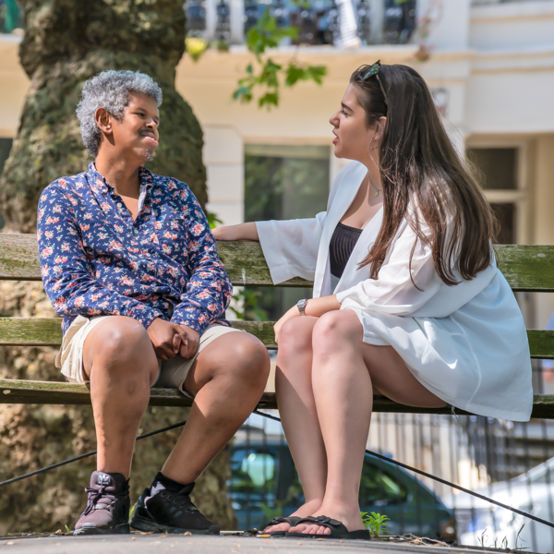
If you are upset after reading this document you can talk to your:
whānau / family
friends.

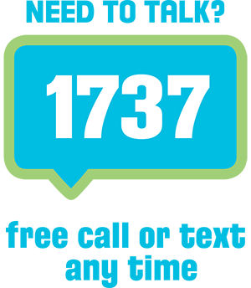
You can also contact Need to Talk by:
calling 1737


texting 1737.

It does not cost any money to call / text 1737.
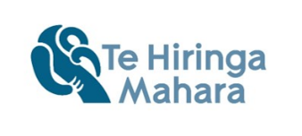

More information about support is available on the Te Hiringa Mahara website here:

tinyurl.com/bdsa8yvx

What you will find in here

Page numbers:
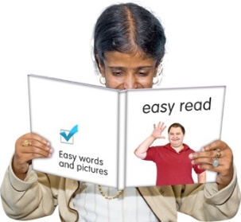

About this Easy Read 5
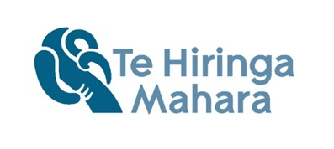

About Te Hiringa Mahara 10

What this report is about 13

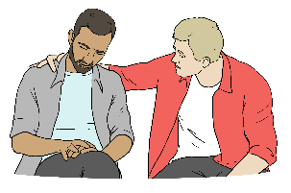
Key finding 1 – fewer people
are getting support for crises 16
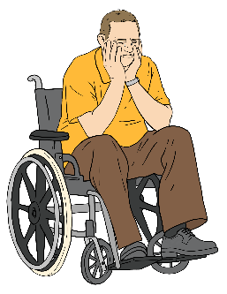

Key finding 2 – there are many
challenges with crisis responses 18

Page numbers:
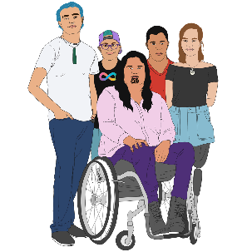

Key finding 3 – Māori and young
people need more support 22

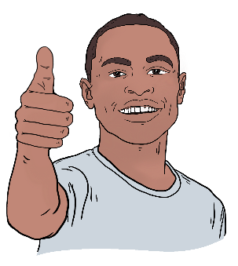
Some crisis responses that
work well 25

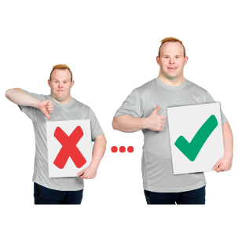
Changes we want to see in
crisis responses 28

What happens next 35
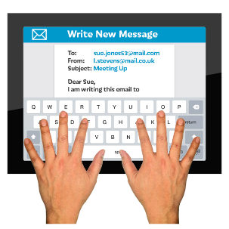

How to contact us 37

About this Easy Read

This Easy Read report is from
Te Hiringa Mahara – Mental Health and Wellbeing Commission.

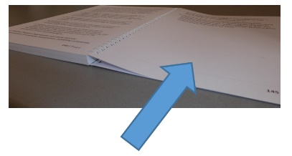
More information about Te Hiringa Mahara – Mental Health and Wellbeing Commission is on
page 10.

In this document:
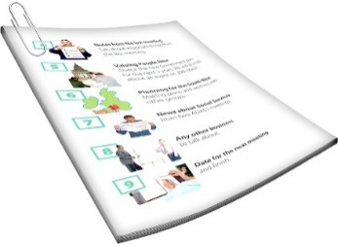

Te Hiringa Mahara – Mental Health and Wellbeing Commission is called
Te Hiringa Mahara
when you see the words
we / us / our it means
Te Hiringa Mahara.
This Easy Read report is about
crisis responses in Aotearoa
New Zealand.

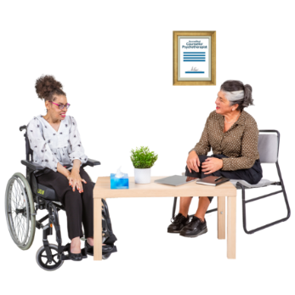
Crisis responses are support for people who are having a very hard time with:
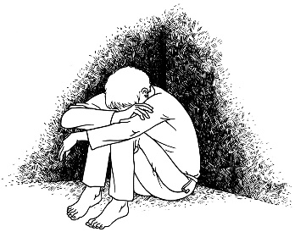
their mental health
addiction.

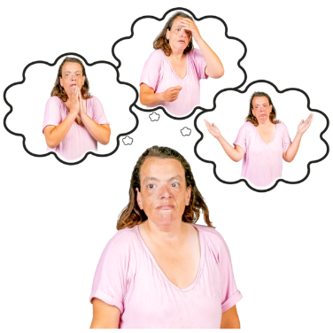
Mental health is how you:
think
feel in your mind.

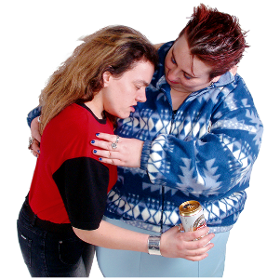
Here addiction is about when someone:
uses a substance a lot
has a very hard time trying to stop using / taking it.

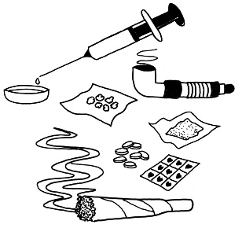
Here a substance is something
like:
alcohol
drugs.

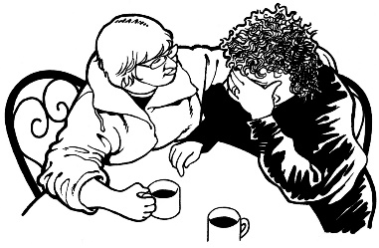
Crisis responses are for people who:
are going through a crisis
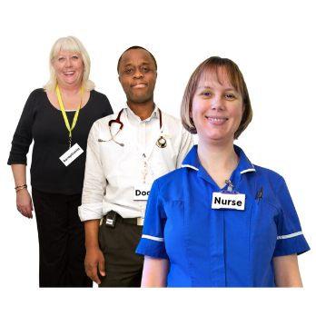
need more support than they
can get from a:
- doctor
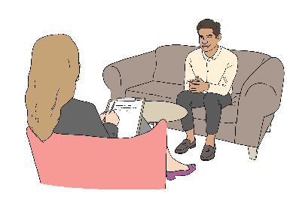
- nurse
- community mental health
and addiction worker.

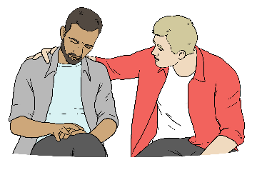
Crisis responses look like urgent:
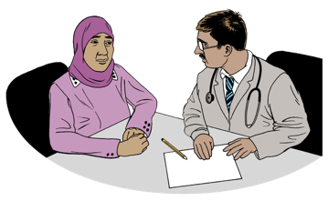
support
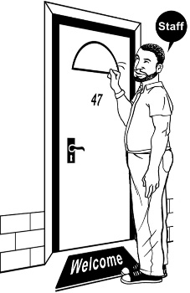
assessments – seeing if someone needs urgent
support / care
interventions – people stepping
in to make sure someone is
safe.

Crises are when someone may be
in danger of:
being hurt
hurting themselves.
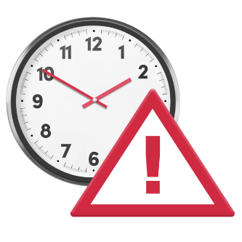

Urgent is when someone needs assistance / support right away.

About Te Hiringa Mahara


Te Hiringa Mahara:
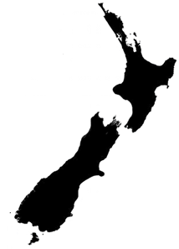
is an independent part of the Government which means the Government cannot tell them what to do
is a kaitiaki / guardian of mental health and wellbeing in Aotearoa New Zealand
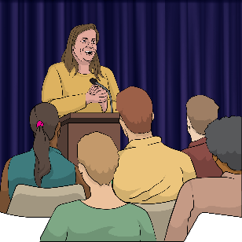
tells other agencies how to make things better for mental health and wellbeing.


Wellbeing means things like:
how we feel about ourselves
looking after our:
- bodies
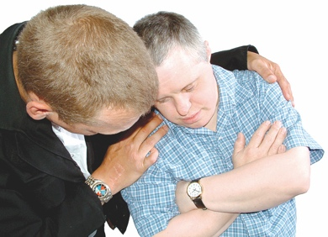
- minds
getting support when we are feeling sad or worried.

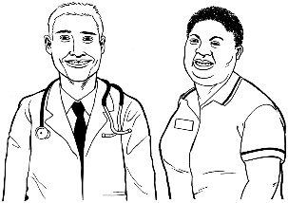
Te Hiringa Mahara looks at:
the wellbeing system
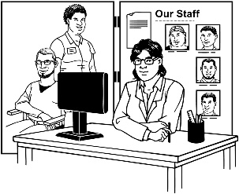
mental health services
addiction services.


Here system is how services work
together.

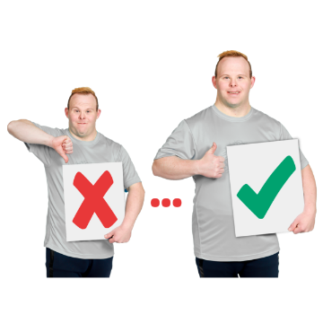
Te Hiringa Mahara speaks up for:
things that make services better
the experiences of people who go through:
- mental health distress which is when your mental health is not doing well
- addiction.

What this report is about

The monitoring report is about how well we are doing crisis responses for:
mental health
addiction.

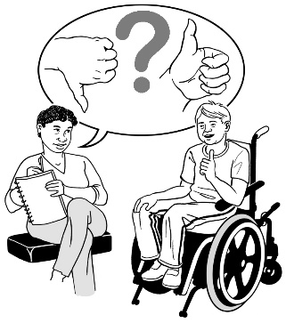
A monitoring report is written information about things that:
are working well
are not working well

we think Health
New Zealand should do.

In Aotearoa New Zealand Health New Zealand is a crown entity that:
funds / gives money for:
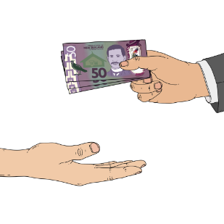
- mental health services
- addiction services
runs:
- mental health services
- addiction services.

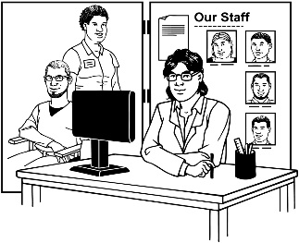
A crown entity is a service run by a government organisation.


More information about crown entities is available online here:

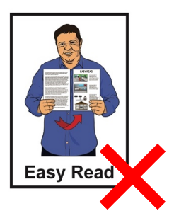
tinyurl.com/yvaa8e8x

This information is not in Easy Read.
The monitoring report includes information about:
how crisis responses work in Aotearoa New Zealand
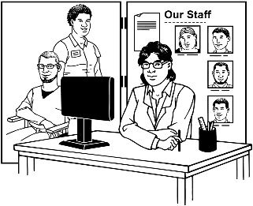
the kinds of crisis responses people can get
the kinds of support people can get

what a good crisis response could look like in Aotearoa
New Zealand.

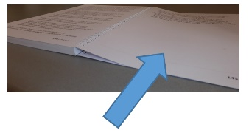
Pages 16 to 24 will go through the key findings of our report.

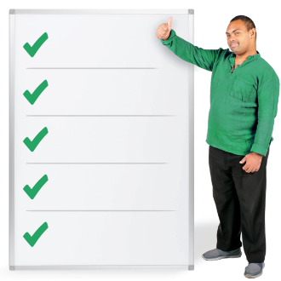
Key findings are the main things
we found when making this report.

Key finding 1 – fewer people are getting
support for crises

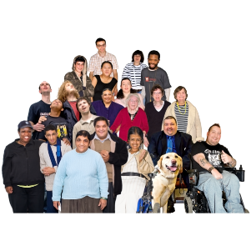
In the last 5 years fewer people have:
used:

- crisis responses
- services
called crisis phone lines.

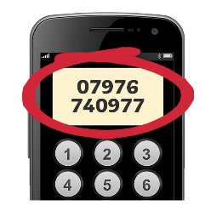
Crisis phone lines are phone numbers you can ring if you:

are going through a crisis
know someone who is going through a crisis.

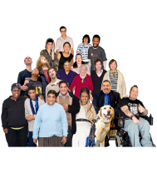
In the last 5 years:
more calls to crisis phone lines have been from people needing urgent support
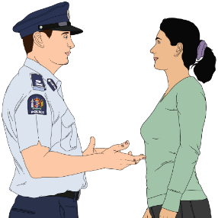
more people have called police for mental heath related issues
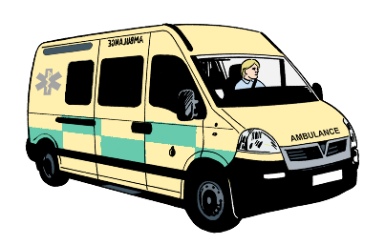
more people have called for an ambulance for mental heath related issues.

The most urgent calls are coming from:
Māori
young people aged:
- under 19
- 20 to 24 years old.

Key finding 2 – there are many
challenges with crisis responses

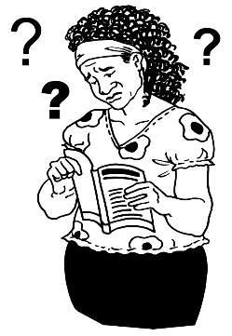
Challenges are things that make something hard to do.

Here are some of the challenges we found with crisis responses.

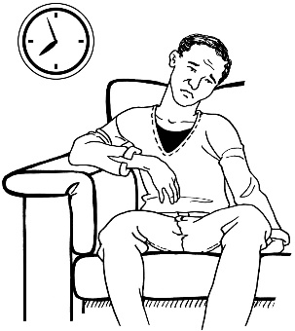
Waiting too long

People who call crisis phone lines have to wait too long to speak to someone.

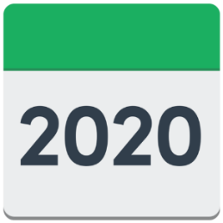
In 2020 people waited 2 minutes to talk to someone.

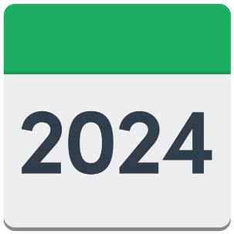
By the end of 2024 people had to wait over 5 minutes.

Longer stay in inpatient services

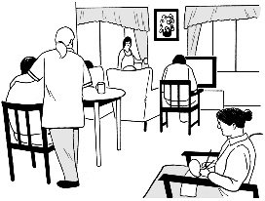
People are staying in inpatient services longer than they did
5 years ago.

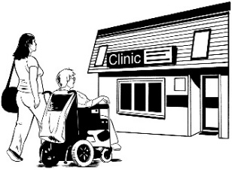
Inpatient services are when
people stay in services like hospitals.

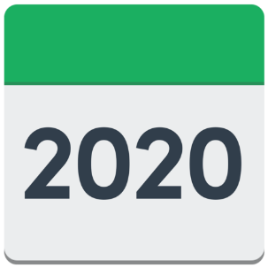
In 2020 most people stayed in services for 18 days.

By the end of 2024 most people stayed in services for 20 days.

Not enough services
Crisis responses are different all over Aotearoa New Zealand.

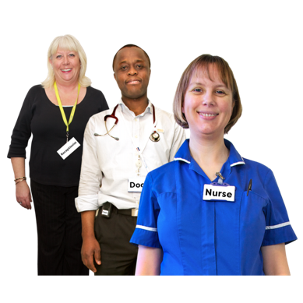
Some areas of Aotearoa
New Zealand do not have enough:
services
staff at services.

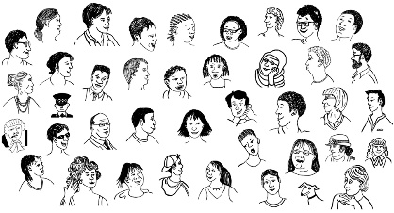
Not having enough services / staff means some people cannot get the support they need.

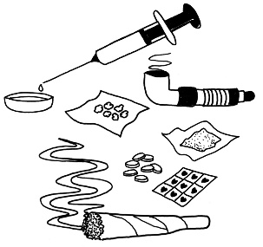
There are fewer services for substance crises than for mental health crises.

Coordination
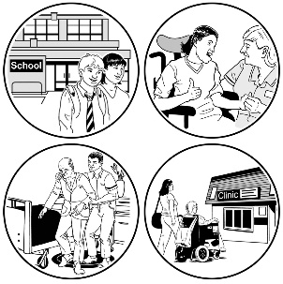
There is not enough coordination between services.

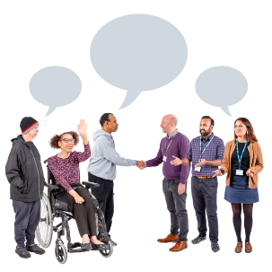
Here coordination means how well different services:
work together to assist people
in crises
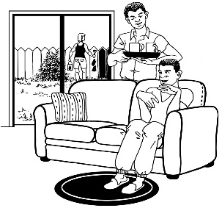
support people going between:
- different services
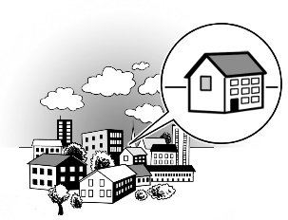
and
- home.

Key finding 3 – Māori and young people need more support

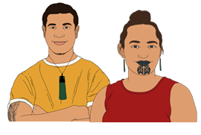
More than other people Māori use:
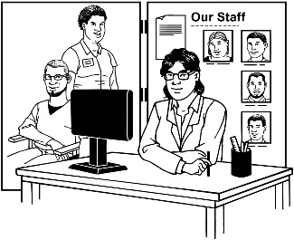
services
crisis services.

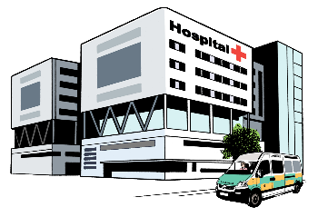
Māori are more likely to:
go to emergency departments for mental health issues

make urgent calls to crisis phone lines
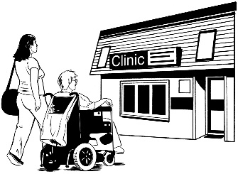
go through a crisis within 2 days of being in a service
keep coming back to services.

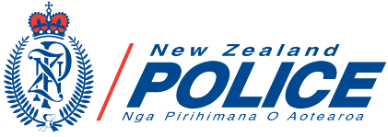
Half of the people who go through a crisis in a Police setting are Māori.

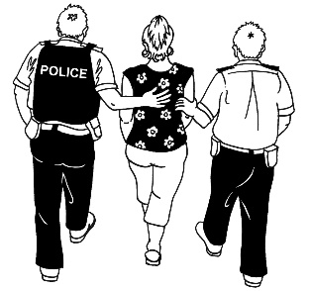
Here Police setting means being in police custody like being in a police cell.

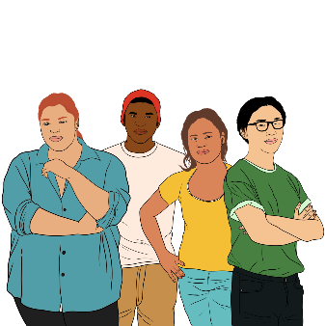
Young people under 25 years old need more urgent support when they call crisis phone lines.

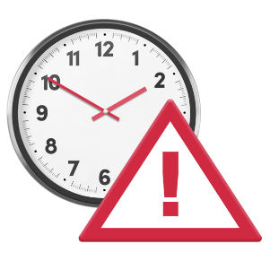
This is because young people usually wait until they need urgent support before they call crisis phone lines.

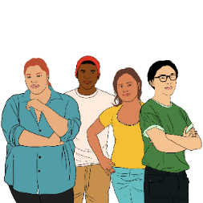
More young people under 25 years old than older people go through:
mental health crises that mean they need an ambulance
crises that mean they:
- need to go to emergency departments
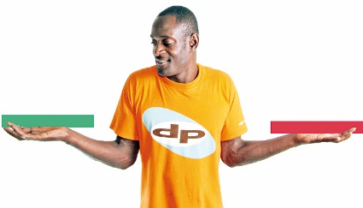
- are more likely to choose to go to emergency departments as they do not have other options available to them.

Some crisis responses that work well

Good crisis responses are:
available across Aotearoa
New Zealand
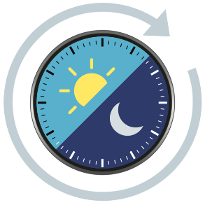

culturally safe which means people of different cultures feel safe using crisis reponses
available all day / night.

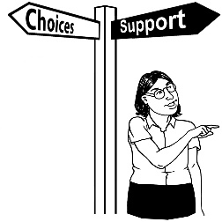
Good crisis responses also give people choice about how they want to be supported.

Good crisis responses include:
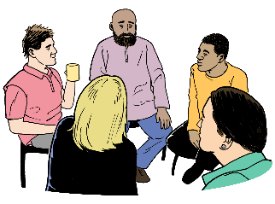
peer support workers
support for young people.
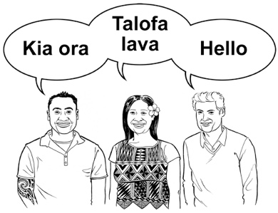
Culture is a way of:
thinking that a group shares
doing things as a group.

Peer support is where people support each other because they have something in common.

When crisis responses include all these things:
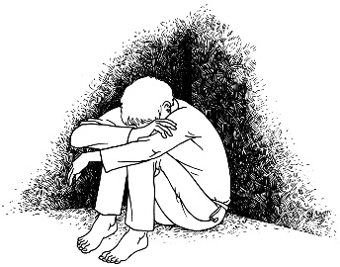
fewer people need to go to emergency departments
people go through less trauma.
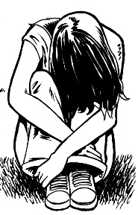

Trauma is what happens when you go through something very bad.

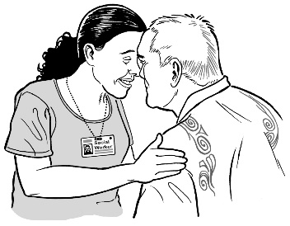
Some parts of crisis responses work well in Aotearoa New Zealand such as:
kaupapa Māori services
services run by peer support workers.

Kaupapa Māori means using all the parts of Māori:
knowledge
skills
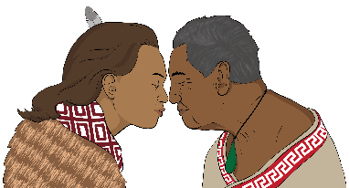
attitudes
values.

Changes we want to see in
crisis responses

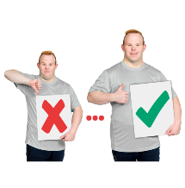
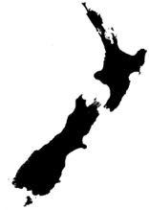
Aotearoa New Zealand needs to get better at a lot of things for people to get good support when they need crisis responses.

We have made some recommendations to Health
New Zealand about how to make crisis responses better.

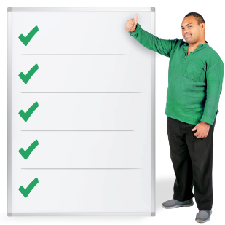
Recommendations are ways to make something better.


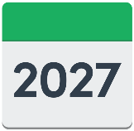
Our main recommendation is that Health New Zealand should make a National Crisis Response System by 30 June 2027.
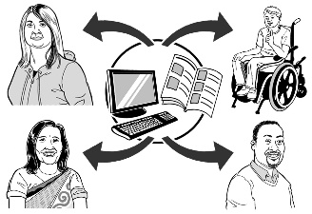
The National Crisis Response System should make sure people get:

information about what will happen when going through a crisis
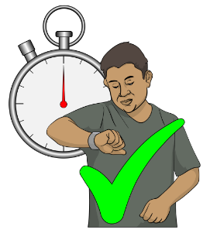
information anywhere in Aotearoa New Zealand
support as soon as they need it.

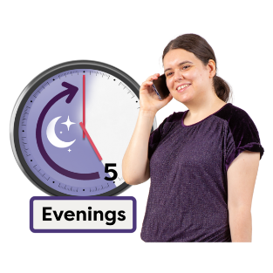
Crisis responses should give more support:
in the evening
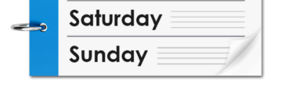
on the weekends.

Services should:
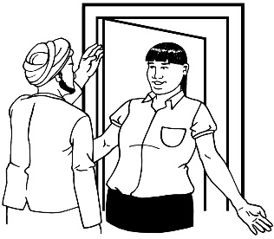
feel:
- safe
- welcoming / friendly
have culturally safe support
follow human rights.

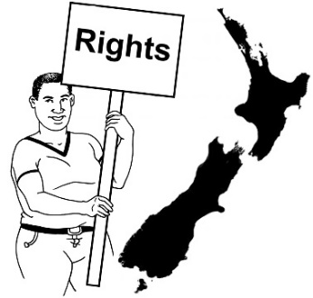
Human rights are things that the
law says every person should:
have
be able to do.


Rights are things like:
having a safe place to live
getting medical care.
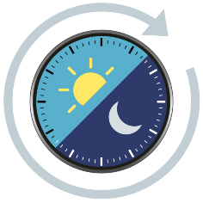
Different kinds of support should include:
crisis phone lines that are open:
- all day / night
- every day

online support
crisis community teams who provide support at homes
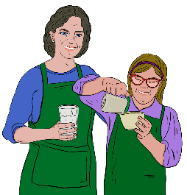
crisis cafes – safe spaces for people to go to
respite services
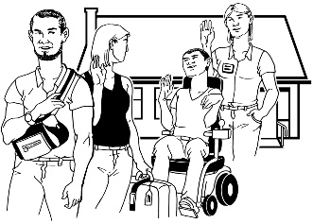
kaupapa Māori services
peer support.

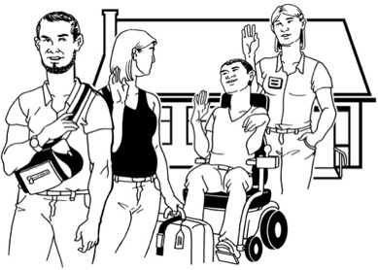
Respite is a way to give
whānau / family a break from caring for someone.

There should be more kinds of support available to people all over Aotearoa New Zealand.

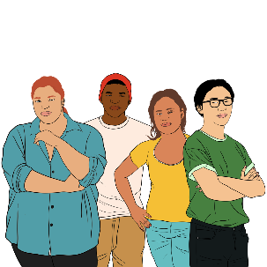
There should also be support that works for:
young people
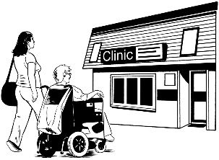
people in inpatient services.

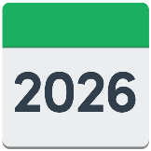
By 30 June 2026 Health
New Zealand should work on seeing how good / useful:
peer support workers are in emergency departments
crisis cafes are for people going through crises.

Health New Zealand should also work on making sure everyone in Aotearoa New Zealand can call a crisis phone line:
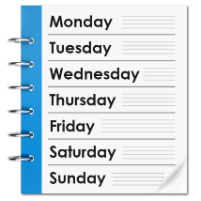
all day
every day.

By 30 June 2026 Health
New Zealand should make it easy for people to move from crisis services to primary care like:
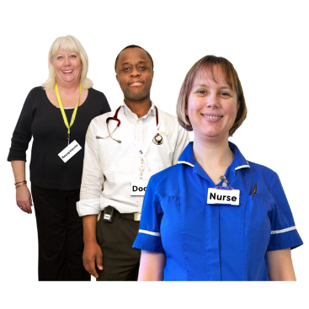
- doctors
- nurses
- community mental health and addiction workers.

What happens next

The full report is availabe online at the Te Hiringa Mahara website here:
tinyurl.com/ps4enkhy

The full report is not in Easy Read.

We will share this report with:
government agencies such as:

- Health New Zealand
- the Ministry of Health
the Minister for Mental Health
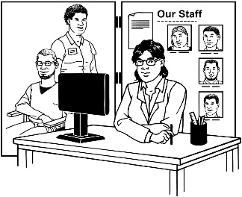
services
lived experience networks.
A minister is someone who is:
part of the Government
in charge of something.

The Minister for Mental Health in
New Zealand is Matt Doocey.

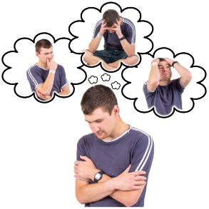
Lived experience means that a person has experience of a mental health condition.

How to contact us

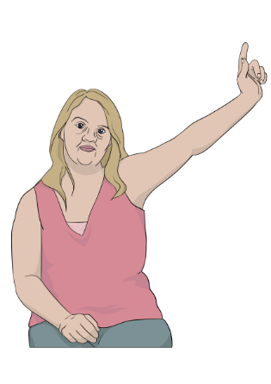
You can contact us:
for more information about the report
with any questions about the report.

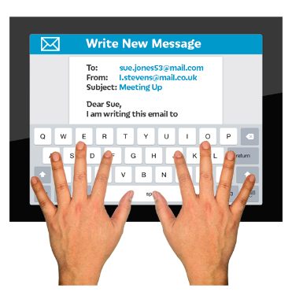
You can contact us by sending an email to:

kiaora@mhwc.govt.nz

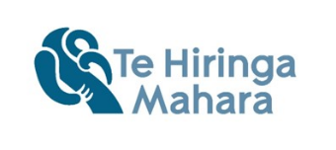
This information has been written by Te Hiringa Mahara – Mental Health and Wellbeing Commission.

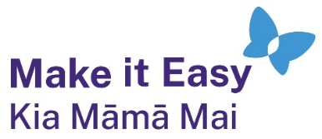
It has been translated into Easy Read by the Make it Easy Kia Māmā Mai service of People First New Zealand Ngā Tāngata Tuatahi.
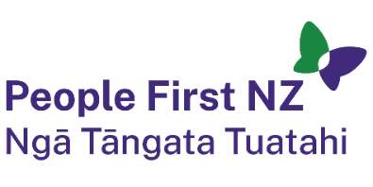
The ideas in this document are not the ideas of People First New Zealand Ngā Tāngata Tuatahi.

All images used in this Easy Read document are subject to copyright rules and cannot be used without permission.


Make it Easy uses images from:

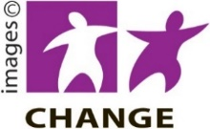
- Photosymbols

- Change Images


- Huriana Kopeke-Te Aho

- SGC Image Works

- T Wood


- Studio Rebeko

- Inga Kramer.

