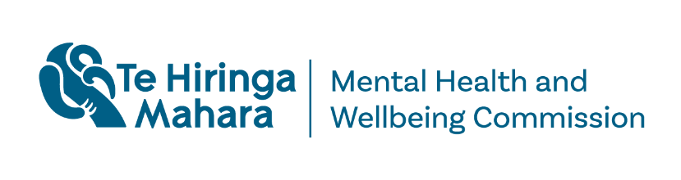

Leading conversations about safety, risk and mental health:

Summary of engagement insights

October 2026

Leading conversations about safety, risk and mental health: Summary of engagement insights
A report issued by Te Hiringa Mahara—the New Zealand Mental Health and Wellbeing Commission (Te Hiringa Mahara).
Authored by Te Hiringa Mahara.
This work is protected by copyright owned by Te Hiringa Mahara—Mental Health and Wellbeing Commission. This copyright material is licensed for re-use under the Creative Commons Attribution 4.0 International License. This means you are free to copy, distribute and adapt the material, if you attribute it to Te Hiringa Mahara—Mental Health and Wellbeing Commission and abide by the other license terms. https://creativecommons.org/licenses/by/4.0/legalcode.
ISBN: 978-1-0671478-5-3 (online version and docx)
Te Hiringa Mahara—the New Zealand Mental Health and Wellbeing Commission—was set up in February 2021 and works under the Mental Health and Wellbeing Commission Act 2020. Our purpose is to contribute to better and equitable mental health and wellbeing outcomes for people in Aotearoa New Zealand.
For more information, please visit our website: www.mhwc.govt.nz

Te Hiringa Mahara New Zealand Mental Health and Wellbeing Commission. 2024. Leading conversations about safety, risk and mental health: Summary of engagement insights. Wellington: Te Hiringa Mahara.
Published: October 2026.

Introduction
This paper summarises Te Hiringa Mahara – Mental Health and Wellbeing Commission’s engagement exploring how agencies and groups understand current issues in relation to safety, mental health and risk; the aims of a national conversation; and opportunities to support positive change with collective action.
We thank everyone who generously offered their knowledge and experience to help guide our thinking.

About Te Hiringa Mahara
Te Hiringa Mahara - Mental Health and Wellbeing Commission is a kaitiaki (guardian) of mental health and wellbeing, contributing to better and equitable outcomes for people ​in Aotearoa New Zealand.
We are an independent Crown entity established following the Government Inquiry into mental health and addiction’s 2018 report He Ara Oranga. We have important obligations to Te Tiriti o Waitangi and our functions include system-level oversight and leadership, monitoring, reporting and advocacy. We promote alignment, collaboration and communication between agencies and groups involved in mental health and wellbeing. We advocate for the collective interests of people who experience mental distress or addiction and those who support them.

Context for a national conversation on safety, risk and mental health
In 2018, He Ara Oranga report recommended repeal and replacement of the Mental Health (Compulsory Assessment and Treatment) Act 1992 so that it reflects a human rights-based approach, promotes supported decision making, aligns with the recovery and wellbeing model of mental health, and provides measures to minimise compulsory or coercive treatment (Recommendation 34).
He Ara Oranga report also recommended that there be a national discussion to reconsider beliefs, evidence and attitudes about mental health and risk (Recommendation 35). This was in response to a perceived risk averse culture and defensive practice negatively affecting the experience of care for patients, health professionals and the community, and causing harm. He Ara Oranga report recognised that Māori are overrepresented in terms of being subject to coercive practices.

The aim was noted in the report as being to increase understanding about mental health and risks, confirm the proper role of review processes, discuss responsible reporting of sad and difficult situations and to support good clinical decision-making.
He Ara Oranga report, recommendation 35, identified stakeholders who should be engaged in the debate:
Encourage mental health advocacy groups and sector leaders, people with lived experience, families and whānau, professional colleges, DHB chief executive officers, coroners, the Health and Disability Commissioner, New Zealand Police and the Health and Quality Safety Commission to engage in a national discussion to reconsider beliefs, evidence and attitudes about mental health and risk.
Media leaders were also mentioned in this context in the body of the report.
In response to the above call to engage in a national discussion, the former District Health Boards’ Mental Health and Addiction Partnership Group released a discussion paper in 2020 – Reframing Risk and Risk Management in Mental Health and Addiction Services. The paper reviewed the context of risk management and presented possible ways forward, such as development of a Just Culture approach to the review of harm-related incidents and deaths.
In 2022, Manatū Hauora | Ministry of Health released a discussion paper – He Arotake ngā Tūraru | Reviewing Risk (He Arotake ngā Tūraru / Reviewing Risk). The evidence-informed paper is a resource for the mental health and addiction sector and the public. It addresses themes that include the harm resulting to people because of a risk-averse culture, perceptions about people with mental illness being a risk to society, and the use of compulsory treatment to mitigate the perceived risk of harm.

Our role leading conversations about safety, risk and mental health
In 2023, as part of our work monitoring services’ use of coercive practices under the Mental Health Act 1992, we reported on lived experiences of compulsory treatment orders in community settings. We acknowledged government action towards He Ara Oranga recommendations 34 and 35. In particular, we referred to He Arotake ngā Tūraru | Reviewing Risk commenting that mental health clinicians are faced with responding to complex needs in the current service context of limited options and a stretched workforce and that public attitudes towards risk and mental health are important to support the transformation in how we approach mental wellbeing.
Since 2024, through our system performance monitoring and submissions on the Mental Health Bill, we continued to examine how safety, risk, rights, supported decision-making and coercive practices are understood and applied across the mental health system.
We have continued to hear from lived experience communities that a national level discussion about safety, risk and mental health envisaged by He Ara Oranga remains a priority. We recognise that understanding how people with lived experience, and their supporters, perceive risk and safety across a diverse range of contexts is fundamental to shifting practices towards meeting the needs of tāngata whaiora and away from managing risk.

Why now
We undertook this engagement in response to Hon Minister Matt Doocey, Minister of Mental Health’s 2025/26 Letter of Expectations. The Minister identified “a role for the Commission to provide leadership in supporting positive discourse about mental health and wellbeing … in particular [leading] a national conversation about risk and mental health.”
We have undertaken early work to understand the most important issues, what needs to change, and the role that we can play alongside other agencies and groups identified in He Ara Oranga report and He Arotake ngā Tūraru, Reviewing Risk. We wanted to better understand the current context and issues through the lenses of the agencies and groups and to identify active work underway.
After years of policy development and consultation, the Mental Health Bill passed its third reading in Parliament on 4 July 2026 and will transition into law by July 2028.
The implementation of the new Act provides an opportunity to understand the impact of beliefs, evidence and attitudes on safety, risk and mental health within the context of the Government’s broader commitment to the Mental Health and Wellbeing Strategy 2026-2036 and implementation.

Summary of engagement insights
Here is a summary of what we heard. Where relevant, we have linked themes to agencies or groups based on their roles and publicly known work. The conclusions and key insights are those of Te Hiringa Mahara.
More information is in our appendices – Appendix A identifies the 17 agencies and groups we engaged with – and Appendix B explains our methodology.
The last sections are ‘Shared directions for change’ which is our synthesis of shared understandings, multiple perspectives, and opportunities for both collective action and system change and ‘Next steps’.
Key themes from the engagement
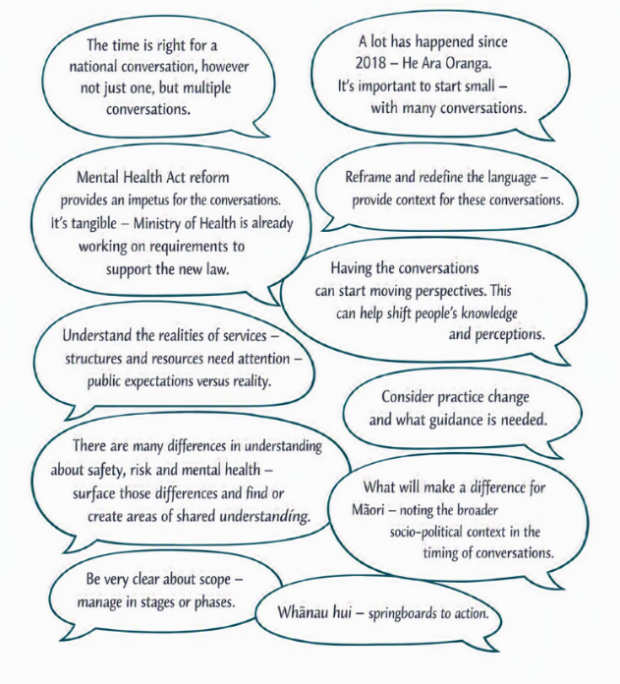

Aims of a national discussion

Not ‘a national’ conversation, but multiple complex conversations
A significant insight is that all agencies and groups favoured encouraging multiple, complex conversations, rather than a single national discussion. We heard these conversations already take place every day between tāngata whaiora and people who support them, within services, and across the wider system, such as police and courts.
A few agencies and groups emphasised that Te Hiringa Mahara would need to carefully consider both the timing and public responsiveness within the broader policy and social change context of any national action.

Increase understanding about mental health and risk
Agencies and groups commonly suggested an aim of a national conversation should be to increase understanding, about mental health and risk. The mental health and addiction sector’s context and experiences had informed their understanding, but they were quick to recognise that others did not always have that same level of understanding.
Clinicians suggested understanding risk including identifying risk factors and using risk assessment tools is important to reduce harm and build resilience. Some lived experience, whānau Māori and family groups talked about having a greater tolerance for risk versus others who seemed more risk averse. Most entities discussed the need to clarify their roles, responsibilities, and boundaries, reinforcing the need for greater understanding between key agencies and groups about their roles and how they perceive risk in the work they do to meet needs of tāngata whaiora.

Clarify meanings of ‘risk’ and ‘safety’ shaped by Lived Experience and Te Ao Māori perspectives
Advocacy and some service provision and workforce training groups described how for tāngata whaiora, whānau Māori and families risk carried varied meanings shaped by their own personal lived experience of being harmed by the system. They thought it was important for others to understand their informed perspectives and those meanings. Māori lived experience described both historical and social intergenerational factors that often contributed to negative risk experiences and emphasised the importance of culturally safe practices that were more holistic in response to risk. Lived experience identified safety defined by lived experience as an important concept, encapsulating the factors that support tāngata whaiora, whānau Māori and families to feel safe and supported. While it is becoming more common to talk about safety alongside risk, it is risk that still dominates the conversation.

Move from away from blame and fear towards healing and learning
Advocacy and service groups, and government agencies described the importance of conversations to reframe the way incidents causing harm are managed. Blame and fear (sometimes related to how risks were assessed and managed) are very real and compound harm to tāngata whaiora, whānau Māori, families, and health professionals. Although these agencies and groups intend to move towards healing, learning and improvement, blame and fear continued to shape responses in practice.

Build shared language because perspectives are diverse
Agencies and groups consistently emphasised the need to enable understanding by building a shared language because there are multiple knowledge areas including cultural, clinical, legal, management, and experiential expertise driving diverse perspectives. We shouldn’t force consensus – it doesn’t make sense to try and do that. We should aim to build a shared language to bridge knowledge and action.
We heard that simply listening to different perspectives is important to help shift people’s thinking. Some entities emphasised the importance that these conversations are in the public domain to help people understand the realities of the care, treatment and support services can and can’t provide.
We heard that it is not enough to just hear different perspectives. These conversations must lead to actionable insights.

Successful system change
We heard that system change requires clearer accountability for roles and responsibilities. At a service level, this means more learning, less reliance on risk prediction models and tools, and greater recognition of the impact of inequities.
Culture change in services needs to be deliberate, with less use of coercive practices, fewer handoffs to other health professionals and groups and less blame attribution. Most of all it means being more respectful of tāngata whaiora, whānau Māori and families.
Some agencies and groups described their priorities within the context of their core role and responsibilities and provided examples. Multiple stakeholders supported strengthening work underway with further collective action:
- strengthen ‘restorative practice’ in investigation of complaints and inquiry into harm and death events, and ensure processes are culturally grounded in tikanga and lived experience expertise,
- establish whānau Māori and family roles in service provision organisational structures,
- confront discrimination in access to and provision of services through awareness and education,
- keep the big picture on better outcomes for people through monitoring, policy advocacy and public reporting,
- move practice away from reliance on clinical risk tools as a predictor of future behaviour, especially for suicidality.

Current conversations and strengthening action

Risk as a constant consideration
Agencies and groups described how risk is a constant consideration in planning and delivering care and supports to tāngata whaiora and their whānau Māori and families, especially interpreting and applying risk when working with Māori.
At a system level, the overrepresentation of some groups experiencing coercive practices highlights how processes and risk-related practices contribute to inequities.
Several agencies and groups commented that the dominant concern may be more aversion to publicity than aversion to risk — how to respond to public scrutiny and/or criticism.

Risks of harm within the system
Risks of harm at the system, organisation and individual practice-levels were all discussed. A main concern was the risk of harm to people who access and navigate the system in good faith, with expectations that skilled professional support will reduce the likelihood of harm.
Professional colleges and others also highlighted how stigma, prejudice and discrimination can affect people’s access to, and experience of, care and support.

Whānau Māori, family and culturally grounded approaches
Agencies and groups called for greater involvement and recognition of whānau Māori and family contributions to the care and support of tāngata whaiora emphasising that approaches should be culturally grounded in te ao Māori, evidence-informed and reflect more collaborative decision-making. At the same time, some agencies acknowledged the practical constraints impacting Health New Zealand (as funder and provider) and constraints on the involvement of both judges and police because of their system roles variously interpreting the law and enforcing it.

Using legislative change as a lever
Agencies and groups see the new Mental Health Act as an opportunity to support change across the sector. Agencies want more certainty about what the Act will mean in practice for service delivery, professional decision-making and the experiences of tāngata whaiora and whānau Māori and families.

Strengthening collective action
Agencies and groups saw collective action as essential to achieving positive impact and suggested these approaches:
- identifying key agencies and their roles across the system,
- using existing networks to support wider engagement and communication,
- drawing on assets and capabilities from health care and other sectors,
- taking a staged approach to change,
- using approaches such as restorative practice where they can support learning, accountability and repair.

System-wide opportunities for positive change

Opportunities
The enactment of the Mental Health Act 2026 is an opportunity to reset the narrative about safety, risk and mental health, and to build a more consistent language and shared understanding across the system.
To make this change meaningful, we consistently heard that all stakeholders need to collaborate, model and spread better practice, and to address inequities by making them more visible. Agencies and groups commented that a stronger focus on shared learning and improvement could support better outcomes for all people.

Challenges and constraints
Agencies and groups were realistic about the scale and complexity of change. They described a low-trust environment, entrenched cultures of blame, and widely differing expectations and perceptions across stakeholder groups, including tāngata whaiora, whānau Māori and families, agencies, the public and media.
Reaching consensus about action in a specific area of work may be difficult. Agencies and groups commented that additional resources would be needed at a time when services are already experiencing workforce constraints. Inequities add complexity and will require sustained attention.

Enabling change
Agencies and groups identified their mandated roles and/or their engaged communities that could help support positive change, while commenting that they may not be best placed to “own” the change.
Many groups with advocacy as core to their work characterised their role as trusted enablers or bridges, able to bring values-based leadership, front-line insight and practical, evidence-informed solutions.
To maximise collective impact, we heard how important is to clarify entity role, responsibilities, and boundaries. This includes understanding how each supports shared learning, service quality improvement, provider accountability, rights protection, public safety and more responsive practice to meeting the needs of tāngata whaiora and their support people.

Shared directions for change
Agencies and groups identified the need to hold space for multiple complex conversations. They highlighted the importance of building shared understanding across diverse perspectives, especially those shaped by lived experience, Te Ao Māori, whānau Māori and families, clinical practice, law, policy, regulation and service delivery.
Agencies and groups see the replacement of the Mental Health Act as an opportunity to reset the narrative. They see themselves as both enabling and contributing to meaningful change requiring collaboration, clearer roles, visible accountability, shared learning and stronger attention to inequities.
Agencies and groups identified aims for a national discussion:
- Greater shared understanding of mental health, risk and safety across tāngata whaiora, whānau Māori and families, professionals and groups shaped by lived experience and Te Ao Māori perspectives.
- Shared language is needed but not forced consensus.
- Success means moving away from blame, fear and coercive practice towards healing, learning, accountability, culturally grounded, and rights-based approaches, greater recognition of whānau Māori and family contributions, and learning-oriented responses to harm and better outcomes.

What next
Conversations about safety, risk and mental health have been given new impetus with the coming into force of the Mental Health Act by July 2028.
We’ve emphasised thematically the commonalities however, there are also areas where priorities and interests diverge. The diagram below shows four broad activities that drive conversations about safety, risk and mental health across the wider system. Agencies and groups described their work in at least one or more of these four areas while recognising the need for a common aim. Contributing to supporting responsible media reporting has been identified as an important area for public influence and future work.
Te Hiringa Mahara can contribute to positive shifts in attitudes and beliefs about safety, risk and mental health through our system leadership role promoting alignment, collaboration and communication between agencies and groups involved in mental health and wellbeing.
We will determine next steps as part of our 2027/28 planning.
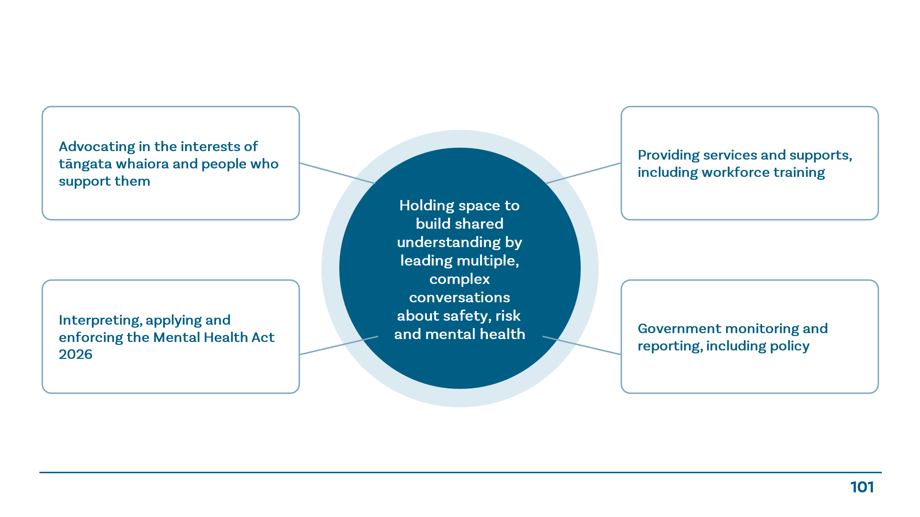

Appendix A: Agencies and groups
Te Kete Pounamu
Changing Minds
Mental Health Foundation
Asian Family Services
Yellow Brick Road
Le Va
Te Rau Ora*
Health New Zealand | Te Whatu Ora
Platform Trust
Royal Australian and New Zealand College of Psychiatrists
Australia and New Zealand College of Mental Health Registered Nurses
Office of the Health and Disability Commissioner
Health Quality and Safety Commission | Te Tāhū Hauora
New Zealand Police
Ministry of Health | Manatu Hauora
District Inspectors
Principal Family Court Judge’s Advisory Board
Coroners*

*Te Rau Ora and the Chief Coroner were unavailable.

Appendix B: How we engaged
We developed a detailed information sheet including background information, setting out our preliminary aim and six questions to guide our conversations:
- What should be the aims of a national discussion?
- What change/s do you want to see from having a national conversation on safety, risk and mental health?
- What, if any, conversations are you/your organisation most interested and involved in? E.g. increasing understanding about mental health and risk, confirming proper role of review processes, discussing responsible reporting, supporting good clinical decision-making, something else?
- What and where are the opportunities for strengthening your/these areas of work? E.g. What assets and resources, including evidence or other information might you bring? Who else needs to be involved?
- What do you see as your role and core work in a conversation about safety, risk and mental health?
- What are the biggest challenges and/or opportunities to succeed?
We held online and in person engagements throughout February and March 2026 followed by an internal sense-making workshop.
We analysed our initial conclusions alongside our descriptive summaries for each question, identifying important areas of both commonality, and divergence, across all agencies and groups.

Government Inquiry into Mental Health and Addiction. 2018. He Ara Oranga: Report of the Government Inquiry into Mental Health and Addiction. Wellington: Government Inquiry into Mental Health and Addiction. https://mentalhealth.inquiry.govt.nz/inquiry-report/he-ara-oranga
Government Inquiry into Mental Health and Addiction, op cit, p196.
The Mental Health & Addiction Partnership Group. 2020. Reframing Risk and Risk Management in Mental Health and Addiction Services. Wellington: TAS Kahui tuitui tāngata.
Sidney Dekker. 2007. Just Culture. Taylor & Francis Ltd.
Changem Ltd. 2022. He Arotake ngā Tūraru | Reviewing risk: He kohinga kōrero | A discussion paper. Wellington: Ministry of Health. https://www.health.govt.nz/publications/reviewing-risk-a-discussion-paper
Te Hiringa Mahara Mental Health and Wellbeing Commission. 2023. Lived experiences of compulsory community treatment orders. Wellington: Te Hiringa Mahara Mental Health and Wellbeing Commission.
Beehive.govt.nz (2026). Biggest mental health law change in over 30 years. https://www.beehive.govt.nz/release/biggest-mental-health-law-change-over-30-years; and Ministry of Health. (2026). Third reading of Mental Health Bill now passed. https://www.health.govt.nz/news/third-reading-of-mental-health-bill-now-passed.
Mental Health and Wellbeing Strategy 2026–2036 | Ministry of Health NZ

