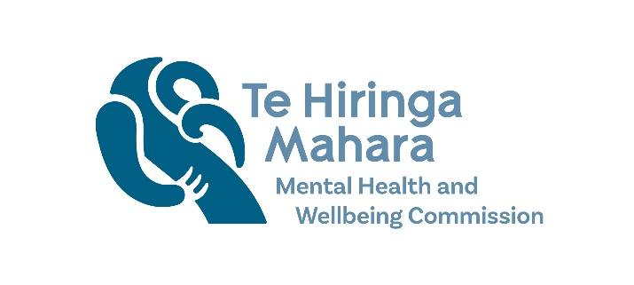
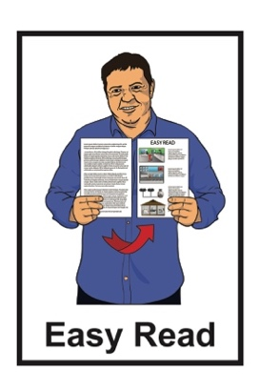

6 changes to improve
mental health and wellbeing
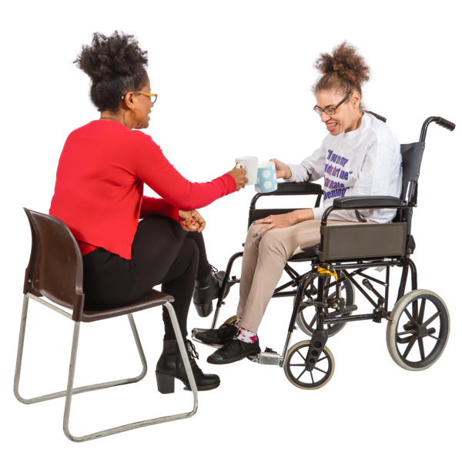

Published: July 2025

Before you start

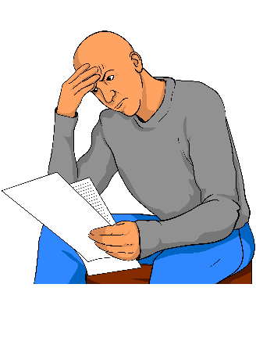
This information may upset some people when they are reading it.

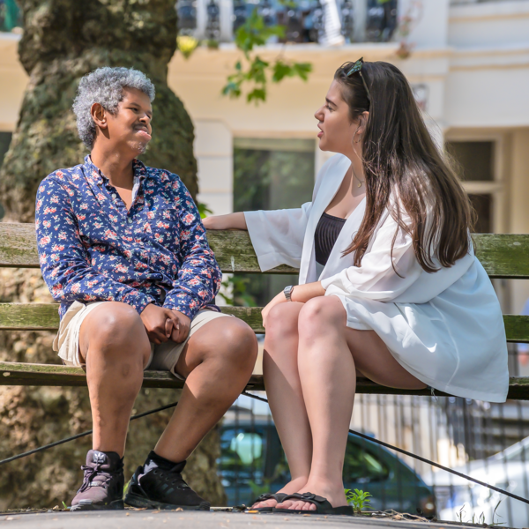
If you are upset after reading this document you can talk to your:
whānau / family
friends.

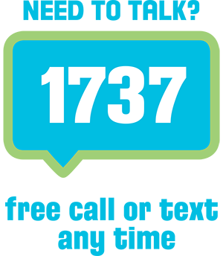
You can also contact Need to Talk by:
calling 1737
texting 1737.
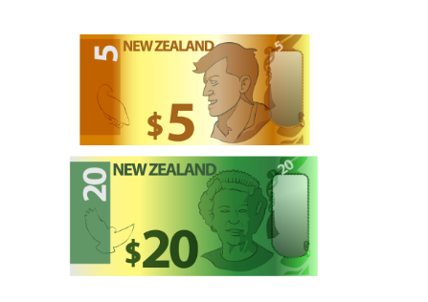


It does not cost any money to call / text 1737.

What you will find in here

Page number:
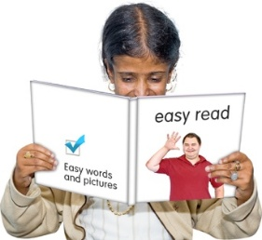

About this Easy Read 3
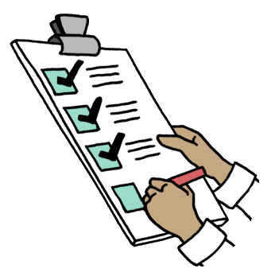

Making 6 changes
to improve services 6

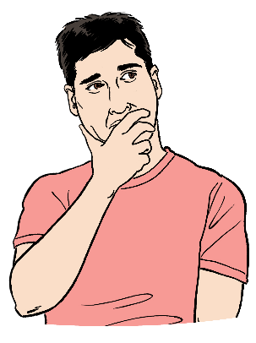
Why these changes are important 19

What needs to happen next? 22

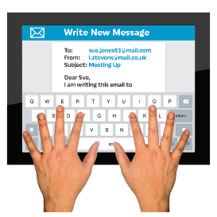
More information 24

About this Easy Read

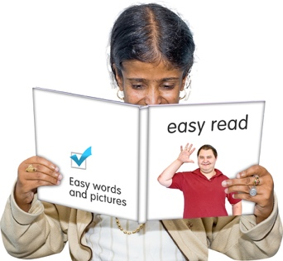
This is the Easy Read of the document called:

6 changes to improve mental health and wellbeing.
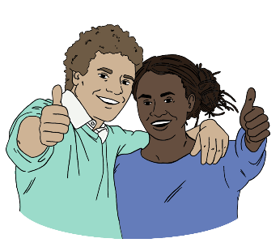

Improve means to make something better.

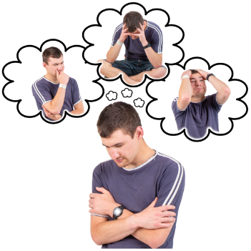
Mental health is about:
how you feel
your mind.
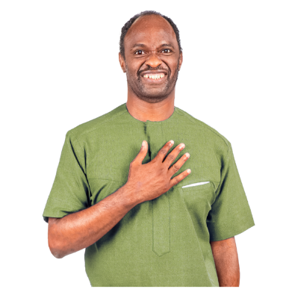
Wellbeing means things like:
how you feel about yourself
getting support when you are feeling sad / worried
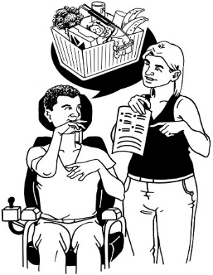
feeling safe
being able to choose what is important to you.

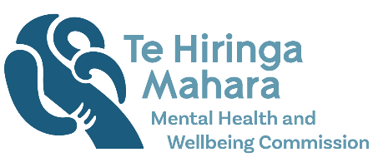
The Easy Read is written by Te Hiringa Mahara – Mental Health and Wellbeing Commission.

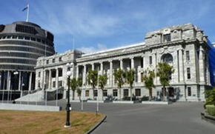
Te Hiringa Mahara – Mental Health and Wellbeing Commission:
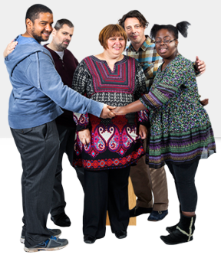
is an independent part of the Government which means the Government cannot tell them what to do

is kaitiaki / guardian of mental health and wellbeing in Aotearoa New Zealand
tells other agencies how to make things better for mental health and wellbeing.

When you see we / us in this document it means Te Hiringa Mahara.

Making 6 changes to improve services

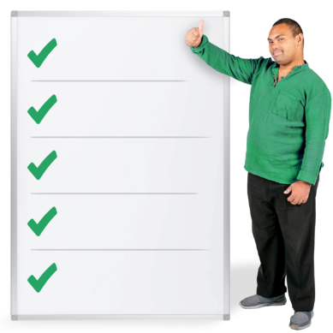
There are 6 important changes we think need to be made to improve the:
mental health services / system
addiction services / system.

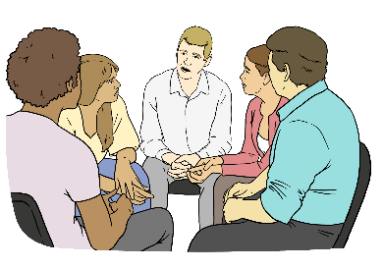
Here system is how the mental health services work together.

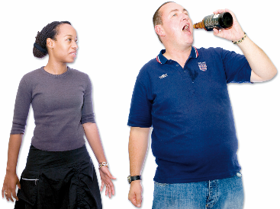
Here addiction is about when someone:
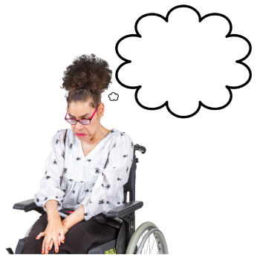

uses a substance a lot
has a very hard time trying to stop using / taking it.
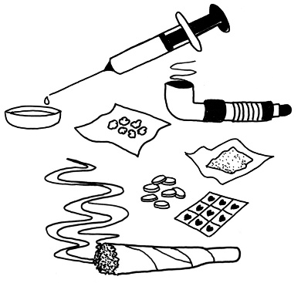
Here a substance is something like:
- alcohol
- drugs.

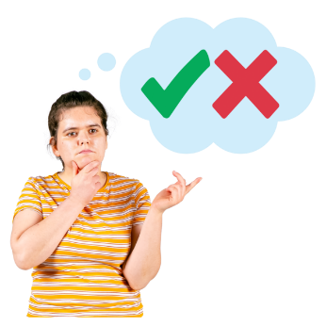
We worked with other people
/ groups to decide what 6 changes need to be made.

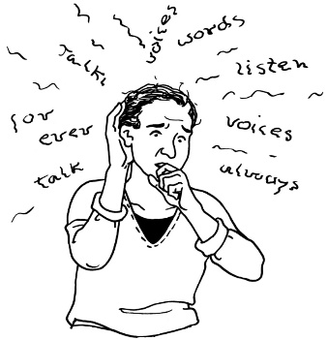
These people have lived experience of using services for their:
- mental health
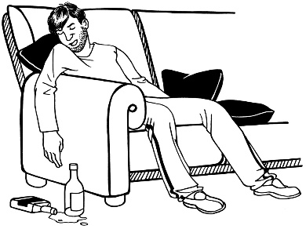
- addiction
- mental health and addiction.

Here lived experience means if someone has / had:
- mental health distress
- addiction.

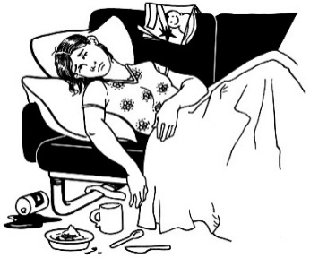
Mental health distress is when your mental health is not doing well.

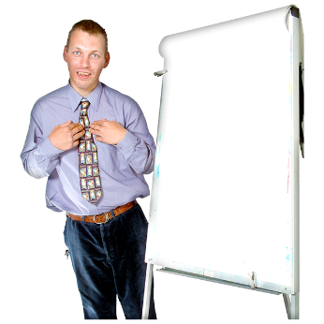
Change 1: Lived experience

This change will mean doing things like:
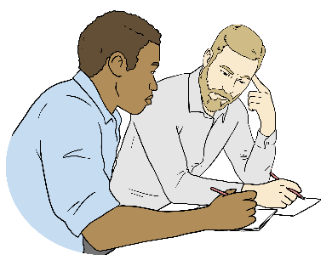
- making sure there are jobs as leaders in mental health
/ addiction services for people with lived experience
supporting people with lived experience to be leaders
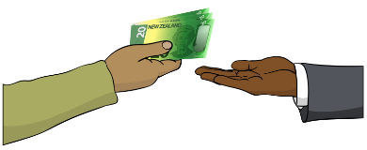
putting money into peer support services.

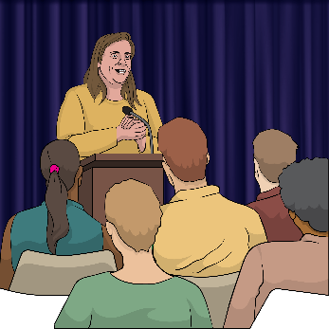
Here leaders are people who lead
/ guide others in a place like an organisation.

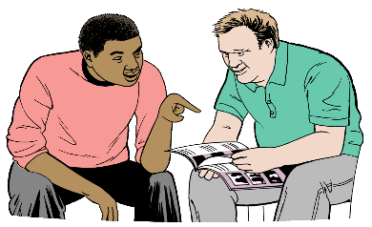
Here peer support is when you get support from someone who has been through the things you are going through.

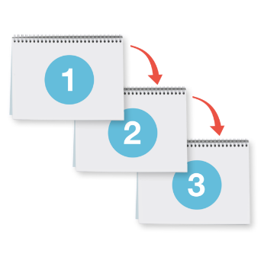
Change 2: Prioritise mental health / addiction services

for people who need them most
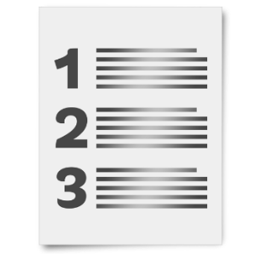
Here prioritise means to work out who needs to get services first.

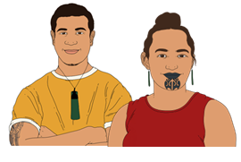
This change will mean doing things like:
putting more resources / money into making more kaupapa Māori services
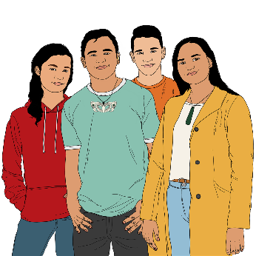
the Government working with other organisations to improve wellbeing for:
- rangatahi Māori / Māori youth
- young people.

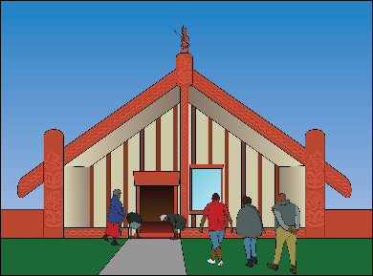
Kaupapa Māori means Māori ways of doing things.

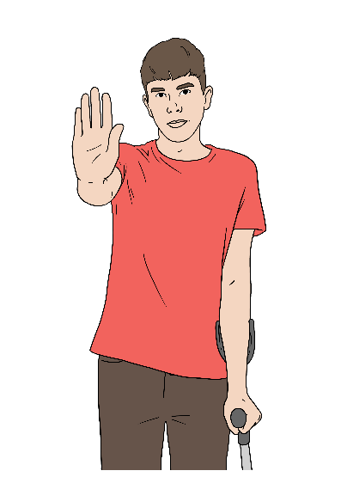
Change 3: Getting support early to prevent mental health distress / addiction

Preventing means stopping something before it starts.

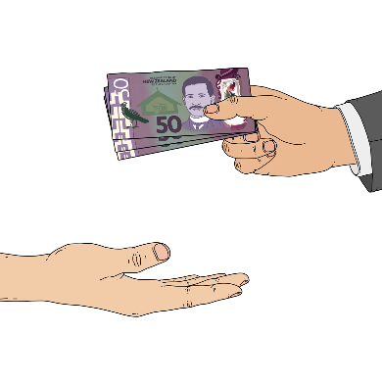
This change will mean putting more resources / money into finding out what causes:
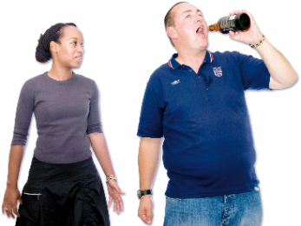
- mental health distress
- addiction.

Doing this will help prevent people from getting very unwell:
with mental health distress
because of addiction.

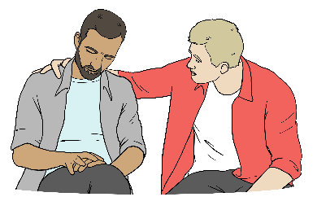
Getting support early can stop people from getting very unwell.

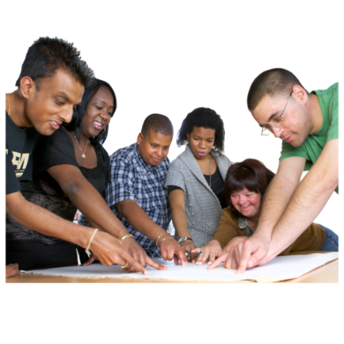
To do this public health services should:
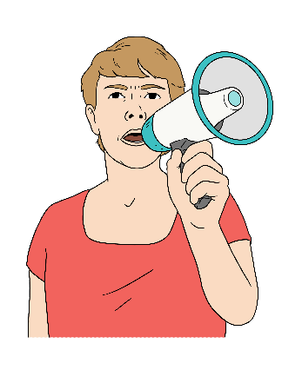
- plan ways to make it easier for people to get the support they need earlier
- let people know how they can get these services earlier.

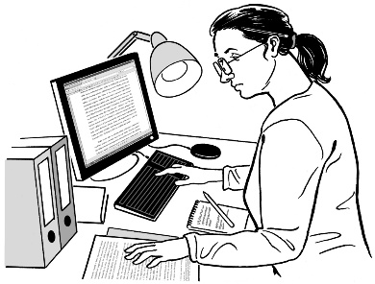
The Government should find out what causes mental health distress
/ addiction.

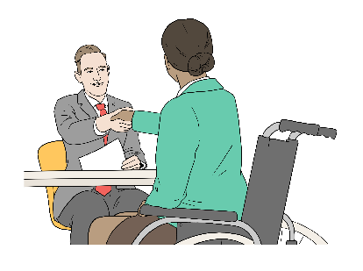
This will support them to find ways to prevent mental health distress
/ addiction from happening.

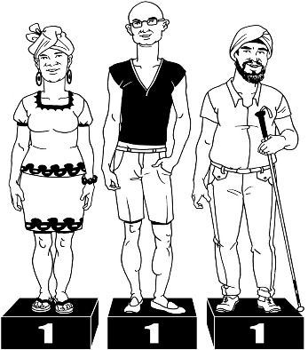
Change 4: Equal access to good mental health / addiction services

Here equal means being treated the same as everybody else.

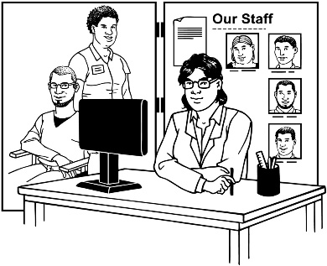
This change will mean doing things to make it easier to get the right services for people who:
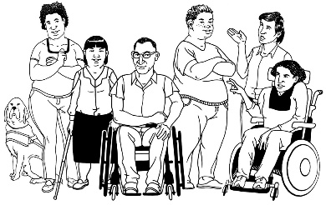
- do not have a lot of money
- are disabled.

This change will also mean doing things like:

trying new ways to support people in mental health
/ addiction services
making sure people do not have to wait for a long time to get the services they need.

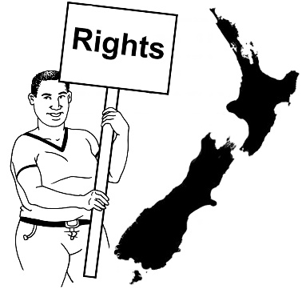
Change 5: Making sure human rights are protected

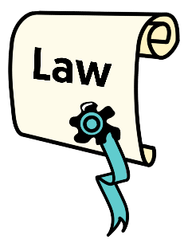
Human rights are things that the
law says every person should:
have
be able to do.
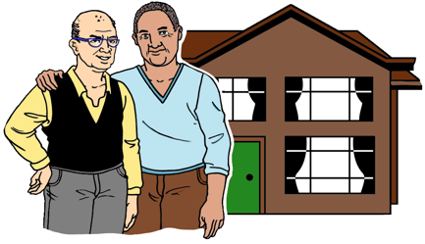

Rights are things like:
having a safe place to live
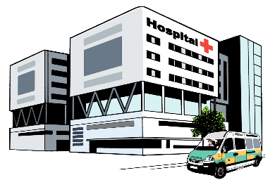
getting the health services you need.

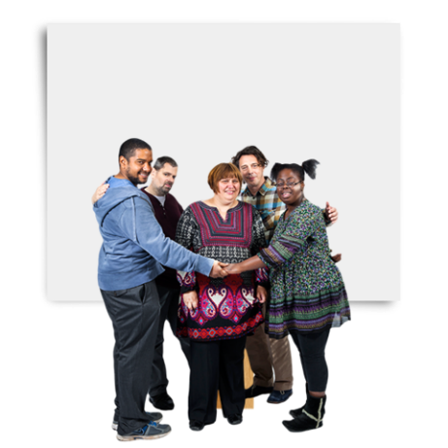
Here protect means to make sure everyone can always get their rights.
Protecting human rights will mean doing things like:
stopping seclusion
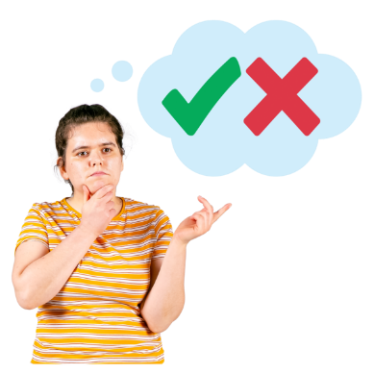
preventing stigma about mental health / addiction
making sure people using mental health / addiction services can make their own decisions about their care.

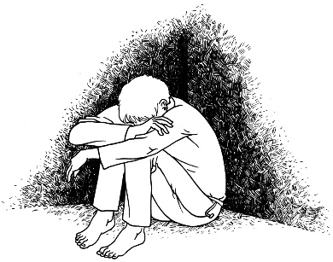
Here seclusion is when someone is:
- put in a place where they are alone
- kept away from other people.
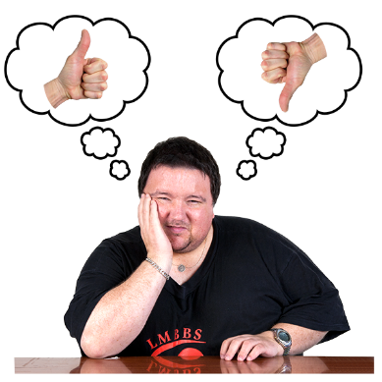

Stigma is an unfair belief about something like mental health distress / addiction.

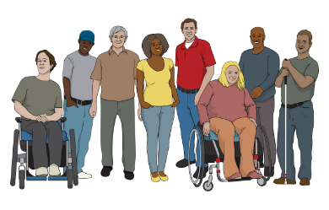
More workers will be needed in
mental health / addiction services to protect human rights.

Change 6: Supporting people working in mental health / addiction services

This change will mean doing things like:
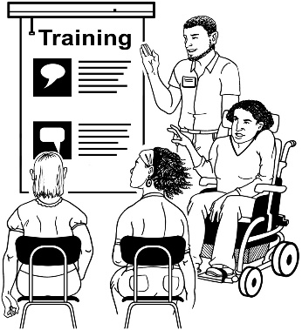
- getting more people to work in mental health / addiction services
- training more people to learn skills to support people using mental health / addiction services
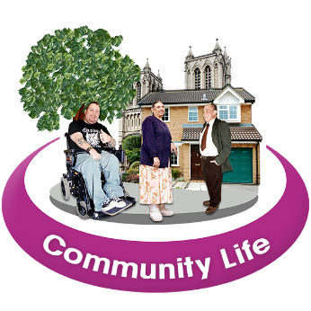
- making sure people working in mental health / addiction services represent the communities they are working in.

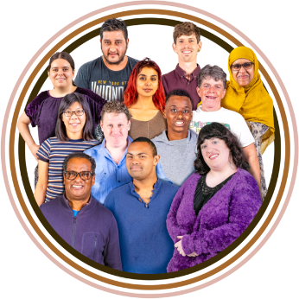
Here represent means some of the workers in mental health / addiction services should be part of the community they are working in.

Why these changes are important


The Ministry of Health is making a Mental Health and Wellbeing Strategy.
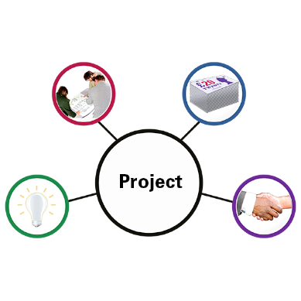

A strategy is a set of long-term plans that are made to reach a goal.

This Strategy:
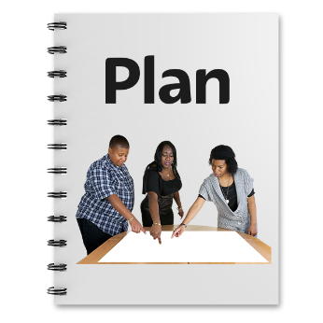
will guide organisations like Health New Zealand to improve the mental health / addiction system
is a plan to improve the mental health / addiction system for the next 8 years.


We want the Ministry of Health to put our 6 changes into the strategy.
6

We believe these are the most important areas to focus on.

We want the Ministry to Health to find out ways to make the mental health system better for:
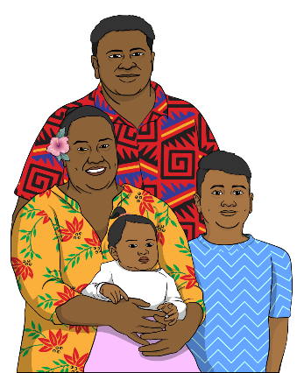
- people who have experienced mental health distress / addiction
- Māori
- rangatahi / young people
- Pacific people
- disabled people.

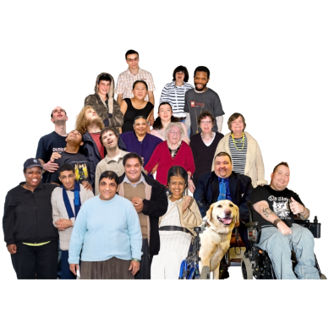
We want the Mental Health and Wellbeing Strategy to make it easier to get information about:
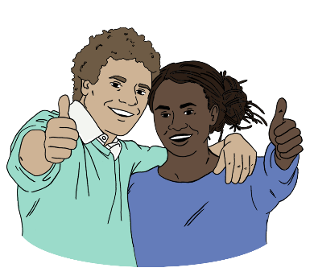
- how many people are experiencing mental health distress / addiction
- how many people are using mental health / addiction services
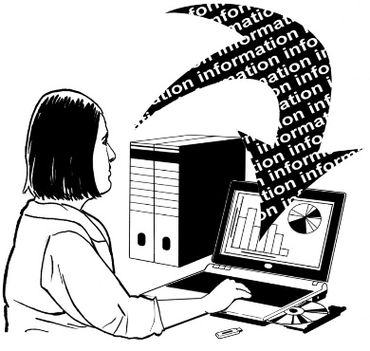
- if the services are working for the people using them.

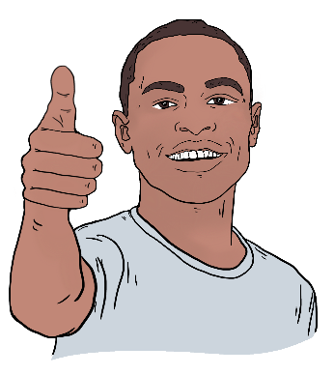
Having this information will support the Ministry of Health to make services better for people with:
- mental health distress
- addiction.

What needs to happen next?
6

It is important the 6 changes are part of the Mental Health and Wellbeing Strategy.

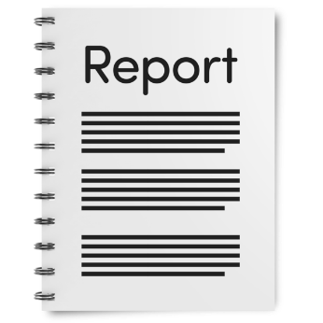
We made a report about these
6 changes.

We have shared our report with:
- the Minister for Mental Health
- the Ministry of Health
- government agencies
- mental health and addiction services.
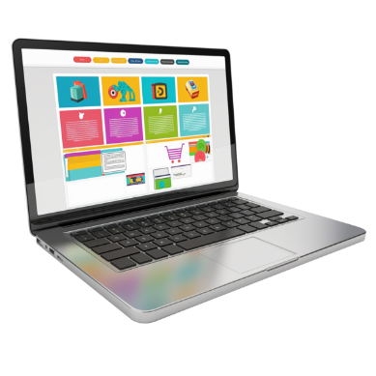
You can read the full report on our website:

https://tinyurl.com/2myntppu
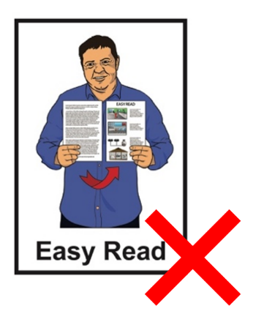

This website is not in Easy Read.

More information

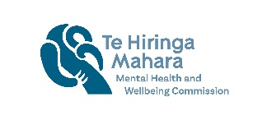
You can contact us if you want more information about:

- these 6 changes
- the Mental Health and Wellbeing Strategy
- mental health services.
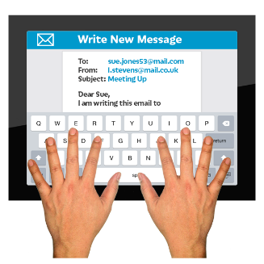

You can send an email to us at:

kiaora@mhwc.govt.nz

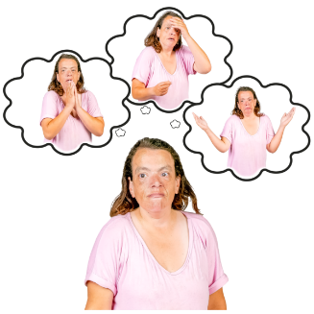
Reading about mental health can bring up lots of different feelings.


For information about support you can go to this website:

www.mhwc.govt.nz/where-to-get-support/

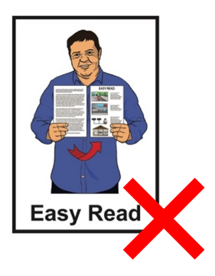
This website is not in Easy Read.
This information has been written by Te Hiringa Mahara – Mental Health and Wellbeing Commission.

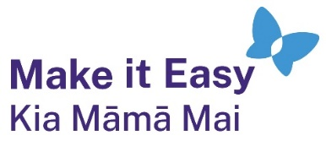
It has been translated into Easy Read by the Make it Easy Kia Māmā Mai service of People First New Zealand Ngā Tāngata Tuatahi.
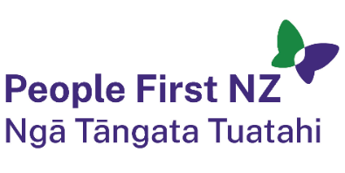
The ideas in this document are not the ideas of People First New Zealand Ngā Tāngata Tuatahi.

All images used in this Easy Read document are subject to copyright rules and cannot be used without permission.


Make it Easy uses images from:

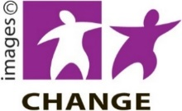
- Photosymbols

- Change Images


- Huriana Kopeke-Te Aho

- SGC Image Works

- T Wood


- Studio Rebeko

- Inga Kramer.

