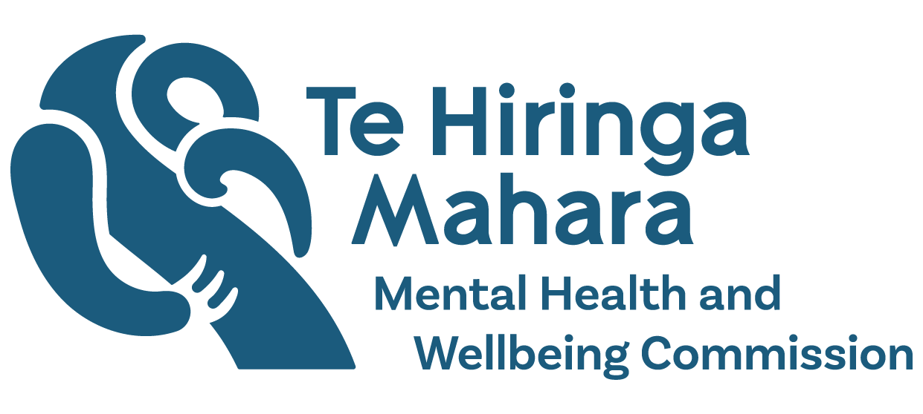
Six Changes to improve mental health and wellbeing outcomes
Adapted in 2025 by Accessible Formats Service,
Blind Low Vision NZ, Auckland
TN: The logo at the top of the page is Te Hiringa Mahara Mental Health and Wellbeing Commission.

About Te Hiringa Mahara
- Te Hiringa Mahara—Mental Health and Wellbeing Commission is an independent crown entity and a kaitiaki (guardian) of mental health and wellbeing in Aotearoa New Zealand.
- Te Hiringa Mahara monitors the wellbeing system, mental health and addiction services and advocates for improvements to services and the interests of people who experience distress or addiction.

What a good mental health and addiction system looks like
- Te Hiringa Mahara has identified six changes that need to happen to improve the mental health and addiction system.
- These changes have been developed with people who experience distress or addiction, or both.
The six changes are:
- Lived experience. This change includes developing and supporting more lived experience leadership roles and investing more in peer support services.
- Prioritising effective mental health and addiction services for people who need them the most. This change includes investing more in kaupapa Māori services, and government working together to improve wellbeing for rangatahi Māori and young people.
- Preventing distress or addiction and getting support earlier. This change includes investing more in prevention and public health approaches, making it easier for people to get support earlier, and government focusing on the causes of distress or addiction.
- Equitable access to effective mental health and addiction services. This change focuses on making it easier for people who are disadvantaged to get the support and services they need, trying new things, and decreasing the time people wait to access specialist services.
- Upholding human rights. This change includes ending coercive practices, like seclusion, reducing the stigma of distress or addiction, and ensuring people experiencing distress or addiction can make their own decisions about their care.
- Supporting the mental health and addiction workforce. This change includes growing and upskilling the mental health and addiction workforce, and making sure the workforce represents the communities it serves.

Why these changes are important for the Mental Health and Wellbeing Strategy
- The Ministry of Health is developing a Mental Health and Wellbeing Strategy, which will guide health entities, like Health New Zealand, to improve the mental health and addiction system over the next eight years.
- Te Hiringa Mahara wants to see the six changes in the strategy because they are the most important areas to focus on.
- We want the strategy to be developed by people who experience distress or addiction, include solutions for Māori, Pacific people, young people and disabled people.
- We also want the strategy to make it easier to collect data on how many people are experiencing distress or addiction, how well services are supporting people, and outcomes.

What happens next
- Te Hiringa Mahara will monitor the six changes and advocate for these changes to be part of the Mental Health and Wellbeing Strategy.
- Te Hiringa Mahara has published a report about these changes on our website. We have shared this report with the Minister of Mental Health, Ministry of Health, government agencies and mental health and addiction services.
- You can read the full report on our website https://www.mhwc.govt.nz/news-and-resources/system-performance-monitoring-report-2025/ or here https://tinyurl.com/2myntppu

Contact us
- For questions or more information about our work, please contact kiaora@mhwc.govt.nz
End of Six changes to improve mental health and wellbeing outcomes

