Access and Choice

Programme:
Report on the first two years

Te Hōtaka mō

Ngā Whai Wāhitanga me

Ngā Kōwhiringa:
He purongo mō te rua tau tuatahi

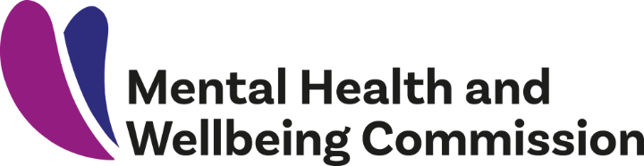

Access and Choice Programme: Report on the first two years – Te Hōtaka mō Ngā Whai Wāhitanga me Ngā Kōwhiringa: He purongo mō te rua tau tuatahi
A report issued by the New Zealand Mental Health and Wellbeing Commission
This work is protected by copyright owned by the Mental Health and Wellbeing Commission. This copyright material is licensed for re-use under the Creative Commons Attribution 4.0 International License. This means you are free to copy, distribute and adapt the material, if you attribute it to the Mental Health and Wellbeing Commission and abide by the other license terms. To view a copy of this license, visit https://creativecommons.org/licenses/by/4.0/legalcode.
ISBN: 978-0-473-59790-0 (online version and docx)
The New Zealand Mental Health and Wellbeing Commission was set up in February 2021 and works under the Mental Health and Wellbeing Commission Act 2020. Our purpose is to contribute to better and equitable mental health and wellbeing outcomes for people in Aotearoa New Zealand.
For more information, please visit our website: www.mhwc.govt.nz
New Zealand Mental Health and Wellbeing Commission (2021). Access and Choice Programme: Report on the first two years – Te Hōtaka mō Ngā Whai Wāhitanga me Ngā Kōwhiringa: He purongo mō te rua tau tuatahi. Wellington: New Zealand.

Foreword

The Mental Health and Wellbeing Commission’s purpose is to oversee the transformation of our mental health and addiction system. We are the kaitiaki of mental health and wellbeing and our vision is outlined in He Ara Oranga: Report of the Government Inquiry into Mental Health and Addiction (2018).
A critical part of this stewardship role is to ensure people have access to the support they need, when they need it, and for people to be able to choose how they are supported. Illustrating just how important these two principles of access and choice are in the transformation of our mental health services, we have made this monitoring report the
first publication of the newly-established Commission.
It is vital that solid and early progress is made on access and choice. It needs to create the momentum that will accelerate the rest of what is a very large programme of transformation over the next few years. We need to learn quickly from experience, spot errors, and solve the problems that can release the considerable energy in the sector for change.
This report finds that the programme is on track overall, which is heartening. More attention is required to develop Kaupapa Māori, Pacific, and Youth services and support for these populations is a high priority. We will be the eyes and ears of people with lived experience of mental distress or addiction (or both) and those communities who are disadvantaged by inequity. We will listen and advocate for and with them.
Government invested $664 million in 2019 into a five-year programme to provide greater access to and choice of mental health and addiction services for people experiencing mild to moderate mental health and addiction needs. We want to be sure this level of investment produces the intended results.
The Mental Health and Wellbeing Commission, which is grounded in Te Tiriti o Waitangi, came into being in February 2021. This report is
the first of many that will seek to focus the attention of both the community and the health system on the issues that matter for people.

Hayden Wano
Chair, Mental Health and Wellbeing Commission

3 | Mental Health and Wellbeing Commission

Acknowledgements
This report is the product of people’s time, generosity, and support.
We would like to thank our external peer reviewers for their guidance and advice, and the time they gave to strengthen our report:
- Dr Julie Wharewera-Mika
- Dr Sarah Appleton-Dyer
We are grateful to all those who provided information that enabled us to prepare this report.
We are also extremely thankful to the people with lived experience of mental distress or addiction (or both), and service providers who have shared their perspectives and experiences of the Access and Choice programme.

4 | Access and Choice Programme Report

Overall summary

This report provides an update on how the implementation of ‘Expanding Access and Choice of Primary Mental Health and
Addiction Support’ (the Access and Choice programme) is going – it covers the first two years of the five-year programme, up to 30 June 2021.
The report answers the question of how the Access and Choice programme is performing compared with what the programme intended to deliver by 30 June 2021, including whether it has increased people’s access to,
and choice of, primary mental health and addiction services.
The Access and Choice programme was developed in response to He Ara Oranga: Report of the Government Inquiry into Mental Health and Addiction (He Ara Oranga),1 which found there was an urgent need to provide better access to, and more choice in, services – particularly for people with mild to moderate, and moderate to severe, mental health and addiction needs (Government Inquiry into Mental Health and
Addiction, 2018).
The 2019 Wellbeing Budget (Budget ‘19) invested $664 million over five years to roll out the Access and Choice programme nationally.
The Access and Choice programme set out to provide 325,000 people (6.5 per cent of the total population) with mild to moderate mental health and addiction needs with free and immediate support.
To do this, $516.4 million is being invested to support four new national services, which are:
- Integrated Primary Mental Health and Addiction services (IPMHA services): services provided in general practices that are accessible to everyone enrolled in those practices.
- Kaupapa Māori services: whānau-centred services delivered by Māori, for Māori.
- Pacific services: Pacific-led services incorporating Pacific values, beliefs, languages, and models of care.
- Youth services: flexible services delivered in spaces that are acceptable and accessible to young people.
Also included in the Budget ’19 investment was $99.7 million for workforce development, as well as $48.2 million for system enablers, including engagement and collaborative design, IT infrastructure, evaluation, implementation support, and the Ministry of Health’s (the Ministry) capacity and capability.
This report describes the services and initiatives invested in over the last two years. It also provides information and commentary about how well the programme has progressed compared with what was intended after two years.
Our conclusion is that the programme has put much-needed investment and services into primary and community care in line with many of the recommendations in He Ara Oranga.

1 https://mentalhealth.inquiry.govt.nz/inquiry-report/he-ara-oranga/

- | Mental Health and Wellbeing Commission

A lack of detailed planning intentions for the programme has made it difficult to assess whether the implementation of specific services is on track. This has meant we have had to look at funding commitments relative to funding allocated (with the focus on the 2023 / 24 ongoing funding path), workforce recruitment, and uptake of services at an aggregate level to assess progress.
Data quality issues have limited our ability to understand if services are meeting the needs of people accessing care, or whether they are making a positive difference. The
Ministry is working with the sector to improve information systems, which will allow more comprehensive reporting in the future.
Overall, the programme is on track in terms of population coverage and people seen at the end of June 2021. However, there have been delays with implementing the Kaupapa Māori, Pacific, and Youth services and we encourage the Government to priortise the
ongoing roll out and development of these services.
Workforce recruitment and development has been a challenge for many services, particularly Kaupapa Māori and
Pacific services.
We note that some of the actions to address the recommendations of He Ara Oranga
are in the early stages of development. There needs to be further investment to fully address the recommendations relating to access and choice, and the broader recommendations of He Ara Oranga.
This includes wellbeing promotion, growth in the peer support workforce, and more investment in community settings for people experiencing acute distress. It is also critical that future service design is undertaken in collaboration with communities, as called for in He Ara Oranga.

6 | Mental Health and Wellbeing Commission

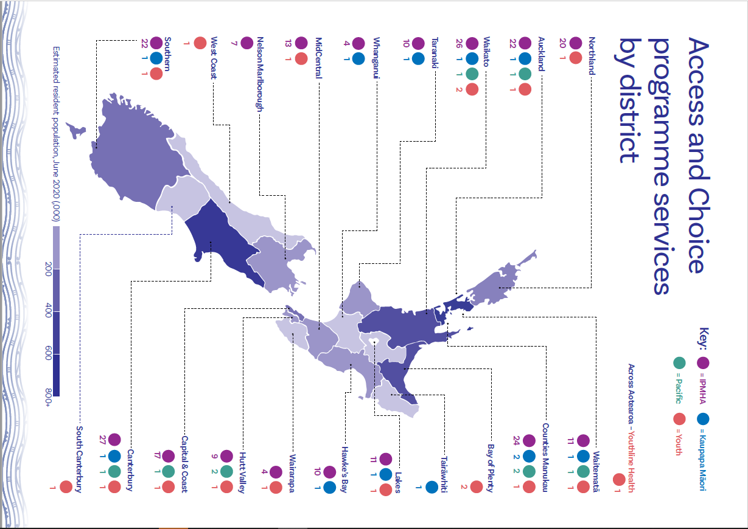
Contents
Foreword 4
Acknowledgements 5
Overall summary 6
Context 9
Overview of the Access and Choice programme 11
Integrated Primary Mental Health and Addiction services 14
Kaupapa Māori services 22
Pacific services 26
Youth services 30
Workforce development 34
Enablers 38
Conclusions 40
References 44

Context

He Ara Oranga recommended increasing access to mental health and addiction services, and expanding the choice of services available
He Ara Oranga envisioned a transformed mental health and addiction system and advocated for a new system with a vision of mental health and wellbeing that recognises the aspirations of Māori and Pacific peoples at its core. It proposed that this system should be holistic and focused on what everyone needs to achieve good mental wellbeing, so people who are experiencing mental distress or addiction have the resilience, tools, and support they need.
He Ara Oranga found there was an urgent need to provide better access to, and more choice in, mental health and addiction services. The report also found there were few services available for people with mild to moderate, and moderate to severe, mental health and addiction needs. These groups were described as the ‘missing middle’ of the population.

The 2019 Wellbeing Budget included funding for

the Access and Choice programme
Budget ‘19 invested $664 million over five years for the national rollout of the Access and Choice programme. The funding for this programme is often quoted as $455 million over four years, which reflects the standard Budget forecast period of four

years. The programme planned to allow 325,000 people (6.5 per cent of the total population) with mild to moderate needs to access new models of primary mental health and addiction support each year.

We have heard mixed views from people about the Access and Choice programme
Since the Mental Health and Wellbeing Commission (the Commission) was established in February 2021, we have frequently talked with our priority groups,2 people with lived experience of mental distress or addiction (or both), and service providers about their general experiences and thoughts about mental health and addiction services. We have also met specifically
with some providers and people with lived experience to discuss the Access and Choice programme.
Throughout these conversations, we heard considerable positive feedback about the expansion of primary mental health and addiction services. We also heard many questions and concerns. We have noted some of this feedback in relevant sections of this report. Where information is available, we have addressed these concerns and answered the questions people have about the Access and Choice programme.
While we have tried to bring some of the views of communities and providers into the report, we have not undertaken a comprehensive consultation with priority
groups and providers about their
experiences of the programme. This is
because the report is primarily focused
on progress of the rollout of the programme.

For future reports, we will specifically seek the views of service users, communities, and providers.

This report provides an update on the implementation

of the Access and Choice programme
This report provides an update on progress on the Access and Choice programme.
It builds on the work of the Initial Mental Health and Wellbeing Commission (Initial Commission), which published Mā Te Rongo Ake: Through Listening and Hearing in March 2021 (The Initial Mental Health and Wellbeing Commission, 2021).3 Mā Te Rongo Ake assessed the Government’s progress on implementing 36 of the 38 recommendations made in He Ara Oranga. It found that the Government had shown commitment to deliver on its obligations to He Ara Oranga, but also highlighted that transformation will take time, focus, and leadership. Progress toward meeting the recommendations was varied. Most progress had been made toward areas the Government prioritised. This included increasing access to, and choice of, mental health and addiction services.
Part of the Commission’s role is to provide independent scrutiny of the Government’s progress in improving mental health and wellbeing in Aotearoa New Zealand. This includes being a kaitiaki of He Ara Oranga. The Commission has oversight of the Government’s response to He Ara Oranga and the rollout of the Budget ‘19 mental health and wellbeing programmes. We had planned to report on the Access and Choice programme in our upcoming Mental Health and Addiction Service Monitoring Report due later this year. However, given strong interest in the programme’s progress in recent months, we decided to publish our findings on the Access and Choice programme as a stand-alone report.
This report provides an update on how the implementation of the Access and Choice programme is going – it covers the first two years of the five-year programme, up to 30 June 2021. The report answers the question of how the Access and Choice programme is performing compared to what the programme intended
to deliver by 30 June 2021, including whether it has increased people’s access to, and choice of, primary mental health and addiction services.

2 The Commission’s priority populations, as noted in the Mental Health and Wellbeing Commission Act 2020, include Māori, Pacific peoples, Asian peoples, rainbow communities, trans communities, people with variations of sex characteristics, migrants and former refugees, rural communities, disabled people,
veterans, prisoners, young people, older people, children experiencing adverse childhood events, and children in state care.
3 https://www.mhwc.govt.nz/the-initial-commission/progress-reporting/

- | Access and Choice Programme Report

Overview of the Access and Choice programme

The intent of the Access and Choice programme is to provide free and immediate services for people with mild to moderate mental health and addiction needs
The programme is intended to change the way in which services are delivered, and to provide services and supports to anyone who needs them in a range of settings – Kaupapa Māori, Pacific, and youth settings, as well as in general practice (GP) and community settings. The services can be accessed for as long as they are needed, and people can return to the service whenever they need to.
The four types of services funded are:
- Integrated Primary Mental Health and Addiction services (IPMHA services): services provided in general practices that are accessible to everyone enrolled in those practices.
- Kaupapa Māori services: whānau-centred services delivered by Māori, for Māori.
- Pacific services: Pacific-led services incorporating Pacific values, beliefs, languages, and models of care.
- Youth services: flexible services delivered in spaces that are acceptable and accessible to young people.

Programme investment covers three core components delivered over a five-year period between 2019 / 20 and 2023 / 24
Investment covers the following:4
- Service delivery: $516.4 million to support four new national services that provide a ‘first point of contact’ for people with mild to moderate levels of need
- Workforce development: $99.7 million to grow and upskill existing workforces, and build new and emerging workforces
- Enablers: $48.2 million for system enablers, including engagement and collaborative design, IT infrastructure, evaluation, implementation support, and the Ministry’s capacity and capability.
The investment over the five years is shown in Table 1 below.

4 Unless otherwise referenced to an alternative source, all data used in the report has been provided by the Ministry of Health.

- | Mental Health and Wellbeing Commission

Table 1: Budget 2019 – Expanding Access and Choice of Primary Mental Health and Addiction Support funding

Funding stream | 2019 / | 2020 / | 2021 / | 2022 / | 4-year | 2023 / 24 | 5-year
($ millions) | 2020 | 2021 | 2022 | 2023 | totals | and ongoing | totals
Service delivery | 25.000 | 70.781 | 101.250 | 141.875 | 338.906 | 177.500 | 516.406
Workforce  development | 13.888 | 18.186 | 22.330 | 22.664 | 77.068 | 22.664 | 99.732
Enablers | 9.250 | 8.250 | 10.050 | 11.550 | 39.100 | 9.050 | 48.150
Annual totals | 48.138 | 97.217 | 133.630 | 176.089 | 455.074 | 209.214 | 664.288

The $209.214 million of funding allocated in 2023 / 24 is intended to be sustained into the future beyond 2024 to support these new services. The assumptions in Table 2 were used to calculate the funding envelope and inform the phasing of the funding for the Access and Choice programme.

Table 2: Access and Choice programme assumptions
Assumptions
Total estimated population 5,000,000 people

Expected uptake (% of total population) 6.5%

Expected uptake (number of people) 325,000 people

Low levels of support $300 to provide

% of target population expected to uptake low 50% of people using the services Medium levels of support $500 to provide
% of target population expected to uptake medium 30% of people using the services Higher levels of support $1,000 to provide
% of target population expected to uptake high 20% of people using the services
Indicative allocation of ongoing service delivery funding from the end of 2023 / 2024:
Māori 20% of funding

Pacific 8% of funding

Young people 15% of funding

Population5 57% of funding

5 General population (including Māori, Pacific, and youth) enrolled in general practices that have IPMHA services.
- | Access and Choice Programme Report

The assumptions about expected uptake and increasing population coverage by the end of 2023 / 24 (up to 325,000 people per year) were used to calculate how much funding was needed, and how the funding should be allocated by year. They relate to the whole five-year programme and were not used to plan service implementation or to determine yearly targets.

There has been significant investment in workforce
Most of the service funding will be used for growing the workforce needed to provide the services. The original Budget ‘19 modelling estimated that approximately 1,600 full
time equivalent staff (FTE) would be needed
by 2023 / 24 to deliver these new services. The Ministry assumed that 25 FTE would be required to provide support for every 5,000 people accessing the services. This number
was reached by estimating how many sessions each FTE could provide to people needing low, medium, and higher levels of support to ensure the estimated 325,000 people could access the services.
As the service model has rolled out, assumptions have been revised to allow for local variation in the ratio of registered to non-registered workforce. It is now estimated that 611 clinical FTE, 889 non-clinical FTE, and 126 senior cultural FTE (1,626 total FTE) will be required by the end of 2023 / 24.

- | Mental Health and Wellbeing Commission

Integrated Primary Mental Health and Addiction Services

What are Integrated Primary Mental Health and Addiction services?

IPMHA services are based in general practices and available to people enrolled in those practices
They are based on an existing service delivery model that had been trialled in the Tāmaki Makaurau (Auckland) region and then evaluated (Appleton-Dyer and Andrews, 2018; Appleton-Dyer, Andrews, Reynolds, Henderson and Anasari, 2018).6,7
The services are based in general practices, and are available to anyone whose thoughts, feelings, or actions are impacting on their health and wellbeing. IPMHA services comprise multiple components delivered by district health boards (DHBs), primary health organisations (PHOs), and non-governmental organisations (NGOs) working together. People typically get referred to the service following a visit to their General Practitioner.
Services include health coaches and support workers, Health Improvement Practitioners (HIP), the general practice team, access to cultural and social supports, and facilitation
of links and coordination between primary and secondary services.
Health coaches and HIP are two new roles in general practices.
Health coaches:
  - provide support for people to self-manage their wellbeing, thoughts, feelings, and actions

- act as a bridge between a primary care clinician, the person, and whānau
- help to navigate the health and social service system, including linking people to appropriate community supports
- provide emotional support
- help make sure people’s needs are met by different health care workers within the practice
- have received health coach training and are not registered as health practitioners.
As part of the local flexibility, in some areas the health coach and support worker roles are combined while in others these are separate. Some services have employed peer support workers into these roles.
Health Improvement Practitioners (HIP):
- are registered health practitioners who have received HIP training
- provide rapid access to evidence-based brief interventions (generally 30 minutes long) to help people make changes that enhance their health and wellbeing
- build general practice confidence and capability to meet the needs of people experiencing mental health and / or alcohol and other drug concerns
- ensure anyone whose thoughts, feelings, or actions are impacting on their health and wellbeing are being effectively responded to
- develop care pathways for problems experienced by many people
- provide timely access to community supports
- ensure timely access to community mental health teams for people who need
this support.

6 https://static1.squarespace.com/static/57a93203d482e9bbf1760336/t/5c09b5f58a922de1eafd8235/1544140300132/ Synergia+ADHB+FftF+Enhanced+integrated+practice+teams+evaluation+FINAL+1.
7 https://synergia.consulting/news/fit-for-the-future-evaluation/

- | Access and Choice Programme Report

IPMHA services are required to employ a mutually agreed average of registered to non- registered workforce.
There is a range of 1:1 and 1:1.5 clinical to non-clinical FTEs. The actual ratio can vary from site to site based on local decision-making about level of need. The workforce is funded based on one HIP for an enrolled population of 10,000 people.

There have been concerns that local communities were not involved in the design of the service
The Ministry specified core components of the services, including the type of workforce to staff the services and the training the workforce must undertake, while allowing for some flexibility to adapt to local needs.
We have heard concerns from communities and providers about the model being specified by the Ministry, and the lack of a co- design process, which was called for in He Ara Oranga. We have also heard concerns from Māori providers about the limitations of the model, and that it doesn’t fit well with Hauora Māori approaches.
However, the Ministry has advised the model was co-designed before being implemented in the Tāmaki Makaurau region, and since this was used as the basis for the core components required by all IPMHA services across the motu, national co-design wasn’t needed. Instead, the Ministry set expectations for collaborative design at the local level. This includes the establishment of local ‘collaboratives’ to govern the rollout and make decisions on what parts of the service would best suit their district’s needs, such as the make-up of the non-registered workforce.
One aspect of the service model that is agreed locally is the way in which the health coach and support worker roles are implemented. In the Tāmaki Makaurau pilot, the support worker role (called Awhi Ora) was co-designed and is highly valued by service users; it focused on addressing social and economic determinants of distress. We have heard from people with lived experience of mental distress that they are disappointed the Awhi Ora service component has not been included as a specific requirement in the national service specifications.
The Ministry, however, has advised that the core functions of the Awhi Ora role, including linking people to wider social supports to address the broader determinants of distress, is specified as a core function of IPMHA services. The Ministry has not described how this function and the health coach function are implemented, nor what they are called locally. Some local areas have chosen to replicate the Tāmaki Makaurau model with separate health coaches and support workers; in other areas these functions are combined into one role.

There have been concerns about funding allocation for the services
Some service providers have expressed concerns that the funding allocation model doesn’t account for the different needs of the enrolled population, and does not allow an appropriate level of service for practices with high enrolled Māori populations or other populations with high needs. However, the total funding available to each DHB was allocated on the mental health population- based funding formula, which is calculated based on need, and is greater for areas with a high Māori population and high deprivation. The aspect of the model that is fixed is the 1 HIP to 10,000 people enrolled in a practice.

- | Mental Health and Wellbeing Commission

There have been challenges in implementing the model in very small practices, particularly where these are geographically isolated,
and it is not practical to share a HIP across a cluster of smaller geographically-close practices. The Ministry has set up a national network to share information and learning across collaboratives regarding these types of implementation challenges. It is one aspect of the model that will be considered in the external evaluation.

How well are IPMHA services progressing?

The rollout of IPMHA services is ahead of schedule
The Ministry accelerated implementation of IPMHA services as providers were ready to expand the services more quickly than expected, and the funding committed for IPMHA services is therefore ahead of schedule. Funding committed as at 30 June 2021 is 47.6 per cent of the way towards the total ongoing annual funding allocated of $101.175 million per year from 2023 / 24.

The services are available across 16 DHBs in 237 general practices
As of 30 June 2021, IPMHA services have been implemented in 237 GP sites across 16 DHBs. This represents 23 per cent of the number of GP sites in the country. The services are available to 34 per cent of the population enrolled8 with a GP.
The infographic on page 18 shows the population and service coverage as of 30 June 2021. It’s important to note that ‘Coverage by the end of 2023 / 24’ does not show programme targets. A lack of annual goals or targets makes it difficult to assess progress and whether services are on track.
Figure 1 on page 20 illustrates the proportion of people in Aotearoa who have access
to these services through the GP they are enrolled with, by DHB. Figure 2 shows that the programme rollout has included GP sites
with higher enrolled populations, which allows faster population coverage. The programme has also rolled out IPMHA services to 59 (30.3 per cent) of the 1959 rural practices across Aotearoa.
Four DHBs are yet to establish IPMHA services.
Phased roll out will begin in two of these areas in October / November 2021 and the remaining two in early 2022.

The number of people

using services appears to be on track
From February 2020 to 30 June 2021, 137,121 sessions were delivered. Fifty-nine per cent were provided by HIPs and 41 per cent by health coaches and support workers. Approximately 14,000 further sessions were delivered in the first seven months of the programme, from July 2019 to January 2020. This early activity is not included in our analysis as the data received for this period did not include sufficient detail.

8 Approximately 95 per cent of Aotearoa’s population is enrolled with a GP.
9 Based on New Zealand Rural General Practice Network’s list of rural practices.

- | Access and Choice Programme Report

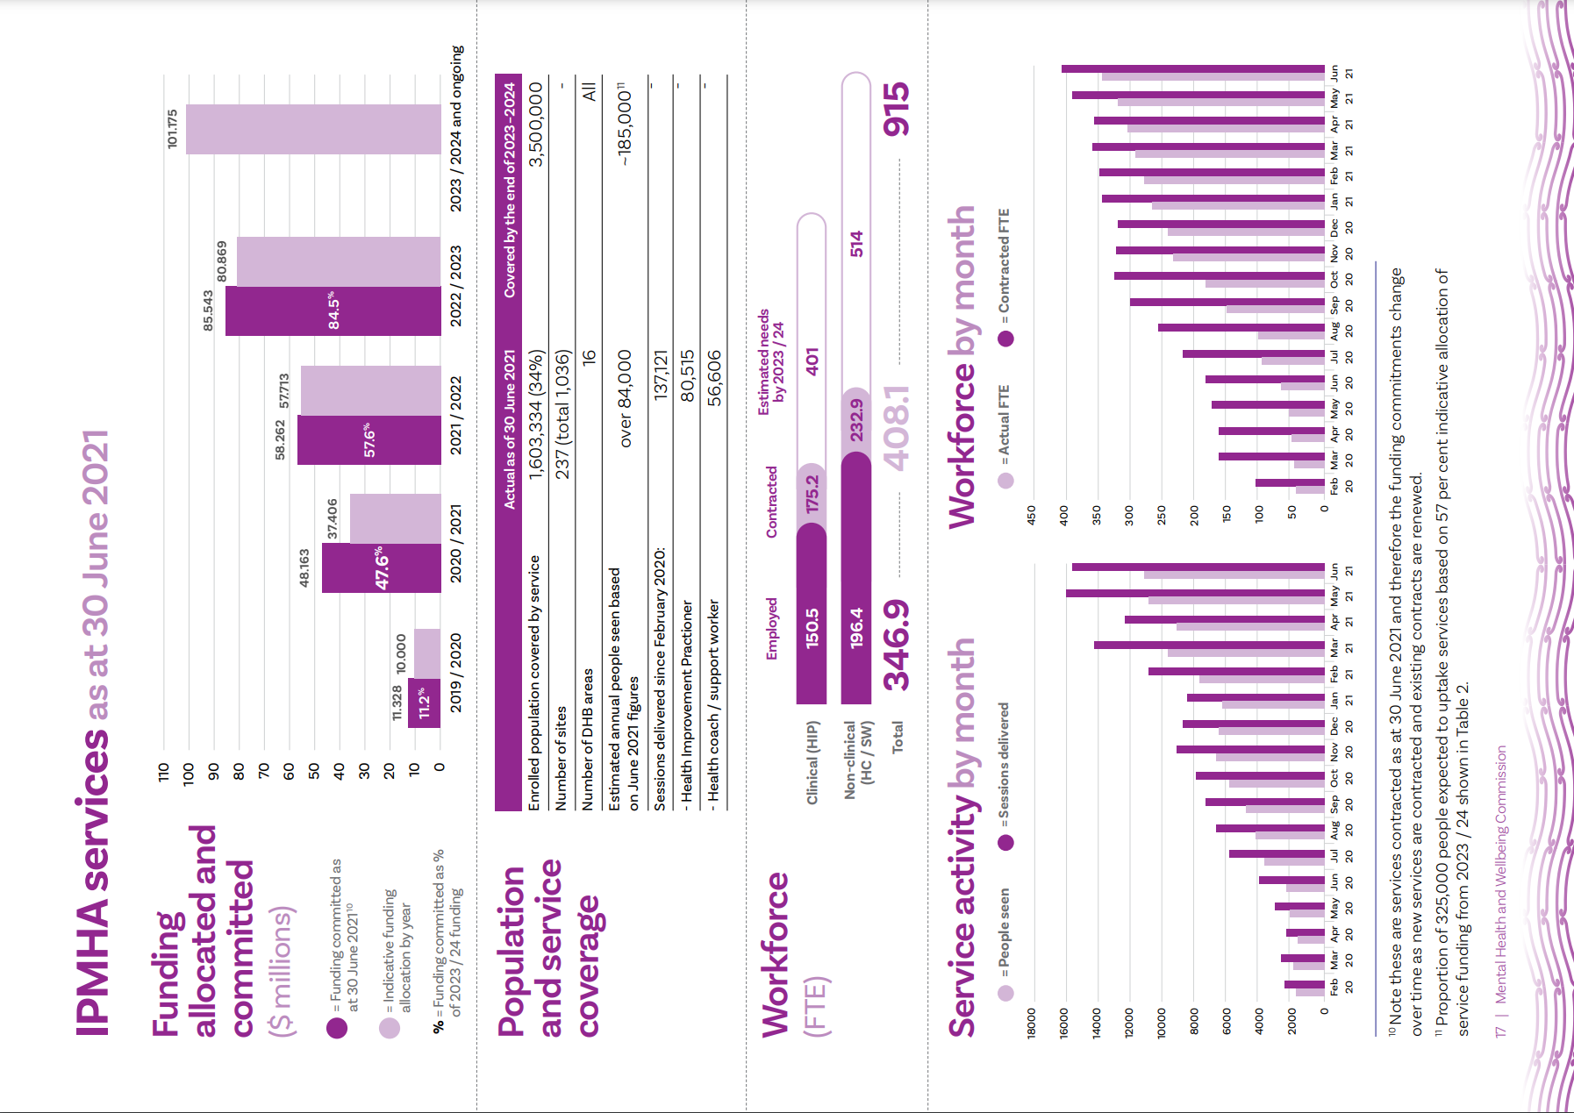
- | Access and Choice Programme Report

It is not possible to report an exact number of people seen by the services. The data reported by providers includes some individuals seen more than once, both within a month and across months. These figures will become more accurate as providers move to a new national health index number (NHI)-linked reporting system. Based on June 2021’s NHI-linked reporting, the Ministry has estimated that over 84,000 people currently have access to the services each year.
The infographic on page 18 shows the people seen and sessions delivered by month using the data reported by providers to the Ministry. As noted above, the people seen in one month may include some individuals being seen more than once, and some individuals being seen in numerous months. However, this graph is useful to show the increasing
activity of services and programme implementation progress.

Recruiting and training the workforce is a challenge.

However, the gap between the contracted and employed workforce is decreasing
There is a gap between the number of staff contracted (funded) and the number of staff employed into positions. This is not unusual in the health system as there are long-standing shortages of trained staff.
We have heard concerns from service providers about the time it takes to access health coach and HIP training, and for some providers this has meant staff are employed but not able to work in the service. On the other hand, some training sessions have had to be cancelled because there have not been enough people to attend the training. The delivery of a national training programme for two new workforces is complex, and the workforce shortages

18| Access and Choice Programme Report

and prolonged time to recruit the workforce has presented some challenges for smooth delivery of the training programme.
Service providers have also expressed concerns about the requirement of HIPs to be registered health practitioners. Clinical workforce, including HIPs, are required to be registered under the Health Practitioners Competence Assurance Act 2003 (HPCA Act), fully registered social workers, or fully registered with the Addiction Practitioners’ Association Aotearoa New Zealand (Dapaanz). The additional IPMHA services are stretching an already limited workforce, leading to workforce gaps across all services. Some regions have wanted to employ counsellors into the HIP roles. This has not been allowed by the Ministry as counsellors are a self-regulated workforce with variability in required qualifications, expectations about ongoing professional development, and complaints’ processes. The Ministry has commissioned a project to consider how to ensure the registration requirements would allow counsellors to be employed into clinical positions.
While the shortages in the registered workforce are likely to provide ongoing challenges, the addition of new people into health coach roles is a positive step in expanding the workforce. The gap between contracted and employed workforce numbers is decreasing, with 85 per cent of contracted FTEs employed as of June 2021 compared to 34 per cent as of June 2020.
By June 2021, there were:
- 175.2 contracted HIP FTE and 150.5 had been employed
- 232.9 contracted health coach and support worker FTE and 196.4 had been employed.

Figure 1: Proportion of population with access to IPMHA services by DHB

Estimated resident population (ERP) Enrolled population with access to IPMHAS

DHB (Sites)
Wairarapa (4)
78%
63%
56%
49%
47%
45%
45%
42%
41%
40%
34%
32%
26%
23%
23%
17%

Lakes (11)
MidCentral (13)
Hutt Valley (9)
Northland (20)
Taranaki (10)
Hawke’s Bay (10)
Source: IPMHA, Stats NZ
Whanganui (4)
Southern (22)
Counties Manukau (24) Capital & Coast (17) Canterbury (27)
Waikato (26)
Nelson Marlborough (7)
Auckland (22)
Waitematā (11) Bay of Plenty (0) South Canterbury (0)

Roll out in 2021 / 2022
Tairāwhiti (0)
West Coast (0)

0% 25% 50% 75% 100%

Figure 2: Proportion of NZ population with access to IPMHA services compared to general practice sites

100%-

75%-

50%-

25%-
Enrolled population Sites

0%-

IPMHAS

National

Source: IPMHA
34%
23%

- | Mental Health and Wellbeing Commission

We don’t have a clear understanding of the issues that people present with, due to poor data quality
Table 3 shows the most frequently recorded presenting issues for IPMHA services based on an average across July 2019 to June 2021. This data is undergoing continuous improvement and is only indicative of the main reasons for use of the service. The recording of this information is incomplete, and the list of presenting issues has recently been revised. The shaded lines in Table 3
show that 40 per cent of sessions have no presenting issue recorded.
The Ministry has been actively working with providers to improve this data, and codes, such as ‘not required for follow-up’, have reduced in use from approximately 60 per cent in September 2019 to 25 per cent
in June 2021.

Table 3: Most frequently recorded presenting issues as of June 2021

Presenting issues | Count | Proportion
Not required for follow-up | 32,881 | 27.4%
Other | 7,404 | 6.2%
Not supplied | 4,937 | 4.1%
Unknown | 2,716 | 2.3%

Lifestyle choices (eating, exercise, tobacco) | 13,005 | 10.8%
Anxiety / panic | 11,210 | 9.3%
Stress | 8,901 | 7.4%
Long-term condition | 6,159 | 5.1%
Depression | 6,006 | 5.0%
Family / whānau / parenting / relationships | 3,407 | 2.8%
Self-management – long-term condition | 3,176 | 2.6%
Sleep | 2,670 | 2.2%
Grief | 1,924 | 1.6%
Emotional wellbeing | 1,337 | 1.1%

- | Access and Choice Programme Report

Data collection and reporting is improving
The Ministry has implemented an interim NHI-based reporting system, and from 1 July 2021 all existing service providers will report NHI-based data.
This will enable improved collection and reporting of all data, including demographic information (such as age and ethnicity), and information about why people are accessing the services.
The demographic data available to date is based on only five months of data collection, so we caution against drawing conclusions.
This data shows that 22 per cent of people accessing IPMHA services are Māori, 10 per cent are Pacific peoples, and 17 per cent are youth aged 12 to 24 years. The Ministry, DHBs, and service providers are continuously improving the data and reporting. In time, this data will help us understand how the new services are being used, and we can use demographic information to tell us if the services are reaching the right people.
Outcome measures, in the form of validated questionnaires, are being used by workers to track changes in people’s wellbeing to shape the supports they provide and to measure changes in people’s wellbeing because of accessing these services. Outcomes data for HIP and health coach sessions are now being reported to the Ministry monthly by providers but were not available for this report.
The Ministry reports that during June 2021, outcome measures were collected at 46 per cent of all reported HIP and health coach sessions, and 55 per cent of all reported first HIP and health coach sessions. Frequency is unknown for support workers, most of whose activities are reported via PRIMHD,12 which does not capture the outcome measures used by these services.
The measures used are Hua Oranga (a Kaupapa Māori outcome measure based on Te Whare Tapa Whā) for Māori or others where appropriate, the Duke Health Profile (a
quality-of-life outcome measure that encompasses physical, mental, and social wellbeing) for adults, and the Strengths and Difficulties Questionnaire (SDQ) for children and young people.

12 PRIMHD (pronounced ‘primed’) is a Ministry of Health single national mental health and addiction information collection of service activity and outcomes data for health consumers. The data is collected from DHBs and NGOs.

- | Mental Health and Wellbeing Commission

Kaupapa Māori services

What are Kaupapa Māori Primary Mental Health and Addiction services?

These are services provided by Māori organisations, and promote early identification and support for distress
Kaupapa Māori services are provided by Māori-led organisations13 to reflect a ‘by Māori, for Māori, with Māori’ approach. Though primarily intended for Māori, anyone can use Kaupapa Māori services. The services are innovative, whānau-centred, and use Kaupapa Māori philosophy, design, development, and implementation guided by kawa and tikanga principles and practice. Kaupapa Māori providers deliver expertise in te ao Māori (Māori worldview), te Reo Māori (Māori language), tikanga Māori (Māori customs), mātauranga Māori (Māori knowledge), and are experienced in rongoā Māori (traditional Māori medicine).
The services are designed to contribute towards the following strategic outcomes:
- increased access and equity of access for Māori
- increased choice in addressing holistic needs for Māori
- reduced wait times
- improved outcomes and quality of outcomes for Māori.

Kaupapa Māori services aim to be accessible, provide a range of options for support, and seamlessly connect Māori to other relevant NGOs, cultural, social, and health supports, as well as primary care and secondary services as and when needed.
Kaupapa Māori providers offer free, flexible, and tailored services to each person and their whānau (not pre-defined packages of care). These can be offered face-to-face in community-based settings, such as marae, papakāinga, community centres, and whānau and iwi social services; virtually; or a combination of these. The services offered include:
- evidence-informed assessment and treatment services, including therapeutic interventions, such as talking therapies (particularly those with an emphasis on whānau)
- self-management support
- culturally specific interventions and support
- peer support
- access to social support.

13 Organisations are expected to have 50 per cent or more Māori membership on their Board and 50 per cent or greater Māori workforce.

- | Access and Choice Programme Report

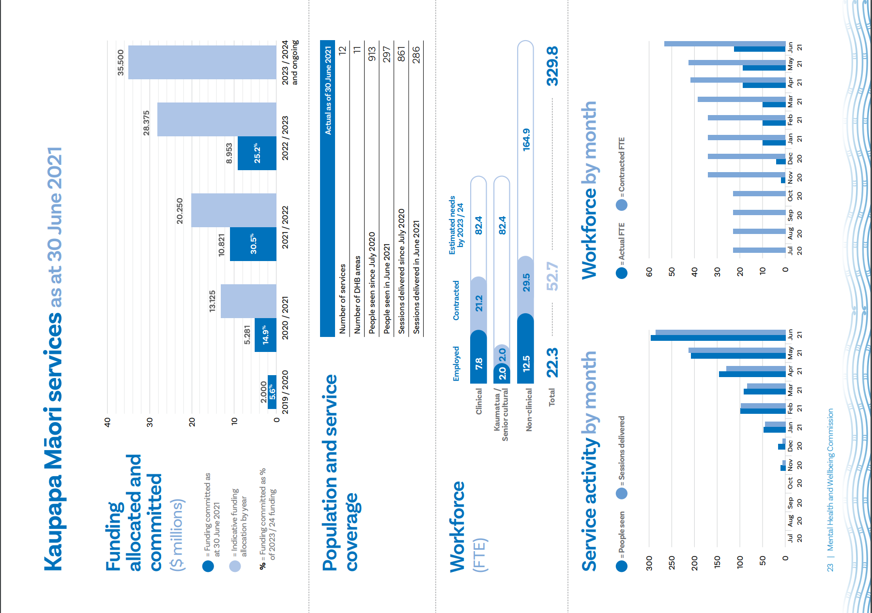

Kaupapa Māori services were co-designed
Services were co-designed with Ngāi Māori (whānau, hapū, iwi, Māori organisations, and tāngata whaiora Māori). In 2019, the Ministry carried out a series of hui across the motu for this investment. The co-design process relied upon a Māori wānanga approach that embraced te ao Māori, kawa, tikanga, mātauranga, and te reo rangatira. Analysis from 12 hui involving over 700 whānau voices was completed (Awa Associates, 2019).14 This informed the foundation for the new Kaupapa Māori primary mental health and addiction service model referred to as the ‘Kawa’ or national service specification. The services were commissioned directly by the Ministry and Requests for Proposals (RFPs), also referred to as ‘Tikanga’ proposals, reflected the new procurement approach for two streams of funding:
- Tuakana stream: best suited for established Māori providers with well- developed infrastructure, service delivery experience within mental health and addiction, or other social services.
- Teina stream: for new or smaller Māori providers with or without previous service experience in mental health and addiction, but may have existing or previous experience working with Māori in another social service sector, such as Whānau Ora, social services, or rehabilitation fields. The Teina stream also receives extra support towards being contract and service delivery ready (subject to meeting criteria).
The new, more innovative, procurement approach was developed based on feedback from the hui Māori-a-motu where Māori providers said they were
disadvantaged by traditional procurement approaches. This is a positive step in enabling new and smaller Māori providers into the sector.
The process of co-design is in line with recommendations in He Ara Oranga that called for services to be co-designed with tāngata whaiora, whānau, communities, and providers. The challenge in a national co-design process is that co-design is ideally localised to ensure local hapū, iwi, and communities are involved in designing services in their area.
The time taken to undertake co-design, the more innovative procurement approach, and COVID-19 have collectively meant Kaupapa Māori services are still in their early stages of development. However, we anticipate these services will be more responsive and higher quality because of this approach.

How well has the Kaupapa Māori service

implementation progressed?

The roll out of Kaupapa Māori services is behind what was expected by this time
The Ministry allocated indicative funding of almost $62 million for services targeted for Māori over four years. By the end of 2023 / 24, the Ministry expects the value of funded Kaupapa Māori services to be $35.5 million annually, which represents 20 per cent (see Table 2) of the $177.5 million service delivery funding shown in Table 1. The commissioning of these services is behind, with less funding committed than intended by June 2021.

14 https://www.health.govt.nz/publication/ngai-maori-insights-kaupapa-maori-primary-community- mental-health-and-addictions-service-model
- | Access and Choice Programme Report

Funding committed as at 30 June 2021 is 14.9 per cent of the way towards the indicative funding allocation of $35.5 million annually from 2023 / 24. However, processes to contract services are progressing with four DHBs in the co-design process and other contracts in negotiation. The Ministry is expecting to be on track by June 2022.
We have heard that the delay in contracting has been due to the COVID-19 pandemic and the impacts of lockdown. Many Kaupapa Māori providers are actively involved in community responses, including COVID testing and providing support for whānau during lockdowns. However, Kaupapa Māori providers have also expressed dismay at the delays in contracting during this period due to the Ministry being focused on supporting the pandemic response.
It is important to note that the drop in funding committed from $10.821 million to $8.953 million in 2022 / 23, shown in the funding chart on page 24, is a result of some of the earlier contracts ending in 2021 / 22. These contracts will undergo renewal processes, whereas IPMHA services have just been
re-contracted for a two-year term.

Twelve Kaupapa Māori services have been contracted across eleven districts
Progress can only be assessed against the funding committed and the number of districts with a service. There were no planned targets for the number of people seen or number of services to measure progress for Kaupapa Māori services as of 30 June 2021.
While the funding commitments are behind schedule, service coverage appears to be progressing well, with 12 Kaupapa Māori services established across 11 DHB areas (some service providers cover multiple
DHB areas).
As of 30 June 2021, contracted providers were all in the Tuakana stream (established providers), but there were some providers mid-contract process in the Teina stream.
The infographic on page 24 shows service coverage, including people seen and sessions delivered. The other services (IPMHA, Pacific, and Youth) are all reporting ‘sessions delivered’ exceeding ‘people seen’. While we know there are some data quality issues with the information currently being reported, the Kaupapa Māori approach to healing is not individualistic by nature. It’s highly likely that ‘people seen’ will be higher for these services due to many whānau being seen in wānanga – for example, one wānanga may include many people being seen in the same session. As the reporting system matures and improves this will become clearer.

Workforce recruitment is a challenge
There are large gaps between the number of staff contracted and the number of staff
employed with only 42 per cent of contracted FTEs employed as of June 2021. It is not unusual to experience delays in appointing staff into newly-created positions, but the size of these gaps is a concern.
By June 2021, there were:
- 21.2 contracted clinical FTE with
7.8 employed
- 29.5 contracted non-clinical FTE with
12.5 employed
- 2 contracted senior cultural FTE with 2 FTE employed.
It is of note that the IPMHA service workforce graph also shows significant gaps in the first nine months of the rollout and over time
the gaps have reduced. The Kaupapa Māori workforce gaps should not be ignored, and more support to increase Māori workforce is required.

- | Mental Health and Wellbeing Commission

Pacific services

What are Pacific Primary Mental Health and Addiction services?

These are flexible holistic services to meet the needs of Pacific peoples, delivered by Pacific services
Pacific services are provided by Pacific-led organisations. These are organisations whose Governance or Trust Board and workforce are made up mostly of Pacific peoples. While primarily for Pacific populations, anyone can use Pacific services.
Pacific services contribute towards the following outcomes:
- increased access and equity of access for Pacific peoples
- increased choice in addressing Pacific peoples’ holistic needs
- reduced wait times for Pacific peoples
- improved outcomes and quality of outcomes for Pacific peoples.
Pacific services aim to be accessible, provide a range of options for support, and seamlessly connect Pacific peoples to other relevant NGOs, cultural, social, and health supports, as well as primary care and secondary services as and when needed.
Pacific services offer free, flexible, and tailored services (not pre-defined packages of care) to each person and their āiga (family) with a holistic approach to mental health and wellbeing that includes a Pacific worldview

- | Access and Choice Programme Report
and Pacific values. Sessions can be offered face-to-face in community-based settings, such as Pacific community centres, sports centres, and churches; virtually; or a combination of these. Services offered by Pacific providers include:
- evidence-informed assessment and treatment services, including therapeutic interventions, such as talking therapies (particularly those with an emphasis
on family)
- self-management support
- culturally specific interventions and support
- peer support
- access to social support.

Pacific services were co-designed
The services were co-designed through a series of 14 Pacific community fono held from December 2019 to February 2020. These included people with lived experience and their āiga (family), service providers, and community representatives. Following the design process, services were commissioned directly by the Ministry.
As with the Kaupapa Māori services, undertaking a co-design process has slowed down the implementation of Pacific services. However, the co-design will ensure services are developed in a way that responds
to communities’ needs and will mean services are likely to deliver higher-quality, responsive services. This approach to service development is in line with what communities called for in He Ara Oranga.

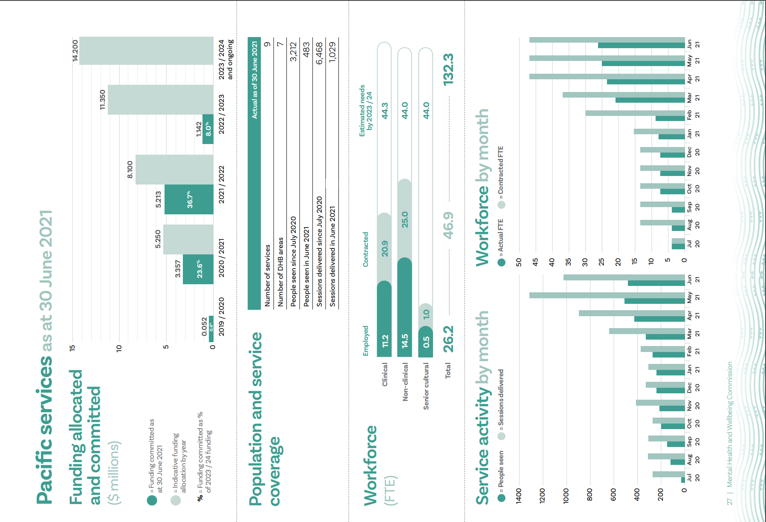

How well has the Pacific service implementation progressed?

The rollout of Pacific services is progressing well, although

implementation is behind what was intended at this time
By the end of 2023 / 24, the Ministry expects the value of funded Pacific services to be
$14.2 million annually, which represents 8 per cent (see Table 2) of the $177.5 million service delivery funding shown in Table 1.
The contracted funding commitments are behind what was anticipated by the end of June 2021. Funding committed as at 30 June 2021 is 23.6 per cent of the way towards the indicative funding allocation of $14.2 million annually from 2023 / 24.

The rollout of Pacific services has been limited by the lack of successful responses to the RFP process in some areas, such as Hawke’s Bay and Southern DHBs, as well as the national COVID-19 pandemic during 2020.
Given the delays with contracting, procurement processes are still in progress and the Ministry anticipates being back on track by June 2022.
As with Kaupapa Māori services, it is important to note that the drop in funding committed from $5.213 million to $1.142 million in 2022 / 23 is a result of some of the earlier contracts ending in 2021 / 22. These contracts will undergo renewal processes, whereas IPMHA services have just been
re-contracted for a two-year term.

- | Access and Choice Programme Report

Nine Pacific services have been contracted across seven districts
The Ministry has intentionally targeted the areas with the highest Pacific populations and does not intend to commission Pacific services in every district.
There were no detailed planning assumptions for Pacific services, apart from the intended funding allocations, which has made it difficult to determine whether they
are on track.
The infographic on page 28 shows service coverage, including people seen and sessions delivered. As noted for other services, the people seen in one month may include some individuals being seen more than once, and some individuals being seen in numerous months. Therefore, the ‘people seen’ numbers will be overstated. The infographic shows the people seen and sessions delivered by month using the data reported by providers of Pacific services to the Ministry. Even overstated, this information is useful to show the increasing activity of services and the progress in rollout.
Between July 2020 and June 2021, 6,468 sessions were delivered, with significant increases in the last few months. This is consistent with the increase in employed staff also shown.

Workforce recruitment is a challenge
As with Kaupapa Māori services, there is a large gap between the number of staff contracted and the number of staff employed, with 56 per cent of contracted FTEs employed as of 30 June 2021. The size of this gap has been consistent since October 2020.
By June 2021, there were:
- 20.9 contracted clinical FTE and 11.2 employed
- 25 contracted non-clinical FTE and 14.5 employed
- 1 contracted cultural FTE and
0.5 FTE employed.
The Pacific services workforce gaps should not be ignored, and monitoring is needed to see whether this also occurs for other Pacific services, and whether more active support is required across the system.

- | Mental Health and Wellbeing Commission

Youth services

What are Youth Primary Mental Health and Addiction services?

These are services for people aged 12-24 years. They aim to build resilience and confidence, support wellbeing and development, and offer clinical interventions when required
Youth services are those that address the needs of young people aged 12-24 years who are experiencing a mild to moderate level of distress. These services are for any young person whose thoughts, feelings, or actions are impacting on their health and wellbeing. Priority groups for Youth services include:
- rangatahi Māori
- rainbow youth (Youth services includes a Rainbow stream)
- Pacific youth
- young people who are former refugees or migrants
- other groups known to experience inequities.
Youth services contribute towards the following strategic outcomes:
- increased access and equity of access for young people
- increased choice in addressing people’s holistic needs for young people
- reduced wait times for young people
- improved outcomes and quality of outcomes for young people.

The services aim to build resilience and confidence, support wellbeing and development, and offer clinical level
interventions so young people can better manage their mental health or reduce their alcohol or drug use (or both).
Youth services are free, have no entry barriers or criteria, and are often the first point of contact for young people who are not eligible for secondary services. They are offered face-to-face in settings that are acceptable to young people, such as schools, marae, and youth health services; virtually; or a combination of these. The services connect youth to other NGOs, cultural, social, and health supports as well as primary care and secondary services as and when needed. They also meet the developmental needs of young people and their whānau (where appropriate).
Youth services include:
  - evidence-informed therapeutic interventions
  - self-management support / self-management education
  - culturally specific interventions
  - peer support
  - access to social supports.

- | Access and Choice Programme Report

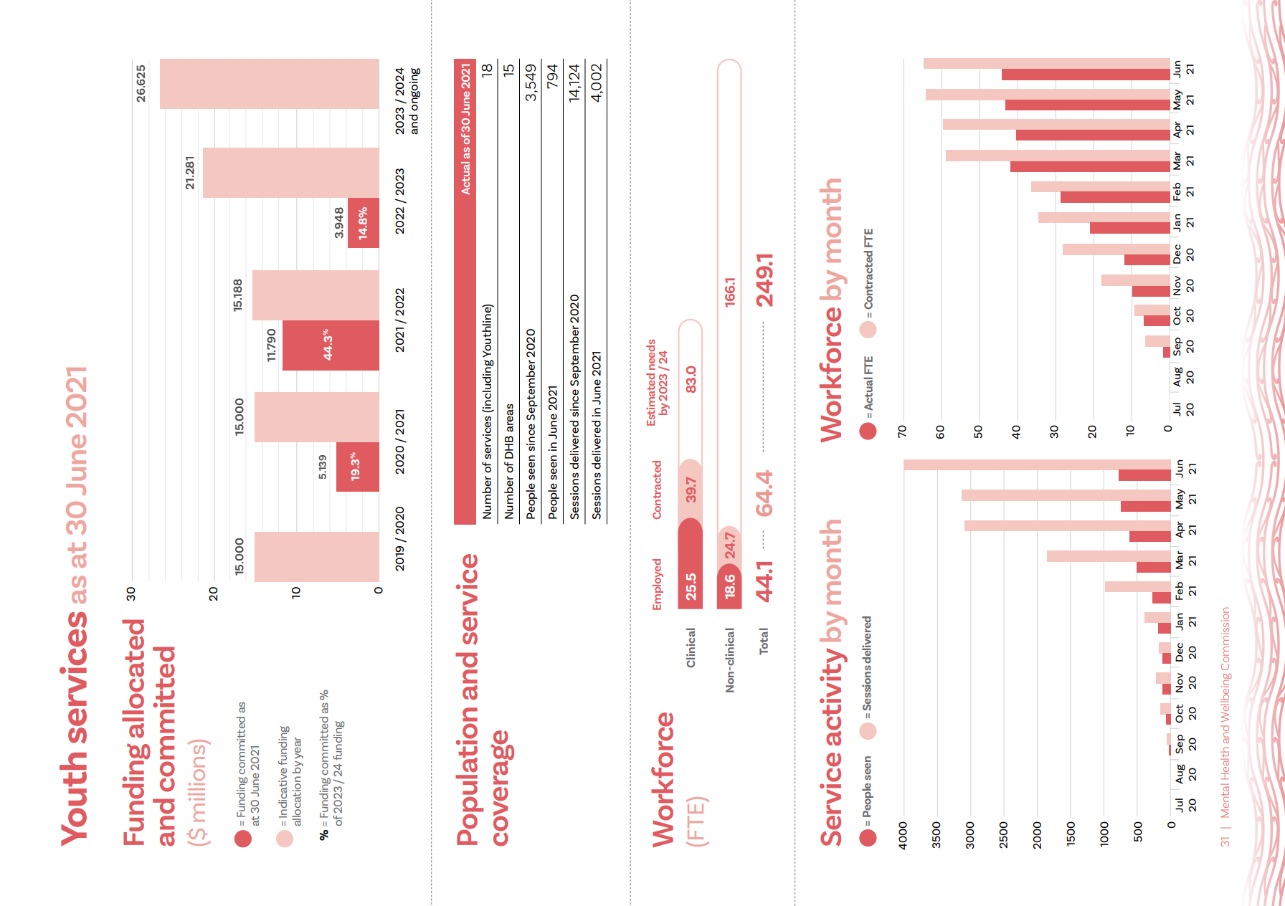

The design of the services was informed by 400 responses to a survey about youth mental health and addiction support preferences
In October 2019, Te Manatū Whakahiato Taiohi / the Ministry of Youth Development engaged with over 1,200 rangatahi on the development of the Youth Action Plan. Of these, over 600 participated in a workshop and 655 filled in an online survey. Feedback gathered through this engagement process was used to inform the core elements and features of the Youth services. This engagement included over 400 responses to a survey question about preferred mental health and addiction support options.
Youth services are commissioned directly by the Ministry through contestable processes. In some instances, the successful application was a collaborative of providers led by the local DHB.

There are services designed specifically for rainbow young people
This expands the range of mental health and wellbeing support available to rainbow young people experiencing mild to moderate distress, and provides early intervention to support them. Rainbow Youth services are promoting protective factors that are needed for good mental health and wellbeing, including responsive interventions, community connections, healthy and supportive relationships, whānau understanding, and a positive sense of identity.

How well has the Youth service implementation progressed?

The rollout of the new Youth services is progressing well, although the contracted funding is behind schedule
By the end of 2023 / 24, the Ministry expects the value of funded Youth services to be
$26.625 million annually, which represents 15 per cent (see Table 2) of the $177.5 million service delivery funding shown in Table 1. The commissioning of these services is behind, with less funding committed than intended by June 2021. Funding committed as at 30 June 2021 is 19.3 per cent of the way towards the indicative funding allocation of $26.625 million annually from 2023 / 24. However, considerably more funding is expected to be contracted in the current 2021 / 22 year.
As with Kaupapa Māori and Pacific services, it is important to note that the drop in funding committed from $11.790 million to $3.948 million in 2022 / 23 is a result of some of the earlier contracts ending in 2021 / 22. These contracts will undergo renewal processes, whereas IPMHA services have just been
re-contracted for a two-year term.

Eighteen Youth services have been contracted across fifteen districts
As of 30 June 2021, 18 Youth services have been contracted across 15 DHBs, including the expansion of the national Youthline helpline. The only data we can assess progress against is the funding committed and the number of districts with a service. There were no planned targets for the number of young people seen or number of services to measure progress for Youth services as of 30 June 2021. This means it is not possible to determine whether these services are on track.
The infographic on page 32 shows service coverage, including people seen and sessions delivered by month using the data reported by providers of Youth services to the Ministry.
Given the high number of sessions delivered compared to people seen, it is clear individuals are being seen many times in each month. It is also likely some individuals will be seen in numerous months.
Between September 2020 and June 2021, 14,124 sessions were delivered, with significant increases in the last few months which is consistent with the increase in employed staff also shown. The rapid growth in the services since January 2021 is promising.

The recruitment of workforce remains challenging
The infographic on page 32 shows the progress in employing staff to fill the job vacancies for the contracted services. By June 2021, 68 per cent of contracted FTEs were employed, with:
- 39.7 contracted clinical FTE and
25.5 employed
- 24.7 contracted non-clinical FTE and
18.6 employed.
Between March and June 2021, the actual staff employed in services has remained constant, and contracted (funded) staff numbers have increased slightly. It is concerning to see there has not been any decrease in the gap between funded and employed staff over this period.

Workforce development

The Access and Choice programme includes almost

$100 million over five years to grow the primary mental health and addiction workforce
The investment is intended to support the development of a resilient, diverse, and skilled workforce, both within the Access and Choice services and across the wider sector.
The Ministry has prioritised three areas of mental health and addiction workforce development:
  - grow the existing workforce across professional groups
  - create and develop new workforces
  - transform the existing workforce through the development of new skills and competencies to align with new service delivery models.

What has been delivered by 30 June 2021?
Funding committed for workforce development of $12.390 million is behind the intended allocation of $18.186 million for 2020 / 21. Table 4 below shows the investment each year and amounts contracted for the three priority areas.

Table 4: Comparison of funding allocation, and funding committed, as at 30 June 2021

Workforce development  ($ millions) | 2019 / 20 | 2020 / 21 | 2021 / 22 | 2022 / 23 | 4-year totals | 2023 / 24  and ongoing | 5-year  totals
Working allocation | 13.888 | 18.186 | 22.330 | 22.664 | 77.068 | 22.664 | 99.732
Funding committed:
Grow existing workforces | 2.853 | 3.378 | 4.722 | 4.915 | 15.868
Upskill / transform  existing workforces | 1.646 | 5.288 | 4.995 | 5.162 | 17.090
Develop new workforces | 5.094 | 3.725 | 0.000 | 0.675 | 9.494
Total committed | 9.593 | 12.390 | 9.716 | 10.752 | 42.451

Table 5 shows details of the total investment and the outputs for each of the three priority areas to 30 June 2021. The table does not show the funding associated with each initiative because the Ministry has advised this information is commercially sensitive.

Table 5: Progress to date on workforce development
Programme | Workforce  investment to 30  June 2021 | Delivery partners
Grow existing workforces | $6.231 million
Additional New Entry to Specialist Practice places each year for nurses, social workers, and occupational therapists to practice in mental health and addiction. | 2021 total: 103  Nursing: 82  Allied: 21 | Te Pou coordinating across a range of education providers
Additional clinical psychology internships each year. | 8 per annum (bringing total supported internships to 20) | DHBs and NGOs that offer intern placements
New bursaries for Māori students pursuing a career in mental health and addiction through the Te Rau Puawai programme at Massey University.¹⁵ | 46 | Massey University
Scholarships for Pacific students pursuing a career in mental health and addiction through Le Va Futures that Work scholarships.¹⁶ | 30 | Le Va
New national Nurse Practitioner Training Programme that aims to increase the currently low numbers of Nurse Practitioners specialising in mental health and addiction over time, and to lift the ability of all Nurse Practitioners to respond to mental health and addiction needs. | 50 places | University of Auckland in partnership with Victoria University of Wellington and University of Otago
Upskill / transform existing workforces | $6.933 million
New training places for mental health practitioners to upskill with post-graduate training in Cognitive Behavioural Therapy; core skills for specialist practice in infant, child, and adolescent mental health and addiction; and assessment and management of coexisting substance use and mental health. | 71 in 2021 | Te Pou coordinating across a range of education providers
New places for primary care nurses to achieve credentials in mental health and addiction. | 200 in 2021 | College of Mental Health Nurses in partnership with Te Pou
New places per annum for Māori and Pacific cultural competence training. | 800 | Te Rau Ora  Le Va
A new programme to support Nurse Practitioners and Enrolled Nurses with a substantive mental health and addiction role into employment with health providers. |  | University of Auckland

15 https://www.massey.ac.nz/student-life/m%C4%81ori-at-massey/he-ringa-%C4%81whina-tauira- m%C4%81ori/te-rau-puawai-m%C4%81ori-mental-health-workforce-development-programme/
16 https://www.leva.co.nz/training-education/scholarships/

34 | Mental Health and Wellbeing Commission

Programme | Workforce  investment to 30  June 2021 | Delivery partners
Training to support the mental health and addiction workforce to better respond to the needs of rainbow communities. | 450 training hours per annum | InsideOUT
Expanding mental health and addiction literacy training available to cross-sector workforces and communities with the expansion of Mental Health 101 (MH101) and Addiction 101 (A101) training programmes. | 80 additional MH101 workshops per annum  80 additional A101 workshops per annum | Blueprint
Develop new workforces | $8.819 million
Health Improvement Practitioner (HIP) and health coach training:  Te Pou has been leading HIP training¹⁷ since February 2020 and co-ordinates the delivery of health coach training. The health coach training¹⁸ programmes are delivered through two training providers, Tāmaki Health and Health Literacy NZ in cohorts of 10-12 people. HIP training is delivered by experienced HIPs who have undergone ‘train the trainer’ training.  In addition to establishing HIP and health coach training, additional funding for supervision and mentoring for these new workforces within general practice settings is also being provided through new ‘clinical lead’ roles.  This programme of work also includes work to develop training modules for support workers who are working in primary care settings, including IPMHA services. | Approx. 200 HIPs trained as at the end of June 2021  Approx. 209 HCs trained as at the end of June 2021 | Te Pou  Health Literacy New Zealand  Tamaki Health  PHOs

17 https://www.tepou.co.nz/initiatives/integrated-primary-mental-health-and-addiction/health-improvement-practitioners-in-new-zealand
- https://www.tepou.co.nz/initiatives/integrated-primary-mental-health-and-addiction/health-coaching

35 | Access and Choice Programme Report

The models of care and workforce approaches are evolving alongside the establishment of the new services in primary and community-based settings. Future workforce development investments are targeted at building a workforce with the skills and competencies to support an integrated wellbeing approach across settings. It includes specific support for the Kaiāwhina,19 peer, and cultural workforces.
The next phase of investment is targeted across five focus areas:
- Supporting Kaiāwhina and peer workforces into new mental health and addiction roles
- development and delivery of knowledge and skills training across Kaupapa Māori, Pacific, and youth settings
- development and delivery of training in talking therapies for mental health and addiction professionals
- targeted investment including psychology, counselling, pharmacists, and youth peer workforces
- continued investment in mental health and addiction workforce initiatives.

We have requested more detailed information on workforce development funding commitments
We requested a detailed financial breakdown of the workforce development investment.
However, to date we have received aggregated information of the total spend for the workforce development programme and
the three priority areas. This is disappointing as it is an area that the mental health and addiction sector have expressed a strong interest in given its importance for the successful delivery of the new services.
The Ministry advised it was not able to provide a detailed financial breakdown of the workforce development investment due to its focus on the COVID-19 response during late August and September 2021. It
has also informed us some of the information is commercially sensitive so there were additional steps to be undertaken before determining whether this data could
be released.
We will continue to request the detailed information and intend to provide more complete information on the Access and Choice workforce development funding once we receive it.

19 Kaiāwhina is the overarching term to describe non-regulated roles in the health and disability sector. The term does not replace the specific role titles, for example: healthcare assistant, mental health support worker.

- | Mental Health and Wellbeing Commission

Enablers

Forty-eight million has been allocated to enablers to support the programme
The Access and Choice programme includes
$48 million that has been allocated over five years to enablers that are crucial for effective delivery of the programme. These include
co-design with communities, implementation support, and reporting and monitoring systems. Enablers also include the tools and resources needed to roll out services as well as evaluations to assess the effectiveness of the programme and interventions.

Progress on enablers is slightly behind as of June 2021, but is expected to be on track by June 2022
Funding committed for enablers of $5.962 million is behind the intended allocation of
$8.250 million for 2020 / 21. Table 6 shows the investment each year and funding committed as at 30 June 2021.

Table 6: Comparison of funding allocated, and funding committed, as at June 2021
Enablers ($ millions) | 2019 / 20 | 2020 / 21 | 2021 / 22 | 2022 / 23 | 4-year totals | 2023 / 24 and ongoing | 5-year totals
Funding allocated | 9.250 | 8.250 | 10.050 | 11.550 | 39.100 | 9.050 | 48.150
Funding committed as at 30 June 2021 | 2.511 | 5.962 | 9.487 | 2.609 | 20.569

The funding for Access and Choice enablers covers programmes both within and external to the Ministry

Table 7 shows the funding commitments across different enabler groups within the Ministry and within the wider sector.

Table 7: Breakdown of funding commitments across different enablers
Within the Ministry:
4-year totals
2021 / 22 2022 / 23
2019 / 20 2020 / 21
Funding committed ($ millions) as at 30 June 2021
Uplift implementation capacity 1.750 1.750 2.050 2.050 7.600
Evaluation 0.050 0.249 0.400 0.180 0.879
Data and reporting 0.000 0.192 0.150 0.000 0.341
Subtotal 1.800 2.191 2.600 2.230 8.820
Within the wider sector:

Shared learning / leadership development, implementation supports, and hui
0.711 0.772 0.872 0.379 2.734

DHB co-design and implementation support 0.000 3.000 6.015 0.000 9.015
Subtotal 0.711 3.772 6.887 0.379 11.749
Total 2.511 5.962 9.487 2.609 20.569
- | Access and Choice Programme Report

The investment into programme enablers has included service development capability,

shared learning initiatives, co-design support, and information technology
Within the Ministry, enablers funding has been used for the following purposes:
- To implement capacity and capability within the Ministry to lead and support the four streams of the programme.
- To fund a service evaluation for each of the four streams of the programme:
  - IPMHA – in progress, final report due March 2022
  - Kaupapa Māori – commissioned June 2021, final report due March 2023
  - Pacific – commissioned June 2021, final report due March 2023
  - Youth – commissioned June 2021, final evaluation report due March 2023, and final exemplar report due June 2023.
- To support the collection, storage, and analysis of service delivery data, including the development of the interim NHI-based reporting system for IPMHA services.20
Within the wider sector, enablers’ funding has been used for the following purposes:
- Shared learning and leadership development, including the establishment of Te Whāriki o Te Ara Oranga,21 a new network for giving and receiving mātauranga, and sharing ideas to improve mental health and addiction services.
- Co-design hui for the Kaupapa Māori services and the Pacific fono. The Youth services engagement was led and funded by the Ministry for Youth Development.
- Funding for each DHB to support local system transformation by facilitating collaborative re-design of existing mental health and addiction systems and then implementing prioritised changes.
There have been other smaller supports for implementation, such as procurement of licences for outcome measures, development of draft data standards for provider reporting, and development of a video to prepare general practices for IPMHA services.

20 There is considerable ongoing work to develop the information systems and support providers to be able to report and improve the information.
21 Whāriki (whariki-ao.nz): The Ministry of Health has engaged Te Pou to develop and support Whāriki and is working with the Health Quality & Safety Commission on this programme.

- | Mental Health and Wellbeing Commission

Conclusions

The size and scale of the Access and Choice

programme should not be underestimated
The Access and Choice programme has put much needed investment into primary and community care in line with many of the recommendations in He Ara Oranga. This has enabled important services to be provided.
As of 30 June 2021, there are:
- 237 IPMHA services across 16 DHBs
- 12 Kaupapa Māori services across 11 DHBs
- 9 Pacific services across 7 DHBs
- 18 Youth services across 15 DHBs, including expansion of Youthline nationally.
The programme seeks to make services available immediately when people need them, early in the course of distress, in new settings, and in many cases with a new or newly-trained workforce. These are much- needed positive changes for the sector.
This programme also seeks to strengthen connections between different parts of the sector through requiring services to connect and work collaboratively with social care and other agencies.
The establishment of ‘Collaboratives’ for IPMHA services is a positive step towards improved integration of services across the sector; however, we saw little evidence of improvement in the relationships between primary mental health and addiction services, and specialist services. There is a need for more work in this area to ensure services respond collaboratively to the changing levels of support needs.

The establishment of new Kaupapa Māori, Pacific, and Youth services in community settings is a positive step
The programme involved the establishment of new Kaupapa Māori mental health and addiction services with strong te ao Māori and mātauranga Māori philosophies and delivery approaches. Similarly, the development of specific Pacific services and Youth services outside of traditional primary care settings
is a positive addition to general practice- based services.
The ring-fencing of funding for these services is a positive step and well-aligned to what communities called for through
He Ara Oranga.

The lack of detailed planning makes it difficult to assess progress
There were key assumptions used to determine the Government funding bid for this programme. These included the cumulative number of people accessing
services each year, the intensity of the service needed by groups of people along with an approximate cost, and indicative percentage allocations for ongoing service delivery funding for priority populations from
2023 / 24.
While the expected uptake of the services by people and the percentage population allocations did inform implementation planning, other assumptions have not been used for the programme’s implementation planning.

There is a programme goal for 2023 / 24 onwards of 325,000 people accessing the services across all four streams, and there are indicative percentage funding allocations for specific populations from 2023 / 24.
However, we have been advised there are no specified annual programme implementation targets at the service level for people seen or sessions delivered, population coverage, or DHB coverage.
Thus, we have looked at funding commitments relative to indicative funding allocated (with the focus on the 2023 / 24 ongoing funding path), workforce recruitment, and uptake of services at an aggregate level to assess progress.
While we acknowledge that very detailed planning may constrain co-design, the absence of national planning intentions at the service level makes it difficult to assess service-level progress, and hard to determine whether services are performing as expected as the programme rolls out. We would like to see more national planning intentions in future to allow more detailed monitoring of progress.

Many aspects of the programme are progressing well, but Kaupapa Māori, Pacific, and Youth services are behind what was expected at this time
Overall, the programme is progressing well with respect to the population coverage and people seen at the end of June 2021. The progress on rollout of the IPMHA services is
ahead of expectations with respect to funding commitments. Conversely, the rollout of Kaupapa Māori, Pacific, and Youth services is behind what was intended for this stage in the programme, with respect to funding commitments.
As noted above, the lack of detailed planning assumptions by service type makes it hard to assess how well each service area is performing with respect to people seen and number of services at this point in the programme rollout.
Many Māori and non-Māori providers have expressed concerns that general population services have been implemented ahead of Kaupapa Māori services. They have said this has put additional strain on some Kaupapa Māori providers who had committed to being involved in IPMHA services and then struggled to find capacity to respond to the Kaupapa Māori-specific tender process.
We understand the pragmatic reasons for progressing the IPMHA programme, which was tried and tested. We are pleased to report that IPMHA services also prioritise services for Māori and Pacific peoples. However, we believe the Government should prioritise the development of Kaupapa Māori and Pacific services over the general population services, given the inequities that exist for Māori and Pacific communities.

Delays in progress should be viewed in the context of the COVID-19 pandemic
The Access and Choice programme has progressed well despite being implemented during the COVID-19 pandemic; a period during which the Government has been focused on responding to the pandemic.

The commissioning for Kaupapa Māori and Pacific services began in late 2019, a few months before the COVID-19 pandemic. The pandemic impacted both the Ministry’s capacity to continue with implementation and providers’ capacity to respond. This was particularly true for Kaupapa Māori and Pacific providers, who were at the forefront of the COVID-19 community response.

General practice

co-payments may limit access for some people
The Government committed to making the Access and Choice services free. However, IPMHA services are in general practices, and an initial visit to the GP is typically required before accessing the IPMHA service. That visit will incur a fee (co-payment) in many cases.
The general practice co-payment is a barrier to people going to see their doctor. Approximately 17 per cent of the population report not visiting a GP or nurse in 2018-19 because of cost.22 Furthermore, 37 percent of those aged 15–24 years report cost as a barrier to visiting their GP or nurse. This increases again to 43 per cent for people in that age group who are Māori or live with any long-term condition (Health Quality & Safety Commission, 2020).23
We have concerns that the IPMHA services are not completely free, and while many people have accessed the services, this may not include people who find co-payment a barrier to visiting general practice. This presents a significant equity issue, and we encourage any expansion of the programme to address this issue.

There is a strong focus on improving data
There are currently significant gaps in the data sets that prevent us from undertaking a more robust analysis of the programme. For example, the outcome data for the early stages of the programme was recorded manually or in separate databases and is not able to be collated and included in the analysis for this report. Similarly, we only had access to five months of demographic data for IPMHA services, so we are not able to confidently report on the characteristics of people accessing those services.
These gaps are not unexpected for a new set of primary mental health and addiction services, many of which are provided by grassroots providers who are not linked to
national data systems. We are pleased to see the considerable work going into developing national information systems and the support being given to providers to improve their reporting and data capabilities.

Workforce capacity and workforce development requires ongoing attention
It is important to differentiate between the investment in workforce expansion (the funding of additional people and roles in services) and the investment in workforce development (the training and development of current and new workforce).
Workforce capacity is an ongoing issue for the mental health and addiction sector and the expansion of workforce through this programme is a positive step. However, the

22 New Zealand primary care patient experience survey question ‘In the last 12 months was there a time when you did not visit a GP or nurse because of cost?’ Health Quality & Safety Commission’s Atlas domain ‘Health service access’ (2018-19).
23 https://www.hqsc.govt.nz/our-programmes/health-quality-evaluation/projects/atlas-of-healthcare- variation/health-service-access/

41 | Access and Choice Programme Report

ongoing demand for a registered clinical workforce remains a problem for recruitment to HIP roles. Despite the funding of additional roles, there are gaps across all workforce roles and service types. It is reassuring to see the work underway to increase workforce capacity through additional training places, internships, bursaries and scholarships, funded through the workforce development initiatives. Kaupapa Māori and Pacific services have particularly large workforce gaps, and we expect to see considerable effort in addressing those service needs with the workforce development initiatives.
We are disappointed that the peer support workforce is not a core component of all services within the Access and Choice programme. Peers are a valuable and underutilised workforce, that bring an important recovery skill set to services and could help address the significant workforce gaps.
While we have been able to report on staff (FTE) numbers, and the number of people trained, we have not had the information we need to report on what funding was applied to specific workforce development initiatives.
As noted above, we have heard from the mental health and addiction sector that they are concerned and interested in the allocation of the workforce development funding, and we hope to be able to receive and report on this information soon.

Ongoing investment is needed to respond to the recommendations and vision of He Ara Oranga
The Access and Choice programme is only one part of the Government’s response to He Ara Oranga, and more investment is needed to meet the broader recommendations of He Ara Oranga, and the needs of communities.
We strongly encourage the Government to invest in the peer workforce – this workforce is key to putting people at the centre and was central to the vision and recommendations in He Ara Oranga.
We are also aware of the ongoing pressures across the continuum of mental health and addiction services. We encourage further investment to expand the choice of services available in the community outside conventional clinical settings, including services to meet the needs of people experiencing acute distress.
Further, with any new investment it is critical that service design is undertaken in
collaboration with communities as was called for in He Ara Oranga.

References
Appleton-Dyer S, Andrews S. 2018. Fit for the Future: An Evaluation Overview for the Enhanced Integrated Practice Teams and Our Health in Mind Strategy (Business Case One): Report for the Ministry of Health. New Zealand: Synergia. https://synergia.consulting/news/fit-for-the-future-evaluation/ (accessed October 5, 2021).
Appleton-Dyer S, Andrews S, Reynolds J, Henderson G, Anasari Z. 2018. Fit for the Future: Evaluating Enhanced Integrated Practice Teams: A Report for the Ministry of Health. New Zealand: Synergia. https://static1.squarespace.com/static/57a93203d482e9bbf1760336/t/5c09b5f58a922de1eafd8235/1544140300132/ Synergia+ADHB+FftF+Enhanced+integrated+practice+teams+evaluation+FINAL+1. pdf (accessed October 5, 2021).
Awa Associates. 2019. Ngai Māori Insights for a Kaupapa Māori Primary (Community) Mental Health and Addictions Service Model: The Analysis. Wellington: Ministry of Health. https:// www.health.govt.nz/publication/ngai-maori-insights-kaupapa-maori-primary-community- mental-health-and-addictions-service-model (accessed October 5, 2021).
Government Inquiry into Mental Health and Addiction. 2018. He Ara Oranga: Report of the Government Inquiry into Mental Health and Addiction. New Zealand: Government Inquiry into Mental Health and Addiction. https://mentalhealth.inquiry.govt.nz/inquiry-report/he-ara- oranga/ (accessed October 5, 2021).
Health Practitioners Competence Assurance Act 2003.
Health Quality & Safety Commission. 2020. Health Service Access. New Zealand: Health Quality & Safety Commission. https://www.hqsc.govt.nz/our-programmes/health-quality-evaluation/ projects/atlas-of-healthcare-variation/health-service-access/ (accessed October 5, 2021).
Initial Mental Health and Wellbeing Commission. 2021. Mā Te Rongo Ake: Through Listening and Hearing. Wellington: The Initial Mental Health and Wellbeing Commission. https://www.mhwc. govt.nz/the-initial-commission/progress-reporting/ (accessed October 5, 2021). Mental Health and Wellbeing Commission Act 2020.

