COVID-19 Impact Insights Paper #1

Media reporting of COVID-19 and mental health and wellbeing

October 2022
Te Hiringa Mahara, the Mental Health and Wellbeing Commission, is studying the impact of the COVID-19 pandemic on wellbeing in Aotearoa.
This paper is the first in a series of eight short, focused insights reports that will highlight key elements of the wellbeing impacts of the pandemic in Aotearoa.
In this first paper, Te Hiringa Mahara looks at what aspects of mental health and wellbeing have been reflected most in media coverage of Covid-19 in Aotearoa. The findings of this study will help shape the ongoing research in the series, by identifying gaps in the current popular narrative, and the facets of wellbeing that are neglected.

The study
News media plays an important role in Aotearoa, in both shaping and reflecting the views of the nation. During the pandemic, this role has been as important as ever – leading our national conversation on the pandemic and sharing important information to keep Aotearoa safe.
Using publicly available media articles, we have investigated themes in media coverage by mainstream news media during the pandemic. Through this, we aimed to answer two research questions:
- What are the broad themes reported by New Zealand mainstream news media relating to the impact of COVID-19 pandemic on mental health, since the outbreak in March 2020?
- Have those themes, and their relative prevalence, evolved over time?
For greater detail on the methodology and findings, please see our technical paper [1].
To collect the data for this analysis, we ‘scraped’ written news articles from reputable online media sources that covered both Covid-19 and mental health topics. The search was limited to online content written in English and published between 1 March 2020 and 30 April 2022.
Retaining only articles of relevant content with special target words, our search resulted in 3374 news articles that draw from 171 reputable news sources. These were analysed, using natural language processing methodology, to identify the main themes present over time.
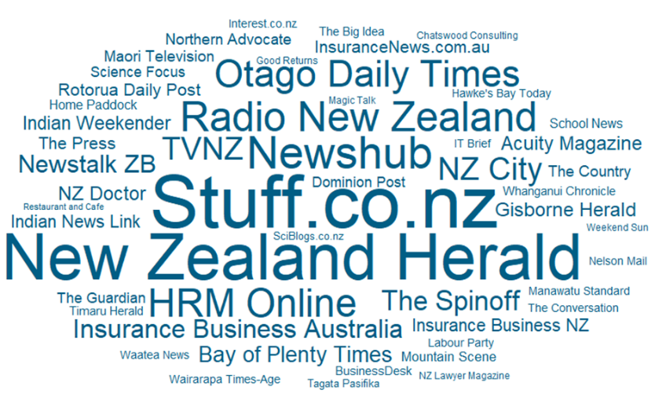
We distilled the media coverage into four phases as defined by the New Zealand Government’s COVID-19 response to the outbreak since March 2020, using the timeline of key events published by the Ministry of Health as a reference.
Figure 1: Article sources, by prevalence
The four phases were:
- Mitigation, March 2020 to April 2020;
- Elimination, May 2020 to July 2021;
- Containment, August 2021 to November 2021;
- Endurance, December 2021 to April 2022

The findings
The study has identified 9 broad themes and 6 sub-themes that describe the impacts of the Covid-19 pandemic on mental health in New Zealand:
- Media coverage on the mental health problems contributed to by the pandemic has been concentrated on the changes to people’s work, education, and lifestyle, the material impacts of this, and loneliness.
- Media coverage on the mental health solutions has focused on resources, chiefly access to services, supports, and resources.
- Distress and other impacts of the pandemic have frequently been normalised and universalised in media coverage.
Figure 2: Coverage themes and prevalence
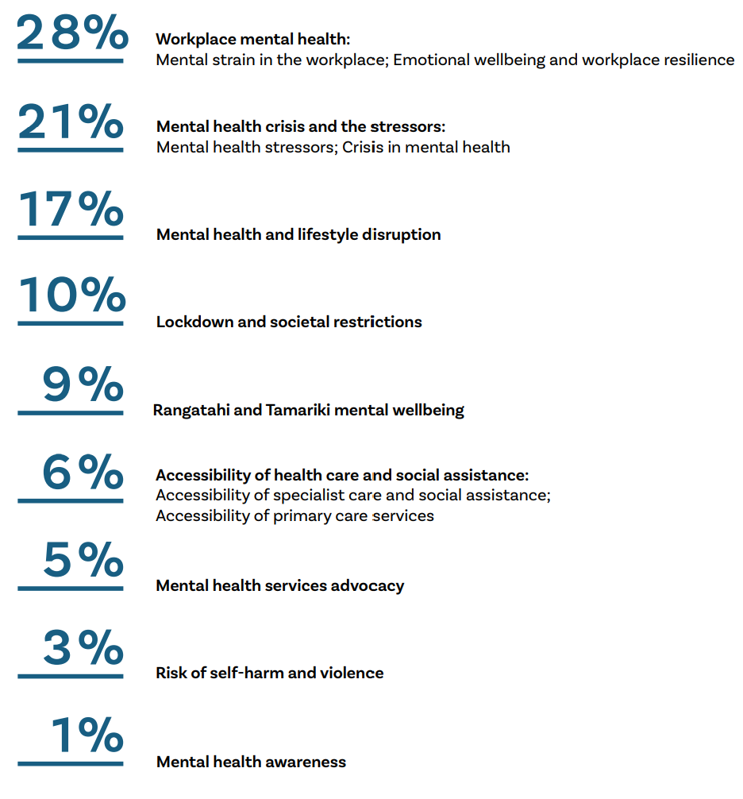

Given the moving nature of the pandemic globally, and the evolving government responses locally, news media narratives shifted during the pandemic. The intensity of media coverage tended to rise with each new phase of the government’s pandemic response, then fall as each phase continued.
Figure 2 - Coverage themes and prevalence
Figure 3: Media coverage of mental health and COVID, over time
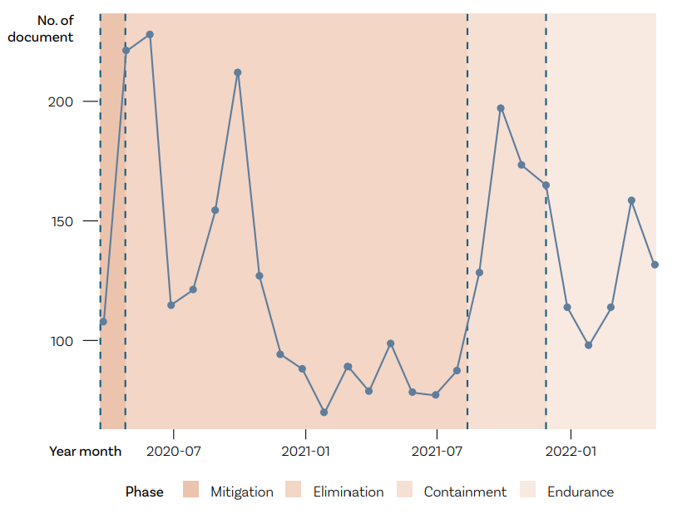

What this means
At Te Hiringa Mahara, our objective is to contribute to better and equitable mental health and wellbeing outcomes for all people in Aotearoa New Zealand.
We do this by assessing and reporting publicly, and by advocating and making recommendations for improved services and approaches. One key tool we must support this, is the He Ara Oranga Wellbeing Outcomes Framework [2], which describes the key elements of wellbeing in Aotearoa.
In general, media coverage of mental health in the pandemic has focused on the material resources and services that people have access to, and stresses that emerge when these are lacking, and life is disrupted. These are important elements, but we know there are other important wellbeing elements that relate to mental health in Aotearoa, such as:
- rights, dignity and tino rangatiratanga;
- tikanga and culture;
- whānau skills and resilience;
- connection and value; and
- having hope, purpose and community self-determination.
Our analysis shows that the way we collectively talk about mental health, as represented by media coverage, can be too narrowly focused. Mental health and wellbeing are tied together and require much more than having access to services in times of distress. Good mental health and wellbeing means having connections to our families, whānau and communities, as well as having the environment and resources we need to thrive. It means having hope and trust, and the freedom to flourish.
Further, by universalising the impacts of the pandemic, some media narratives may be counter-productive to understanding wellbeing. A sense of ‘we are all in this together’ may be beneficial for rallying together a public health response, and for encouraging empathy, however, if our understanding of the peoples’ experience of wellbeing is monolithic, we miss the opportunity to understand and subsequently support greater wellbeing for different communities.
We know that some of these elements of wellbeing were reported in the media. Examples would include expressions of self-determination and tino rangatiratanga, and community initiatives and responses to COVID-19 such as vaccine drive-ins, community hubs, and iwi boundary restrictions. However, these are not highlighted in this paper, because coverage of them was not linked to mental health or not common enough to arise as a key theme.

What we should do next
We have already seen that the pandemic has exacerbated many existing inequities – addressing these requires understanding who has been affected, and how. As we seek to understand the impacts of the pandemic, and as the public and government responses to it evolve, we need to consider what wellbeing looks like. This will help us understand the impacts of the pandemic in Aotearoa and how we can support greater wellbeing in general.

Our analysis highlights the need for:
- Greater inclusion of the broader aspects of wellbeing – including connection, hope, rights, self-expression, Māori cultural needs, and self-determination, of individuals and communities – when talking about mental health in Aotearoa. In the pandemic context, this would mean considering mental health and wellbeing much more broadly than the direct impacts on health and work.
- Recognising the different experience of different communities, and the mental health and wellbeing impacts of that. We experience wellbeing differently, based on a variety of factors; and we know that some communities experience poorer wellbeing across a range of measures. If we are to improve wellbeing for all, we need to understand it.
Over the coming year, Te Hiringa Mahara will produce a series of focused reports to contribute to the collective understanding of the wellbeing impacts of the pandemic in Aotearoa. This programme will seek to address some of the gaps identified in this analysis by examining the pandemic experiences of different parts of Aotearoa, and the impacts on the varied elements of wellbeing.
[1] https://www.mhwc.govt.nz/our-work/covid-19-insights/
[2] https://mhwc.govt.nz/our-work/he-ara-oranga-wellbeing-outcomes-framework/

