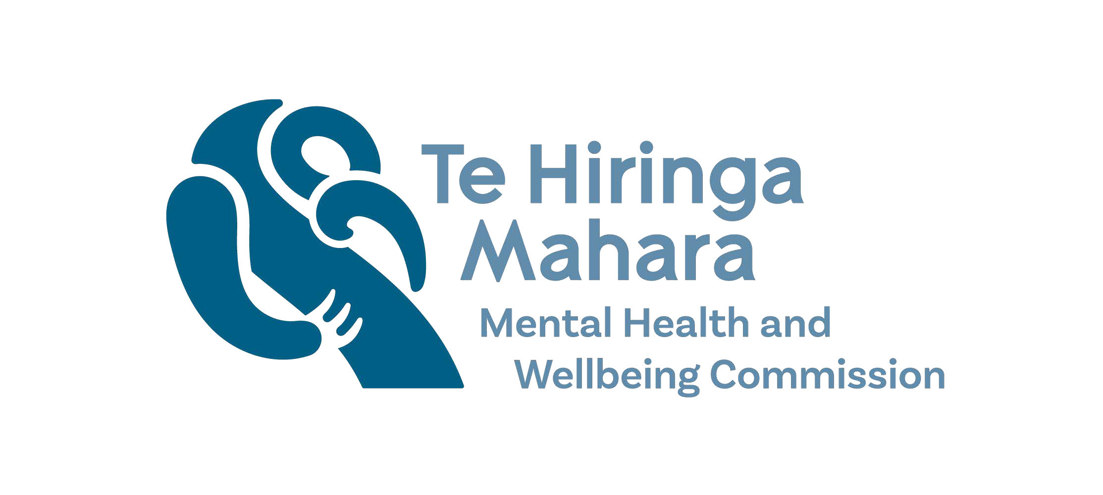
Supplementary paper: Access and Choice Programme workforce development funding – the ﬁrst three years
This paper provides supplementary information about the workforce development funding made available through the Access and Choice Programme in Budget 2019.
When we published our Access and Choice Programme: report on the ﬁrst three years in November 2022, we had received summary ﬁnancial information only from Te Whatu Ora.
In January 2023 Te Whatu Ora provided us with ﬁgures reporting how funding has been allocated across three categories. This data also showed contracted expenditure up to 2021/22.1
As the mental health and addiction sector has expressed strong interest in this area, we are publishing this information as a supplement to our 2022 report.

Background
The Access and Choice programme includes $99.7 million over ﬁve years (2019/20 to 2023/24) to grow the primary mental health and addiction workforce.
The investment is intended to support the development of a resilient, diverse, and skilled workforce within Access and Choice services. Given that there is not a separate primary mental health and addiction workforce Manatū Hauora recognised that this work would need to include the contributing and supporting mental health and addiction workforce pathways across the wider sector.
The Ministry of Health has prioritised three areas of mental health and addiction workforce development:
- grow the existing workforce across professional groups
- create and develop new workforces
- transform the existing workforce through the development of new skills and competencies to align with new service delivery models.

Funding has been consistently underspent
Table 1 shows the allocation of the $99.7 million across the ﬁve ﬁnancial years from 2019/20 to 2023/24. The table uses data provided by Te Whatu Ora in January 2023. The ﬁgures may differ from those we published in our 2021 and 2022 Access and

¹ Allocation of funding began with Manatū Hauora before transferring to Te Whatu Ora in July 2022.

Choice reports due to Te Whatu Ora’s ‘more accurate coding into the three categories and reporting of actual contracted expenditure.’
We do not have data showing the allocated funding by development area (grow, upskill, develop). The funding has been underspent each year of the programme so far (with a total underspend of $15.1 million across the three ﬁnancial years 2019/20 to 2021/22). Te Whatu Ora has advised that, in general, underspent funding has been transferred to future years for workforce development initiatives. Note that the $22.7 million of funding allocated in 2023/24 is intended to be sustained beyond 2024 to support workforce development.
Table 1 Workforce development funding ($ millions)

Workforce development | 2019/20 | 2020/21 | 2021/22 | 3-year totals | 2022/23* | 2023/24  and ongoing | 5-year totals
Funding allocated | 13.888 | 18.186 | 22.330 | 54.404 | 22.664 | 22.664 | 99.732
Contracted funding
Grow existing workforces | 4.699 | 3.390 | 6.460 | 14.549
Upskill / transform existing workforces | 3.563 | 5.270 | 7.579 | 16.412
Develop new workforces | 1.653 | 3.751 | 2.914 | 8.318
Total contracted | 9.915 | 12.411 | 16.954 | 39.280
Underspend | 3.973 | 5.775 | 5.376 | 15.124
% of allocated funding contracted | 71% | 68% | 76% | 72%
Source: Te Whatu Ora
* Data for 2022/23 is not yet available

The following three tables set out what has been contracted for each development area. Note that the contracted initiatives are shown by calendar year while the contracted funding is shown by ﬁnancial year.

Grow existing workforce
The ‘grow existing workforce’ initiatives include funding for promoting careers, training and building networks, and placement in the workforce. The total spend on these initiatives over the three years from 2019/20 to 2021/22 was $14,549,301 (37% of the workforce development funding for the three-year period). The additional new entry to specialist practice places (for nurses, social workers, and occupational therapists to practise in mental health and addiction) received 57% of the ‘grow existing workforce’ initiatives total over the three years from 2019/20 to 2021/22 ($8,265,000).
Table 2 Grow existing workforce - initiatives and contracted funding

Grow existing workforce initiatives | Delivery of initiatives |  |  |  | Contracted $ |  |  | Delivery partners | Notes
 | 2019 | 2020 | 2021 | 2022 | 2019/20 | 2020/21 | 2021/22
Additional clinical psychology internships each year |  | 8 | 8 | 16 | $249,000 | $305,000 | $1,331,198 | Health districts and NGOs that offer intern placements | The Budget 2019 funded places shown here build on the baseline funded 12 places each year. The funding also increased the price paid for the scholarships from 60% to 100% of the multi-  employer collective agreement.
Additional new entry to specialist practice places each year for nurses, social workers, and occupational therapists to practise in mental health and  addiction |  | 98 | 103 | 126 | $3,910,000 | $1,600,000 | $2,755,000 | Te Pou is co- ordinating a range of education providers | The Budget 2019 funded places shown here build on the baseline funded 191 places. Funding has been made available to ensure all eligible applicants receive a place.

Grow existing workforce initiatives | Delivery of initiatives |  |  |  | Contracted $ |  |  | Delivery partners | Notes
 | 2019 | 2020 | 2021 | 2022 | 2019/20 | 2020/21 | 2021/22
Mental Health and Addiction Nursing (2-  year) campaign |  | Campaign live |  |  |  | $500,000 | $450,000
New bursaries for Māori students pursuing a career in mental health and addiction through Te Rau Puawai programme at Massey  University |  | 46 | 46 | 70 | $240,000 | $325,000 | $457,500 | Massey University | The Budget 2019 funded places shown here build on the baseline funded 80 places.
National nurse practitioner training programme to increase numbers of nurse practitioners specialising in mental health and addiction, and to lift the ability of all nurse practitioners to respond to mental health and addiction  needs |  | 12 | 50 | 50 |  | $360,000 | $720,000 | University of Auckland in partnership with Victoria University of Wellington and University of Otago | Te Whatu Ora have committed to increasing this to 72 in 2023 and 100 in 2024 but the increase will not be Budget 19 funded.

Grow existing workforce initiatives | Delivery of initiatives |  |  |  | Contracted $ |  |  | Delivery partners | Notes
 | 2019 | 2020 | 2021 | 2022 | 2019/20 | 2020/21 | 2021/22
Psychiatry Interest Forum to support growth of Aotearoa- trained psychiatrists (focus on Māori and  Pacific peoples) |  |  |  |  |  |  | $246,603
Scholarships for Pacific students pursuing a career in mental health and addiction through Le Va Futures that Work  scholarships | 7 | 30 | 30 | 65 | $300,000 | $300,000 | $450,000 | Le Va | The Budget 2019 funded places shown here build on the baseline funded 60 places.
Scholarships to grow the number of Muslim practitioner students |  |  |  |  |  |  | $50,000 |  | This is a new programme. In 2022 scholarships were offered to Canterbury students. In 2023 these will be nationally available. The funding includes support for the development of a Muslim  Practitioner Network.

Upskill existing workforce
The ‘upskill existing workforce’ initiatives include training in Māori, Paciﬁc and Rainbow cultural competency, mental health and addiction education for pharmacists and practice nurses, and postgraduate skills training. The total spend on these upskill initiatives over the three years from 2019/20 to 2021/22 was $16,411,781 (42% of the workforce development funding for the three-year period). The initiative to expand mental health and addiction literacy hours (MH101, ADD10) and the Skills Matter postgraduate training and development received the most funding within the upskill initiatives ($5,984, 894 and $5,500,000 respectively over the three years).
Table 3 Upskill existing workforce - initiatives and contracted funding

Upskill existing workforce initiatives | Delivery of initiatives |  |  | Contracted $ |  |  | Delivery partners
 | 2020 | 2021 | 2022 | 2019/20 | 2020/21 | 2021/22
A new programme to support nurse practitioners and enrolled nurses with a substantive mental health and addiction role  into employment with health providers | 18 to 27 | 18 to 27 | 18 to 27 |  |  |  | University of Auckland
Expanding mental health and addiction literacy training available to cross-sector workforces and communities with the expansion of Mental Health 101 (MH101) and  Addiction 101 (A101) training programmes | 80 additional MH101 workshops per year, 80 additional A101 workshops per year |  |  | $1,395,880 | $2,294,507 | $2,294,507 | Withheld²
Mental Health and Addiction Education Modules for Community Pharmacy |  | 5 modules developed |  |  |  | $100,000

² Te Whatu Ora requested that the names of some delivery partners be removed due to commercial sensitivity.

Upskill existing workforce initiatives | Delivery of initiatives |  |  | Contracted $ |  |  | Delivery partners
 | 2020 | 2021 | 2022 | 2019/20 | 2020/21 | 2021/22
New places for primary care nurses to achieve credentials in mental health and addiction | 130 | 200 | 230 | $340,000 | $470,000 | $550,000 | College of Mental Health Nurses in partnership  with Te Pou
New places per year for Māori and Pacific cultural competence training | 450 | 650 | 950 | $327,500 | $405,000 | $405,000 | Withheld – Workforce Development  Centres
New training places for mental health practitioners to upskill with post-graduate training in cognitive behavioural therapy; core skills for specialist practice in infant, child, and adolescent mental health and addiction; and assessment and management of co- existing substance use and mental health | 52 | 71 | 301 | $1,500,000 | $2,000,000 | $2,211,387 | Te Pou co- ordinating across a range of education providers
Pae Tata Pae Tawhiti mātauranga Māori- centred early and brief intervention  framework |  |  |  |  |  | $150,000
Puāwai4Kaimahi (P4K) support programmes of educator-led modules and post-module follow-up sessions (starting 2022/23 financial  year) |  |  |  |  |  | $208,000

Upskill existing workforce initiatives | Delivery of initiatives |  |  | Contracted $ |  |  | Delivery partners
 | 2020 | 2021 | 2022 | 2019/20 | 2020/21 | 2021/22
Targeted Workforce Development Programmes for Budget19 Youth, Kaupapa Māori, and Pacific primary mental health and addiction services |  | 3 support programmes via workforce development centres |  |  |  | $1,510,000 | Withheld – Workforce Development Centres
Training to support the mental health and addiction workforce to better respond to the needs of Rainbow communities |  |  | 450  training hours per year |  | $100,000 | $150,000 | Withheld

Develop new workforce
The ‘develop new workforce’ initiatives are focused on the Access and Choice integrated primary mental health and addiction services. The total spend on the ‘develop new’ initiatives over the three years from 2019/20 to 2021/22 was $8,318,464 (21% of the workforce development funding for the three-year period). The initiatives directly related to Access and Choice programmes received 97% of the ‘develop new’ funding ($8,034,644 over the three years).
Table 4 Develop new workforce - initiatives and contracted funding

Develop new workforce | Delivery of initiatives |  |  | Contracted $ |  |  | Delivery partners
 | 2020 | 2021 | 2022 | 2019/20 | 2020/21 | 2021/22
Assistant psychology feasibility report |  |  | Report |  |  | $20,980
Establishing health improvement practitioner and health coach training. Funding is also provided for supervision and mentoring for these new workforces in GP settings through new ‘clinical lead’ roles. This programme includes work to develop training modules for support workers in primary care settings including IPMHA services. | 252 | 358 | 167* | $1,652,979 | $3,723,167 | $2,158,648 | Te Pou has been leading HIP training since Feb 2020 and co-ordinates the delivery of health coach training. Training programmes are delivered through two training providers: Tāmaki Health and Health Literacy NZ, in  cohorts of 10–12 people.

Develop new workforce | Delivery of initiatives |  |  | Contracted $ |  |  | Delivery partners
 | 2020 | 2021 | 2022 | 2019/20 | 2020/21 | 2021/22
Support for youth peer and youth advisory development. |  |  |  |  |  | $499,850 | Withheld
Support for counselling mental health  and addiction accreditation process and membership management |  |  | 2 counselling associations |  | $27,840 | $235,000
* Partial year to June 2022.

