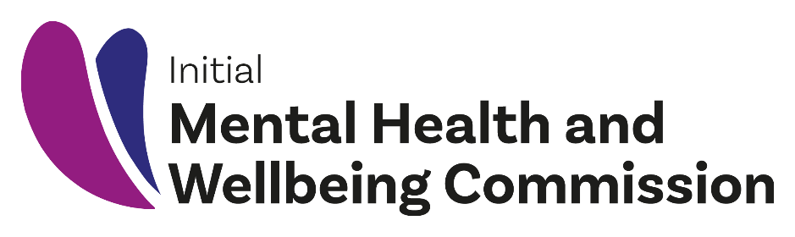

Mā Te Rongo Ake /
Through Listening and Hearing
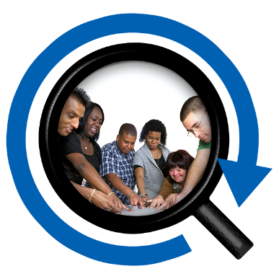

A report from the Initial Mental Health and Wellbeing Commission to the Minister of Health

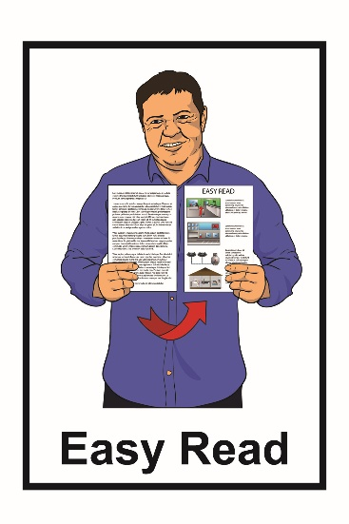
February 2021

What is in this book

Page number:
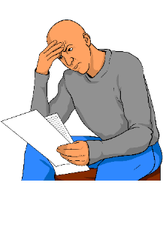
Before you start…………...……3

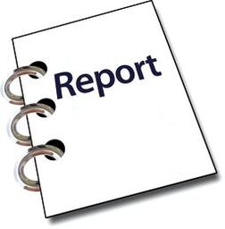
About this report..……..….……4

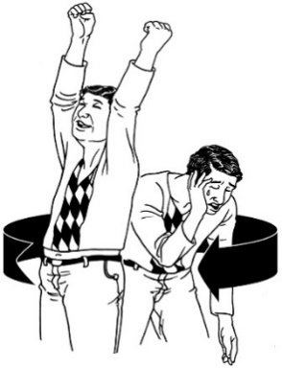
Mental health and addiction......5

The He Ara Oranga report........9

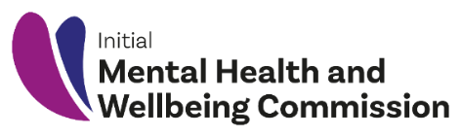
The Initial Mental Health and Wellbeing Commission……....11

What has happened so far…14

Who the Commission
talked to………………………..16
Page number:

What the Commission asked..18

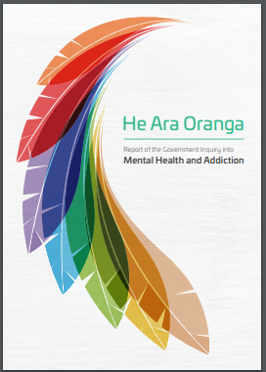
What the government is doing
to make He Ara Oranga happen…………………………19

What people told us…………22
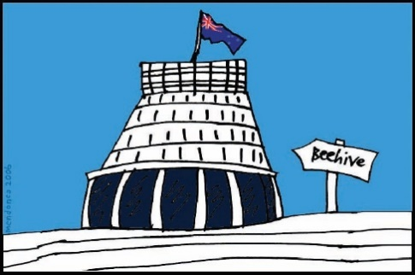

Our advice for
the government……………….25

Where to find
more information……………...27

Before you start

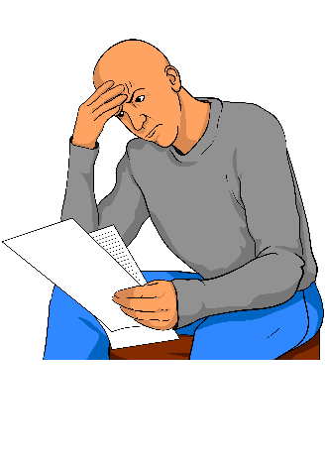
This is a long document.

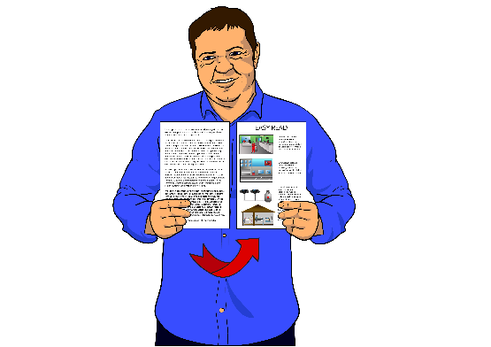
While it is written in Easy Read it can be hard for some people to read a document this long.

Some things you can do to make it easier are:

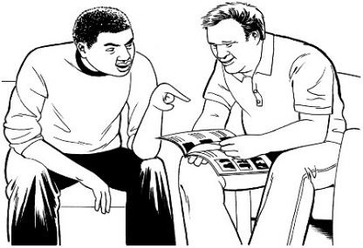
• read it a few pages at a time

• have someone help you to understand it.

About this report

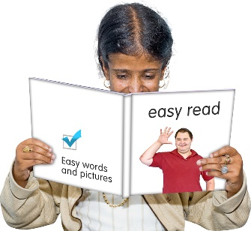
This is an Easy Read document about a report called Mā Te Rongo Ake / Through Listening and Hearing.

The report is about:

- mental health and addiction

- the He Ara Oranga report

- what people told the Initial Mental Health and Wellbeing Commission.

In this document we will explain what all of the words in the list above mean.

Mental health and addiction
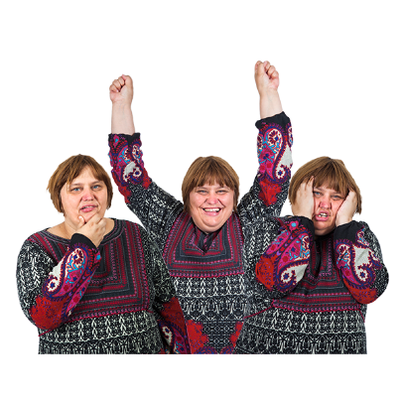

Mental health is about how you feel.

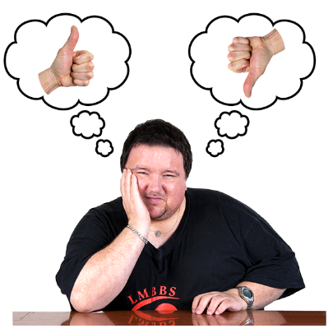
The feelings you have can change:

- how you think about things

- the things you do.

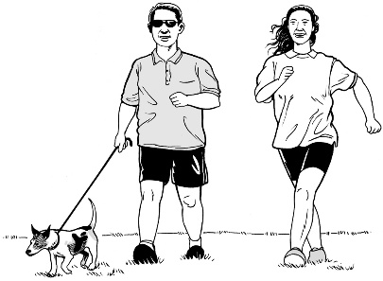
When you feel good you can enjoy the everyday things you do.

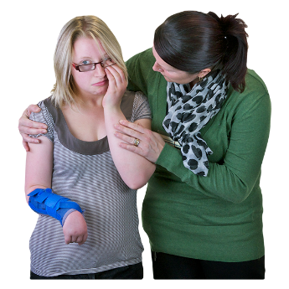
When you do not feel good it can be hard to do these things.

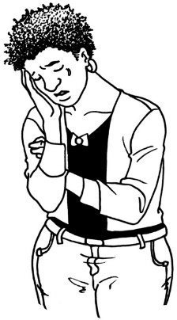
Having a mental illness means having conditions like:

- depression

- anxiety

- bipolar disorder

- schizophrenia

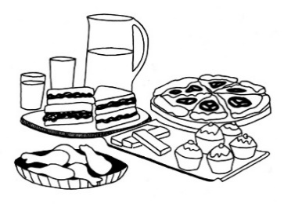
- post traumatic stress disorder

- eating disorders.

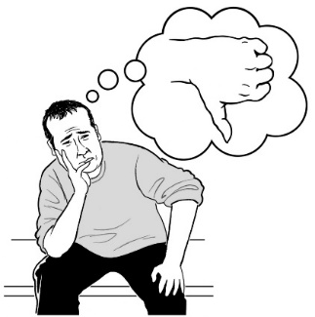
There are many other conditions.

These are just some of them.

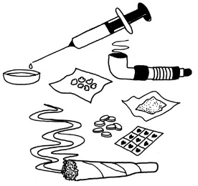
Addiction means not being able to stop yourself from doing things like:

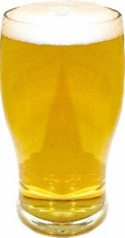
- using drugs

- drinking alcohol

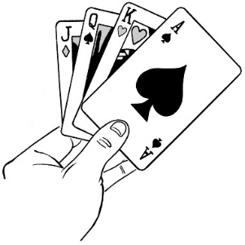
- gambling money – like:

  - betting on the horse racing

  - going to a casino.

There are many other things that people can be addicted to.

These are just some of them.

20 percent of people in New Zealand live with:

- mental health issues

- addiction.

20 percent is the same as 1 in five people.
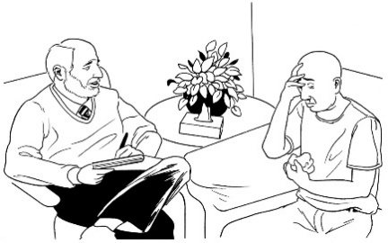

Many of these people do not ask for support.

The He Ara Oranga report

In 2018 the Government looked at what it is like for people living with:

- mental health

- addiction.

In 2018 there was a report called He Ara Oranga.

The report made 40 recommendations to the Government of what needs to change so mental health services can support everyone.
Recommendations are things that should be done.

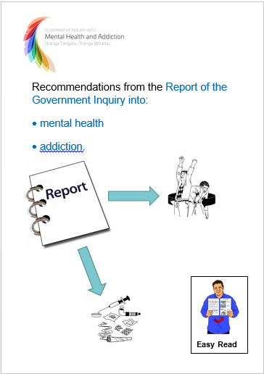
There is an Easy Read document about the recommendations from the
He Ara Oranga report.

You can find the Easy Read document on this website:

https://mentalhealth.inquiry.govt.nz/inquiry-report/recommendations-easy-read/

1 of the recommendations from the He Ara Oranga report was to set up a Mental Health and Wellbeing Commission.

The Initial Mental Health and Wellbeing Commission

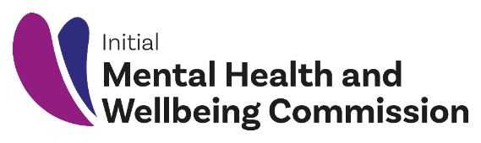
Initial means that a group of people have come together to start the work of the Mental Health and Wellbeing Commission.

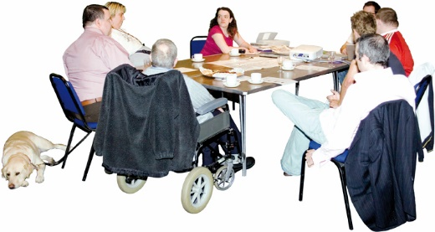
A Commission is a group of people the government asks to look after something.

In this document we will call the Mental Health and Wellbeing Commission the Commission.

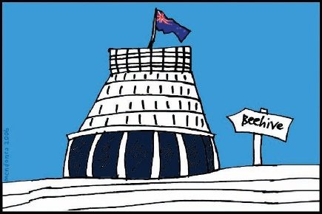
The Commission will tell the Government and people:
- what is happening with mental health services in New Zealand
  - what changes are needed to make things work better.

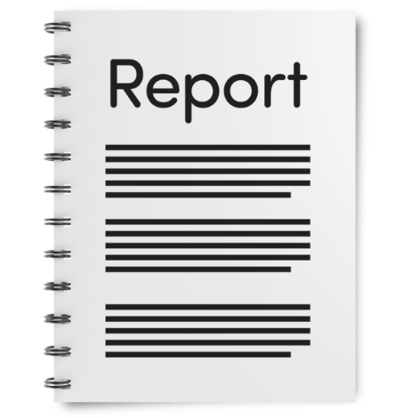
The Commission has written a report called:

Mā Te Rongo Ake / Through Listening And Hearing.

The report looks at how things are going with putting in place the recommendations that were in He Ara Oranga.

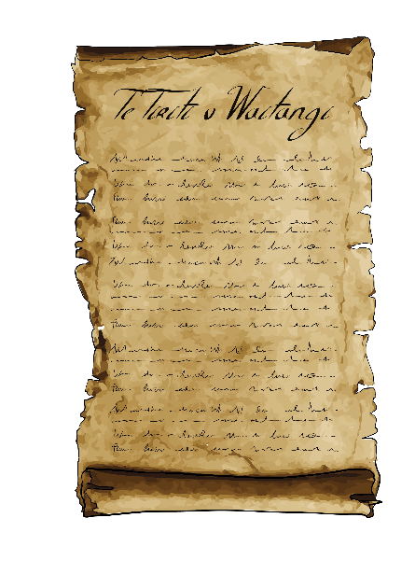
This Easy Read document will look at some of the things that have been happening so far.

The report also talks about how the Government can uphold Te Tiriti o Waitangi.

What has happened so far

Wellbeing means you are able to live a good life.

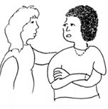
Wellbeing is about what is important to you.

It may be things like:

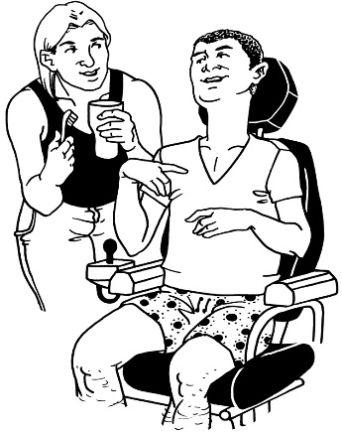
          - being with friends and family

          - feeling you enjoy the things you do in your life

          - have a place to live where you feel happy

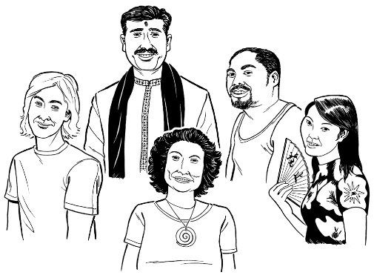
          - being able to be part of your culture

          - being able to decide what is important to you.
The Government wants mental health and addictions services to look after the wellbeing of everyone.

In 2019 the Government agreed to 38 of the 40 recommendations in the He Ara Oranga report.

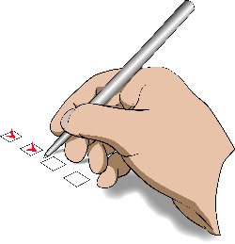
In June 2020 the Commission did its first check-in.

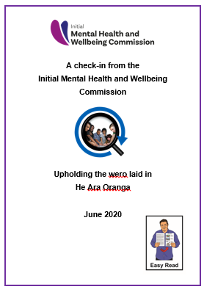
A check-in is when the Commission looks at how things are going.

There is an Easy Read version of the first check-in online.

https://www.mhwc.govt.nz/assets/Interim-Report/Easy-Read-Initial-Mental-Health-and-Wellbeing-Commission.pdf
Who the Commission talked to

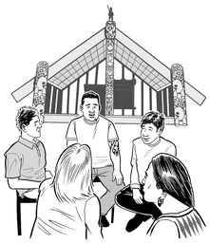
The Commission talked to:

- whānau Māori

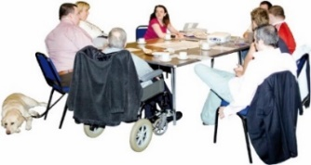
- disabled people

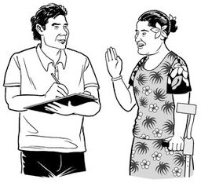
- Pacific peoples

- other groups with mental health and wellbeing needs
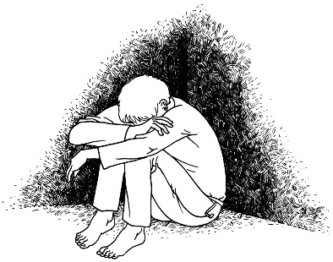
- people with lived experience of mental health and addiction
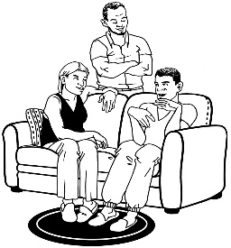
- their families / whānau / caregivers.

The Commission also talked to rainbow communities.

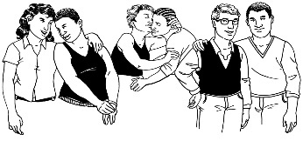
Rainbow communities mean people who are:
- lesbian
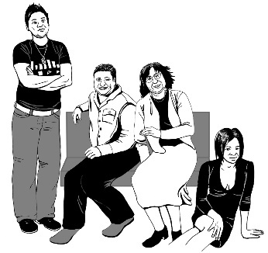
- gay
- bisexual
- transgender
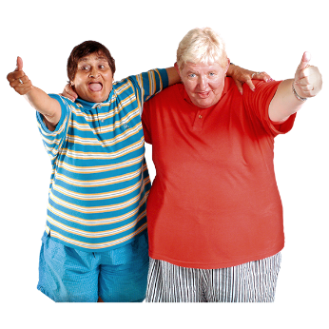
- questioning which means not sure what words best fit them
- intersex
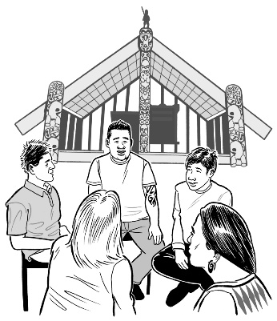
- asexual
- takatāpui

- use other similar words to talk about themselves.
What the Commission asked

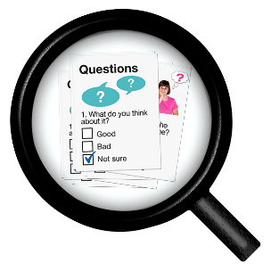
The Commission asked:

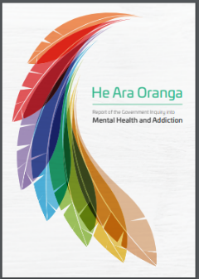
- how many of the recommendations in the He Ara Oranga report the government had put in place
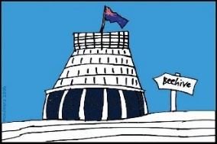
- what the government has changed so far

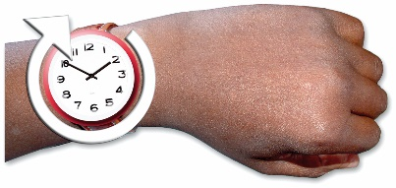
- if things are changing fast enough

- how much still needs to be changed
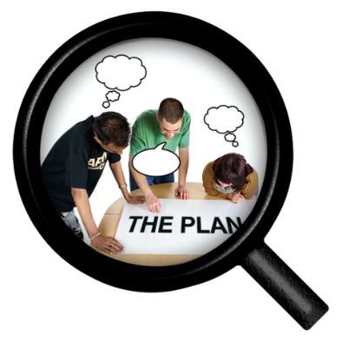
- what the government should focus on next.

What the government is doing to make He Ara Oranga happen

The government wants to make the He Ara Oranga report happen.

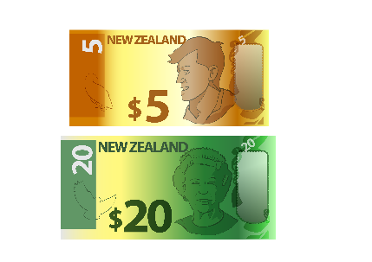
The government is spending money to make things better.

The government has started by making changes in 4 important areas:

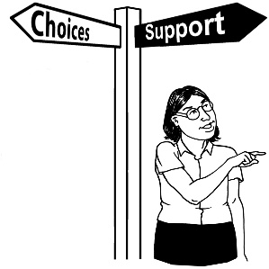
- More choice in mental health services to support the different needs that people have.

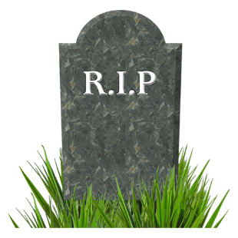
- Trying to stop the high number of people who suicide.

Suicide is when someone ends their own life.

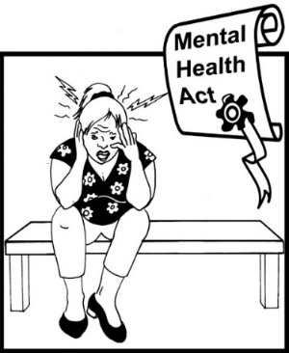
- Changing the Mental Health Act.

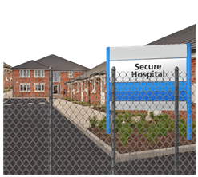
The Mental Health Act is a law that means doctors can make people
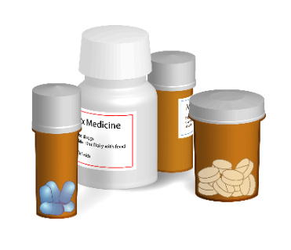
    - go to hospital
    - take medicine.

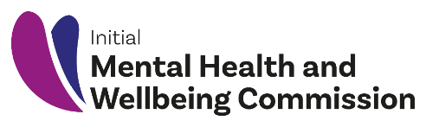
- Setting up a Mental Health and Wellbeing Commission.

What people told us

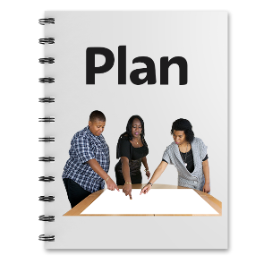
People told us they are worried that there is no written plan for how to make the changes in He Ara Oranga.

People said they want to be more involved in designing new mental health services.

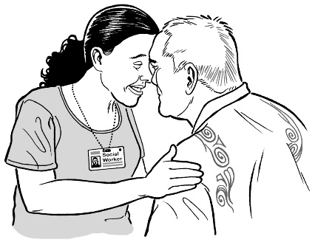
People wanted new services to happen sooner like:

- kaupapa Māori

- peer support.
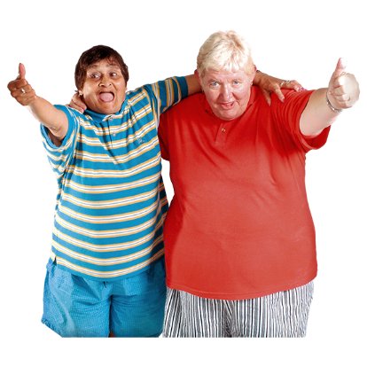

Peer support is when service users support each other.

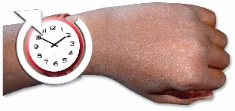
People wanted changes to happen faster.

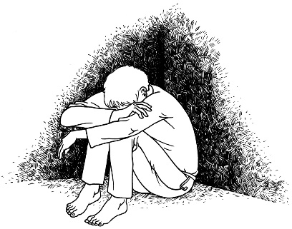
People said that money should be spent on the people who need more support first.

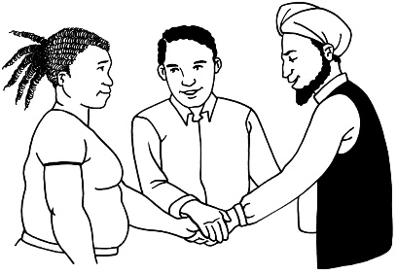
People told us that everyone needs to work together to make things better.

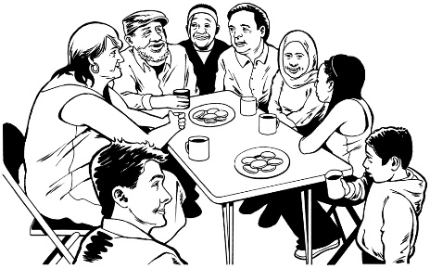
People gave examples of communities that are doing a good job providing services.

People told us that different parts of government are working together.

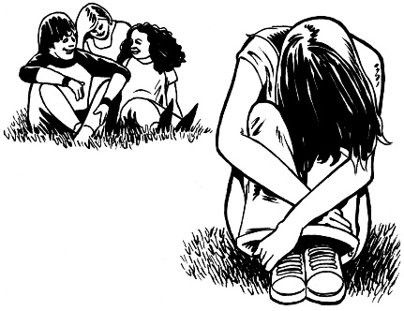
People told us that we need to involve service users in planning so we make the right services for them.

People said the leaders need to help everyone to work together to include everyone as equal partners.

Our advice for the government

We have some advice for the government on how to make He Ara Oranga work.

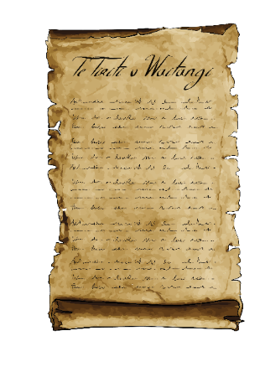
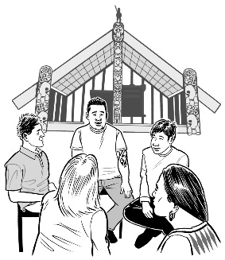
The government needs to share power with Māori to make sure they follow Te Tiriti o Waitangi.

The government should write a plan to make He Ara Oranga happen that includes:

  - all parts of government

  - people

  - communities

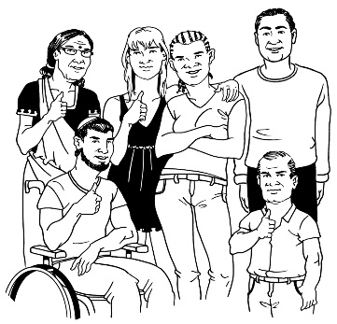
We want the government to help everyone to work together like we did during COVID-19 by:

  - making fast decisions

  - trusting people.

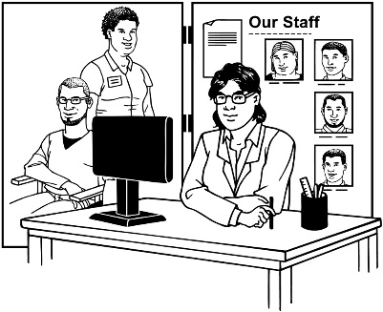
The government needs to make sure people get services at the right time.

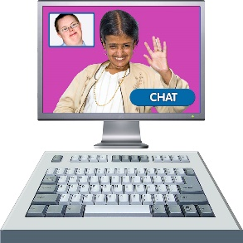
Government departments can help services to use technology like computers and phones to reach more people.

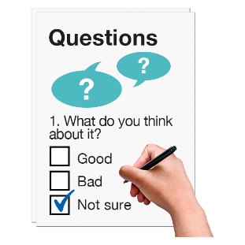
We want the government to measure the things that are important so we can check if they are doing a good job.
Where to find more information

There is more information about the Initial Mental Health and Wellbeing Commission on this website:

www.mhwc.govt.nz

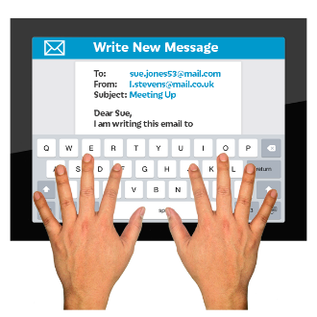
You can also send us an email:
kiaora@mhwc.govt.nz

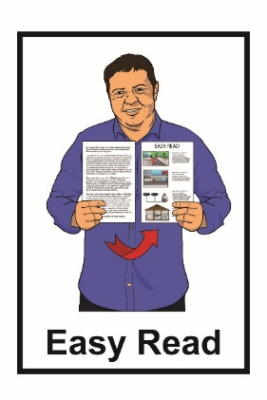
This information has been translated into Easy Read by the Make It Easy service of People First New Zealand Inc. Ngā Tāngata Tuatahi.

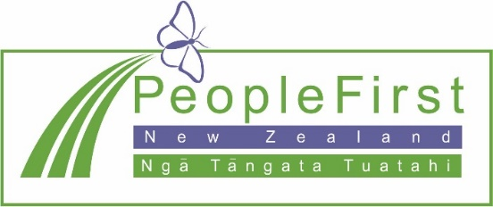
The ideas in this document are not the ideas of People First New Zealand Ngā Tāngata Tuatahi.

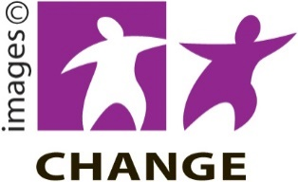
Make It Easy uses images from:

- Changepeople.org

- Photosymbols.com
- Sam Corliss

All images used in this Easy Read document are subject to copyright rules and cannot be used without permission

